The Peaceful Pony
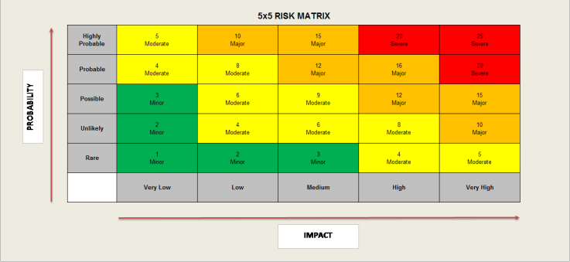
Activity Risk Assessment

• 1-4: Acceptable – no further action may be needed and maintaining control measures is encouraged.
• 5-9: Adequate – may be considered for further analysis.
• 10-16: Tolerable – must be reviewed in a timely manner to carry out improvement strategies.
• 17-25: Unacceptable – must cease in activities and endorse immediate action.

Area to be assessed | Working with other animals | Person assessing area | K Reid H&S Officer
Date of assessment | 03/01/25 | Date of next review | 03/01/26

 | IMPACT DESCRIPTION | IMPACT  LEVEL | PROBABILITY LEVEL | PRIORITY LEVEL | MITIGATION NOTES | Control Measures Checked/Dates | Final Risk Rating
What Is the Hazzard | Who Is at Risk? | Rate  1 (LOW) to 5 (HIGH) | Rate  1 (LOW) to  5 (HIGH) | (IMPACT X  PROBABILITY)  Address the  highest first. | What can be done to lower or eliminate the impact or probability? | Who is responsible? | Rate  1 (LOW) to  5 (HIGH)
Other animals on site -  (Therapy Dogs, rabbits, birds, guinea pigs, rats, mice.)  Bitten  Scratched  Knocked over  Tripping over  Trod on  Allergic Reaction  Infection | Children, Staff | 3  LOW | 4  MODERATE | 12  MAJOR | Experienced handlers are present at all times.  Induction and Introduction to  animals given to all new people  including clients & visitors (if  engaging in animal-assisted work) to mitigate risks of harm to children or animals.  First Aid Qualification & First Aid Kit on site (clearly labelled with  accident book) | Manager  Lead Staff  Support staff carrying out activities  On going daily checks  H&S Officer | 3  LOW
Dogs on site  Bitten  Scratched  Knocked over  Tripping over  Trod on  Allergic Reaction  Infection  Risk of dogs escaping premises  Risk of harm to dog from child | Children, Staff,  Animals | 3  LOW | 3  Low | 9  Moderate | Dogs on-site are training Therapy  Dogs and will be kept under  control at all times by their  handler; create, lead or by their  owner’s side if off lead.  Clients advised not to touch the  dogs nor open/enter the areas  where dogs are, without full  consent of supervision of dogs  owner.  All gates to be kept closed at all times to mitigate risk of dogs escaping. | Manager  Senior Staff  H&S Officer  On going daily checks | 4  MODERATE
Feeding of animals without supervision  Bitten  Allergic Reaction  Infection | Children, Staff  Animals | 3  LOW | 2  Low | 6  Moderate | All children will be supervised when feeding animals to mitigate risk of incorrect diet and over feeding.  To reduce the risk of being bitten or harmed. | Manager  Senior staff  H&S Officer  On going daily checks | 1  VERY LOW
Allergic Reactions  Anaphylaxis | Children  Staff | 4  Moderate | 3  Low | 12  Major | Health issues must be raised by clients before coming on site or disclosed at induction to mitigate risk of anaphylaxis.  Ensure clients have Epi pens if required.  Staff’s discretion if any disclosure  stops the individual remaining on site.  First Aid Trained people on-site. | Manager  Senior staff  H&S Officer  On going daily checks | 4  Moderate

