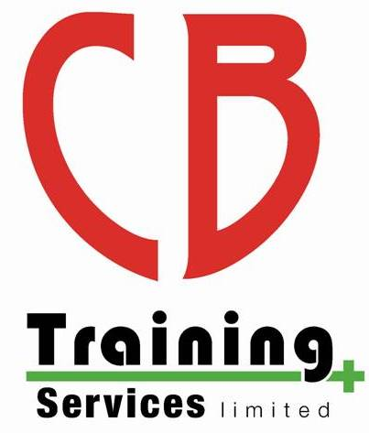
CB Training Services Limited

Consent Policy

Overview

The consent of the data subject is one of the conditions for the processing of his or her personal data and is within the scope of this procedure. CB Training Services Limited needs to obtain consent when no other lawful basis applies.

Consent of the data subject is defined by the GDPR as “any freely given, specific, informed and unambiguous indication of the data subject's wishes by which he or she, by a statement or by a clear affirmative action, signifies agreement to the processing of personal data relating to him or her”.

Explicit consent is required for the processing of sensitive personal data. Specific conditions apply to the validity of consent given by children in relation to information society services, with requirements to obtain and verify parental consent below certain age limits.

The personal information we would like to collect from you

Swim School Lessons (initial enrolment):
- Parent / guardian contact details comprising of name, address, postcode, telephone numbers(s) and email address
- Swimmers name
- Swimmers DOB
- Swimmers medical conditions.

Swim School Lessons(re-enrolment):
- As well as the above information should you choose to enrol via Direct Debit a third-party company (GoCardless) will process your bank account details on our behalf

Training Course Enrolment:
- Depending upon the course information will be requested about your personal contact details (name, address, email and phone number) as well as proof of identity and any accredited prior learning. For example, to complete swimming teachers course there is a pre-requisite that a Safeguarding and Lifeguarding course will have been completed before the qualification can be awarded.

Employees:
- Employees need to provide basic contact information (name, address, telephone number and email address) as well as proof of qualifications.
- We also require some personal information to enable us to process a Disclosure and Barring Service check via The Post Office. This information will include personal information such as driving licence, passport and recent bills.
- To enable payroll to be processed personal tax information will be required which will be supplied to our third-party Sage Payroll
- To enable staff to be paid personal bank account details will be required which will be supplied to our bank (Bank of Scotland)

Financial Information:

- Basic information is required to process invoices and provide our services. This information is for the administration of lessons and does not usually involve swimmers.

The personal information collected is to allow us to run the business. No information is collected unless it is needed for a specific task. For example, swim school enrolment information is required to allow teachers to know who should be in their class while medical information allows us to keep all swimmers as safe as possible.

The only special category of personal data held by CB Training Services Limited relates to medical conditions. This is very brief summaries of any conditions with which we may need to provide emergency medical aid for, or, which may alter how we need to deliver our lessons or training courses.

Responsibilities

As a data controller, CB Training Services Limited is responsible under the GDPR for obtaining consent from the data subject under advisement from the Data Protection Officer (DPO).

Consent Procedure

CB Training Services Limited provides a clear privacy notice wherever personal data is collected to ensure that consent is informed and that the data subject is informed of their rights in relation to their personal data.

CB Training Services Limited demonstrates data subject(s) consent to the processing of his or her personal data or explicit consent for sensitive personal data on all its enrolment forms and signup methods (e.g. online or via BACs) with follow up via email for the swim school lessons. For training courses, the information is detailed on the registration forms and employees have the information within their Employee Handbook.

CB Training Services Limited demonstrates data subject(s) consent to the processing of his or her personal data for one or more specific purposes via the methods detailed above.

CB Training Services Limited demonstrates data subject(s) consent is clearly distinguishable from any other matter relating to the data subject by using multiple signup and tick boxes with each option relating to one specific signup/consent notice.

CB Training Services Limited demonstrates data subject(s) consent is intelligible and accessible using clear and plain language.

CB Training Services Limited demonstrates data subject(s) are informed of their right to withdraw consent before giving consent. However, should a data subject withdraw consent they will be unable to continue lessons or training with CB Training Services Limited.

CB Training Services Limited demonstrates processing of data is limited to that stated in the contract, bound by the explicit consent given by the data subject.

Child consent procedure

CB Training Services Limited does not accept enrolments from children under the age of 16 except where the child is enrolling their own child in to the swim school. At this point the data subject would therefore be the child being enrolled for lessons and not the parent.

Withdrawal of Consent Procedure

This procedure addresses the data subject(s) right to withdraw consent for the processing of his or her personal data.

Withdrawal of consent by the data subject means an unambiguous indication of the data subject's wishes by which he or she, by a statement or by a clear affirmative action, signifies withdrawal of consent to the processing of personal data relating to him or her.

Withdrawal of consent shall be without effect to the lawfulness of processing based on consent before its withdrawal. Whereas consent covered all processing activities carried out for the same purpose or purposes, withdrawal of consent covers all processing activities carried out for the same purpose or purposes.

As a data controller, CB Training Services Limited is responsible under the GDPR for administering withdrawal of consent from the data subject under advisement of the Data Protection Officer (DPO).

CB Training Services Limited demonstrates the data subject has withdrawn consent to the processing of his or her personal data.

The processing activities that relied upon the consent is stopped in accordance with the relevant process.

To withdraw from us send an email to chris@cbtraining.org

Or Write to us at:

CB Training Services Limited
10 Ty Gwyn Road
St Dials
Cwmbran
NP44 4AB

