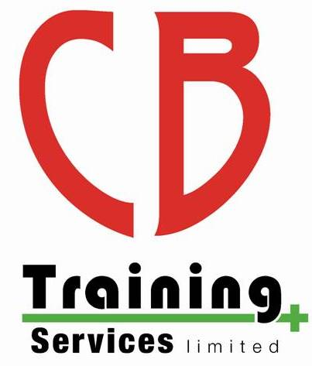
CB Training Services Limited

Subject Access Request Form

CB Training Service Limited,10 Ty Gwyn Road, St Dials, Cwmbran, NP44 4AB
Telephone: 07876 240 043
Email: chris@cbtraining.org
Website: www.cbtraining.org

Data Subject Details
Notes
Title:
Surname:
First Name(s):
Current Address: |  | 1
Telephone Number:
Home
Mobile
Work
Email Address:
Date of Birth:
Details of identification provided to confirm name of data subject: |  | 2
Details of data requested:

Details of Person Requesting:

Details of Person Requesting the Information (if not the data subject):

Are you acting on behalf of the data subject with their written or other legal authority?
If “yes” please state your relationship with the data subject (e.g. parent, legal guardian or solicitor)

Please enclose proof that you are legally authorised to obtain this information

Title:
Surname:
First Name(s):
Current Address:

Telephone Number:
Home
Work
Mobile
Email Address:

Declaration

I, _________________________________, the undersigned and the person identified above, hereby request that in at the deep end provide me with the data about me identified above.

Signature: _________________________________
Date: _________________________________

Notes

1. If you believe it is necessary, please also provide previous addresses
2. We will need two copies of forms of ID. This can be:
- Passport
- Driving licence
- Birth certificate
- Utility bill (within 3 months)
- Current vehicle registration document
- Bank statement (within 3 months)

Office Use Only

Date received SAR: _________________________
Date Completed SAR (within 30 days): ____________
Signed by DPO: _______________________________

