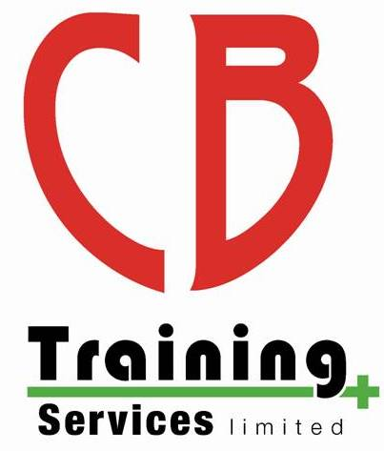
CB Training Services Limited
Appeals Policy

Purpose
CB Training Services Limited is committed to providing an efficient and high standard of service to all. We are continually working to achieve this high level of service by maintaining quality assurance standards which are compliant with regulatory requirements. It is our aim to ensure that all assessment outcomes are fair, consistent, and reliable based on the valid judgements of the assessor using the assessment strategy for the qualification in question. However, occasions may arise where the training provider or learner may wish to question a decision.

Policy
Our training centre will ensure:
- Assessments are carried out by assessors who have the appropriate qualifications, knowledge, understanding, and skills, and the assessments are valid for the subject or qualification in question
- Assessment evidence is authentic, solely being produced by the learner in question
- The consistency of assessments decisions covering all assessors over time
- Appeals are heard by individuals that have the appropriate competence to make decisions in each individual case and have had no prior involvement, or a personal interest in the case

Everyone has the right to appeal if they believe that their assessment decision, or a decision following a malpractice or maladministration investigation is incorrect. This policy will define the stages and procedures you would need to follow, guidance is as follows:
- The process you need to follow to submit an enquiry or appeal
- The timescales for an enquiry or appeal
- How and when you will be notified of the outcome

CB Training Services Limited will accept an appeal in relation to the following:
- Appeals against results of assessment or quality assurance
- Appeals against a decision made relating to a reasonable adjustment or special considerations application
- Appeals against decisions relating to any action taken against a learner or centre following an investigation into malpractice or maladministration
- Appeals against centre or qualification approval decisions

We are committed to providing an equal opportunity for all, where possible to communicate with us. Therefore, if a learner or provider wishes to enquire or appeal against an assessment decision they have clear guidance on how to proceed. Firstly, we advise all learners to discuss any concerns or enquiries relating to the result of the assessment with the assessor to resolve the issue. If you are not satisfied with the outcome, then please contact CB Training Services Limited for further advice and guidance or refer to the guide within this policy.
Stage 1 - Enquiry
Enquiries regarding assessment decisions

If a learner wishes to question an assessment result they should initially discuss their concerns with the course tutor / assessor and follow the centres appeal process. If the learner has exhausted the centres enquiries and appeals process and still remains unsatisfied with the outcome, the course tutor / assessor and learner should complete stage 1 of the enquiry form which is downloadable from Safety Training Awards website. This must be submitted to Safety Training Awards within 28 days of the final results being issued to the learners. https://www.safetytrainingawards.co.uk/policies/enquiries-and-appeals-policy/

Safety Training Awards will acknowledge receipt of the appeal within 7 working days, this will be followed promptly by the adjudication process. Safety Training Awards will appoint the relevant manager to act as an adjudicator who has not had any involvement with the case.

The adjudicator will consider the written submission from the course tutor / assessor and learner and will review the procedures that were followed to reach the result decision, this may include contacting other parties who were included within the course.

The adjudicator may instruct that a further re-mark or reassessment should take place if they consider that the assessment procedures were not adequately followed.

The course tutor / assessor and learner will be notified by letter of the adjudication outcome as soon as it is available, within a maximum of 28 days.

Stage 2 - Appeal

If the appellant is not satisfied with the appeal outcome in stage 1 they may appeal the decision to an appeal committee. Please complete stage 2 of the appeal form. The appeal form is downloadable from Safety Training Awards website. https://www.safetytrainingawards.co.uk/policies/enquiries-and-appeals-policy/

This stage 2 appeal submission must be submitted within 14 days of them receiving the enquiry decision from stage 1, accompanied with an administration fee of £50. Safety Training Awards will acknowledge receipt of this appeal within 7 working days.

The appellant will be contacted within 14 days to outline the procedures that will be adopted. Safety Training Awards will make arrangements to promptly hear the appeal at our head office. You may attend and have one representative present at the appeal hearing. The appeal committee consisting of senior managers or other individuals deemed to be appropriately competent, who have no personal interest in the decision being appealed and an independent person who is not an employee, assessor or otherwise connected to Safety Training Awards will evaluate the procedures used for consistency with Safety Training Awards procedures to review if the previous decision was reached fairly. The appeal committee are unable to re-mark or reassess work but may instruct that a further re-mark or reassessment should take place if they consider that the procedures were not adequately followed.

The appeal committee will make the final decision and notify the appellant of the outcome by letter as soon as it is available, within a maximum of 28 days. If the appeal is upheld the appeal administration fees will be reimbursed to the learner.

If the outcome of an appeal at any stage leads to Safety Training Awards discovering a failure in the assessment process an investigation shall be conducted to determine if there are any other learners affected, and if there are any adverse effects arising from the failure. If this is the case, Safety Training Awards shall promptly implement the adverse effects procedure and take decisive action to correct the failure, or if this is not possible to reduce the impact of the failure on any learners.

Monitoring and Review
This policy and its procedures will be reviewed regularly for improvements as part of our Quality Assurance requirements. This will ensure it is fit for purpose, reflects the services we deliver to our customers and we provide services which are relevant to the requirements of individual needs.

