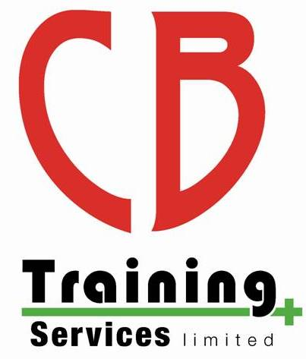
CB Training Services Limited
Complaints Policy

Purpose
CB Training Services Limited is committed to providing a quality service for its learners. We take every care to ensure we are delivering a high standard of service but are aware that there may be occasions that we do not meet both yours and our expectations, in this instance please raise your concerns with us immediately so we can address them, respond positively, and rectify any mistakes made.

Policy
CB Training Services Limited is committed to promoting fairness and equality of treatment to all. We welcome positive or negative feedback from any individual that has been directly affected by our services. We strive to think our learners have confidence that we will listen to their views and act upon them accordingly. All written correspondence will be acknowledged by us within 7 working days, any dissatisfaction received will be treated as a complaint.

Our aim is to provide our learners with a clear, precise process to follow when they feel the need to make a complaint and communicate effectively the process we will follow to resolve the complaint.

We aim to ensure:
- The complaints procedure is an easy process to follow and is prompt and efficient
- All complaints are treated as a dissatisfaction with our level of service
- The resolution is to the complainant’s satisfaction (explanation, apology, action taken) and our staff when dealing with the complaint are courteous, consultative, and responsive
- Complaints and feedback received is reviewed in line with our quality assurance standards to help improve our products and services

Everyone has the right to raise a complaint, so this policy will define the stages and procedures you would need to follow, guidance is as follows:
- The process you need to follow to raise a complaint
- The appropriate person who this should be directed to
- The timescales for the complaint to be investigated
- How and when you will be notified of the outcome

CB Training Services Limited will not accept a complaint under this policy in relation to the following:
- If the complaint relates to any assessment decision or course results please refer to our enquiries and appeal policy
- Any form of maladministration or malpractice, this will be dealt with under our maladministration and malpractice policy

Raising Concerns and Making Complaints
All individuals can access the information about our complaints procedures through our website https://cbtraining.org/policies or can request a copy by contacting us CB Training Services Limited. We are committed to providing an equal opportunity for all, where possible to communicate with us.

If you have attended a course and are dissatisfied with the service or are seeking a refund of your course fee you must firstly try to resolve this matter with the centre co-ordinator. Learners must have exhausted their centres complaints policy before raising a complaint with Safety Training Awards. Safety Training Awards do not offer refunds for courses organised by individual members, please contact the centre co-ordinator directly to discuss your concern / complaint prior to contacting the awarding organisation. If you are not happy with the response, then please contact Safety Training Awards for further advice.

A complaint can be raised by an individual, a group or a third party who is acting on the behalf of someone else. If a third party is submitting a complaint on the behalf of someone else they will need written permission from the complainant along with the written complaint attached, this should then be presented to CB Training Services Limited for acceptance.

Once CB Training Services Limited have received a complaint an acknowledgement will be sent within 7 working days. The complaint will be reviewed in line with our policies and procedures and an investigation will be conducted where necessary. To ensure a fair and thorough process is followed the duration of the investigation will depend on the nature and severity of the complaint we receive at this stage, or the complexity of the response required.

How to Make a Complaint
Informal Process
We understand that most individuals who are not satisfied with a service would like it addressed and dealt with as soon as possible, therefore an informal process would be far more appropriate.

An informal process will be more efficient resolving complaints quickly by mediating between who is responsible for the dissatisfaction and the complainant. The complaint may be resolved immediately following this process, so we encourage our learners to contact CB Training Services Limited directly for an informal discussion if they have a complaint that needs to be resolved to achieve the desirable outcome.

Formal Process
Stage 1
If the complainant is not satisfied with the outcome from the informal process the dissatisfaction should be submitted in writing to CB Training Services Limited. Once we have received this information we will send acknowledgement of receipt to the complainant within 7 working days and an investigation to resolve the dissatisfaction will commence.
CB Training Services Limited will identify an appropriate manager to review the complaint for further investigation and the complainant will be notified of the individual responsible for this. The member of management will conduct a further investigation in to the complaint, upon completion of the investigation they will communicate and notify the complainant and provide them with an explanation or resolution.
To ensure a fair and thorough process is followed the duration of the investigation will depend on the nature and severity of the complaint we receive at this stage, or the complexity of the response required.

If the complainant remains dissatisfied with the outcome from the manager’s investigation the next steps to pursue are stage 2 of the complaints procedure.

Stage 2
If the complainant is not satisfied with the outcome from the stage 1 complaints process they are able to request a review of the complaint by a senior manager. This must take place within 14 days of the outcome of the original complaint and must be submitted in writing. The senior manager will determine if appropriate procedures were followed and the complaint was answered fully, if there is new evidence submitted in support of the complaint this will also be reviewed. Following review, we shall aim to notify the complainant in writing as soon as possible of the outcome, within a maximum of 28 days.

If the learner is not satisfied with the final response they may then refer the complaint to Safety Training Awards.

Monitoring and Review
This policy and its procedures will be reviewed regularly for improvements as part of our Quality Assurance requirements. This will ensure it is fit for purpose, reflects the services we deliver to our customers and we provide services which are relevant to the requirements of individual needs.

