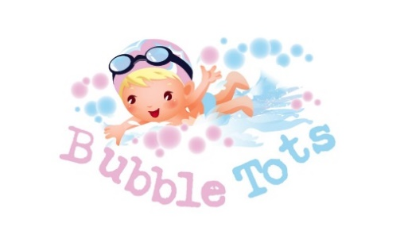
Bubble Tots
Happy Nappy Policy
Dear All Parents
As you may be already aware of, there was a new British Standard that had been released by the British Standards Institute called PAS 520 that we have to adhere to and we implemented it as of 1st January 2016.
Currently the new standard states that children under 4 must wear a double nappy system which compromises of a disposable swim nappy with a reusable nappy over the top called a “happy nappy”. We will only be enforcing this rule to children under the age of 4 who are not toilet trained for at least 3 months as the awarding body is protesting that children who are toilet trained should not have to wear them and this is currently under review.
These “happy nappies” can be purchased on various websites and shops but we will also be selling them for £10.00. If you do wish to purchase one from another distributor, then please check with us first before you purchase it as you may still need an approved “happy nappy”. There are various non-approved alternatives out there without the wide stretch bands around the legs and waist such as the frilly nappy covers that will not reduce the risk of an “accident” being released into the pool and causing a pool closure.
We have the following happy nappies available to purchase from us:
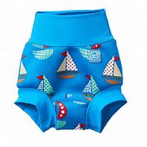
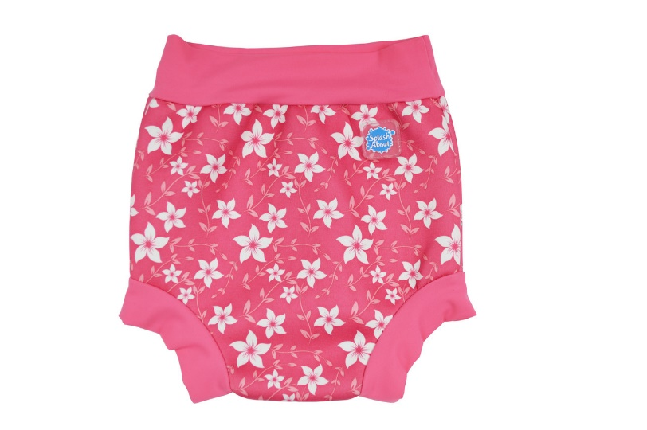
The sizes available are as follows:
0-3 months
3-6 months
6-12 months
12-24 months
2-3 years

If your child has not got a “happy nappy” then we will have to refuse entry into the swimming pool.
To order your child’s happy nappy, please email chris@cbtraining.org specifying which colour and size along with your child’s name and day/time of class and we will reserve one for you.
We will also have some stock available to purchase on the last week of term at a reception desk but sizes/colours will be limited so pre-order is recommended.
Many regards,
Chris Bateman
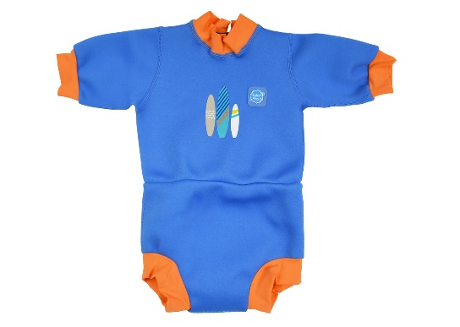
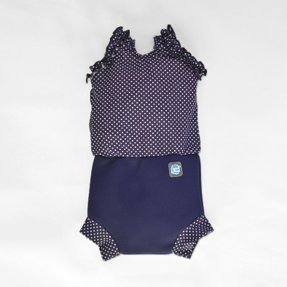
______________________________________________________________________________
Please note,
You can also purchase special happy nappy costumes over the internet but please check with us first before you purchase one to ensure you are not wasting your money.

