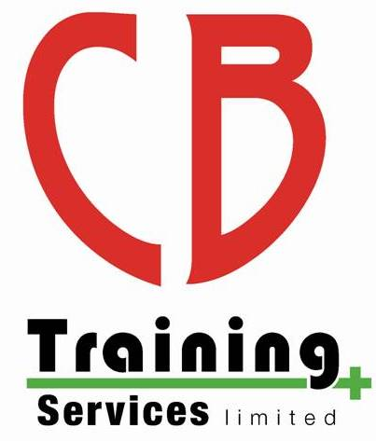
CB Training Services Limited

COVID-19 Policy – Training Courses

Overview

COVID-19 is a new Coronavirus, which The World Health Organisation (WHO) declared as a Global Health Emergency on the 30th January 2020 and as a Global Pandemic on the 11th March 2020.

This policy sets out our response to the challenges COVID-19 has presented to training and assessing, and how we can ensure they recommence in a COVID Secure way. CB Training Services Limited is an Approved Training Centre (ATC) with Safety Training Awards (STA).

COVID Officer

The Swimming Teachers Association (STA) have strongly recommended the appointment of a “COVID Officer.” Their role is to develop and implement COVID specific policies, procedures and risk assessments, ensuring they follow government and awarding organisation guidelines.

Your COVID Officers are:

Name | Phone number | Email
Chris Bateman | 07876 240043 | chris@cbtraining.org
Emma Jenkins |  | emma@cbtraining.org

ATC Commitment to Safety

We are committed to ensuring the health, safety and well-being of all ATC staff and learners. Therefore, this policy builds upon the commitment and procedures set out in the Health and Safety policy, to ensure compliance with The Health and Safety at Work Act (1974), STA Guidance (found on STA.co.uk and safetytrainingawards.co.uk), PWTAG technical notices (pwtag.org) and the Heath and Safety executive for First aid and CPR during CPR https://www.hse.gov.uk/coronavirus/first-aid-and-medicals/first-aid-certificate-coronavirus.htm

Therefore, the ATC is committed to developing and implementing COVID risk assessments, which are reviewed after every course, and on any updates from the government, STA, PWTAG and HSE

Courses

Pre-Course

Prior to all face-to-face training learners must:
- read this policy in full;
- Complete the COVID-19 health questionnaire (sent via email 48 hours before your start date, and must be returned no later than midday the day prior to your start date or bring a paper copy on arrival), should a learner fail to return the form or have any symptoms of Covid-19 they will be refused access to face-to-face training, should book a test and go home to self isolate;
- Read the course and venue specific procedures for their face-to-face session as necessary which will be emailed prior to the course or available to read and discussed at the start of the first day of a course

Course Duration

Online Theory Learning

For online learning please see our ‘Safe use of technology policy’

Face to face Theory Learning

When face-to-face theory sessions are delivered, the following procedures will be in place:
- Social distancing of 2m will be in place at all times;
- Good hygiene will be enforced (regular hand washing/antibacterial hand wash stations, cleaning of work stations, no sharing of equipment etc.);
- Learners will have limited access to facilities (toilets and classroom only), learners may not roam or use other facilities;
- Tea and coffee facilities will be unavailable. Learners must bring their own refreshments and food, which may only be consumed at their work station or outside if the tutor has sort permission form the venue;
- Maximum ventilation will be in place, all windows and doors will be open where possible.
- Face masks can be worn by learners if they wish to do so

Practical Sessions Face to Face

When all practical training commences social distancing will be ensured throughout. This means where possible the 2m minimum distance will be used. Where the 2m distance is unachievable we will ensure 1m+ by implementing the following mitigations:
- Limiting time within a 2m distance to a maximum of 15 minutes;
- Consider the use of PPE (face covering/masks), in line with assessment and best practice recommendations;
- Work back-to-back, or side-to-side to eliminate face-to-face working;
- Learners who are already in a “bubble” (household or otherwise) should remain in their own bubble and do not have to comply with social distancing;

The COVID officer will maintain a “COVID Course Log” for all courses to log contact groups, equipment use and cleaning etc.

Hygiene Throughout Delivery

Learners will be encouraged to maintain good hygiene procedures throughout practical sessions as listed above.
Further consideration is given to equipment:
- Cleaning of equipment is logged in the COVID Course Log;
- Each piece of equipment has its only cleaning procedures in line with manufactures and best practice guidelines, this will be detailed to learners both verbally and through signage;
- All equipment will be deep cleaned and/or replaced with new at the end of each course, in line with manufacturers and best practice guidelines;
- Equipment sharing is kept to a minimum, avoided if at all possible;
- Where necessary PPE will be implemented, learners will be provided both verbal and signage as guidance on their safe use;
- We recommend learners provide their own mask but we will have surgical 3 layer masks for them to use if required.

Assessment Adaptations

In line with the awarding organisation guidelines some adoptions may be possible to the assessments, this may include:
- Verbal discussion on the performance of a skill.
- Wearing of PPE for some assessment skills as detailed in STA/RLSS/HSE guidance

Data Protection

On course booking learners are required to provide particular personal information. All data is stored on a password protected computer, or in a locked filing cabinet. All qualification data is stored in line with the Awarding organisation’s policy.

Please visit our website for full GDPR Policies: https://cbtraining.org/policies

NHS Track & Trace

We are committed to assisting in NHS Track and Trace to help prevent the spread of COVID-19. The COVID Course Log, will detail learners who work in pairs, groups or share equipment. This data is kept for 21 days in line with the government guidance to support Track and Trace. After 21 days this data will be deleted.

To withdraw from your data being used for NHS Track and Trace systems please send an email to chris@cbtraining.org

Or Write to us at:

CB Training Services Limited
10 Ty Gwyn Road
St Dials
Cwmbran
NP44 4AB

Monitoring and Review

This policy was written by Chris Bateman in August 2020.

This policy will be reviewed initially after each course and when there is an update from the government and the awarding organisation policies.

Review no. | Date of review: | Purpose & Details of change | Initial

Appendices

