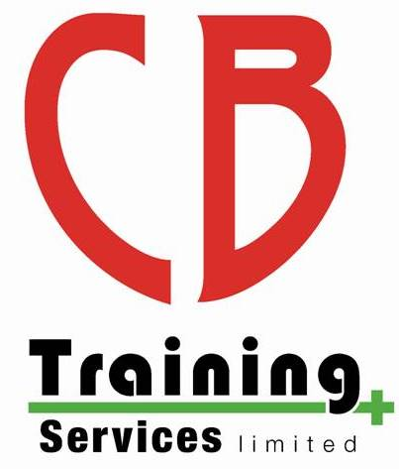
CB Training Services Limited

Manikin Hygiene Policy

Overview

Due to the recent COVID-19 Global Pandemic we have reviewed our manikin hygiene procedures to meet the latest guidance. It is the responsibility of the trainer to ensure that these guidelines are followed at all times.

During a Course

Each learner will be supplied with their own manikin where practicable which has a new/clean face and a new set of lungs. When using the manikin, the learner will be supplied with manikin wipes to clean the manikin and/or pocket mask. Learners will not share manikins unless the face and lungs are changed as per the policy below regarding after the course

After a Course

After each lifeguard/first aid course run or after staff training sessions, each manikin which has been used will have to follow the following hygiene procedure:

- The lungs will be removed and disposed of
- A new set of lungs will be put in the manikin
- The face will be removed and changed with the spare face
- Disinfect the face which was removed ready to be used for the next time they swap back over
- After each face has been used and disinfected more than 10 times, it should then be disposed of and replaced with a new face

Manikins

Each manikin will also be named so we can keep records of which manikins have been changed. The manikins will be named according to the owner, type of manikin and also given a number
e.g.: CBT Adult/01, CBT Child/02, CBT Baby/03,

The choking manikins do not contain any lungs and therefore only cleaning of the manikin and their face will have to take place.

Monitoring and Review

This policy was written by Chris Bateman in August 2020.

This policy will be reviewed initially after each course and when there is an update from the government and the awarding organisation policies.

Review no. | Date of review: | Purpose & Details of change | Initial

Appendices

