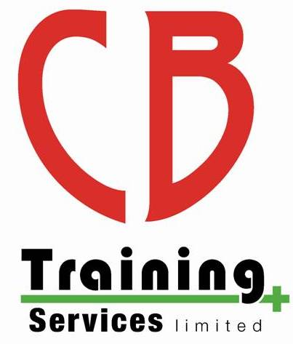
CB Training Services Limited
Whistleblowing Policy

Whistleblowing is a term used when an individual discloses information relating to malpractice or wrongdoing or covering up any malpractice or wrongdoing. This is often committed by the individual’s employer, although this is not always the case.
On occasions, someone making an allegation of malpractice or maladministration or any other issue may wish to remain anonymous, it is always preferable to reveal your identity and provide us with your contact details. If you are concerned about possible adverse consequences that may occur if your identity is revealed to other parties, please inform us that you do not wish for us to divulge your identity and we will ensure we do not disclose your details.
CB Training Services Limited is not obliged to disclose information, if to do so would be a breach of confidentiality and/or any other legal duty. However, on occasions to progress an investigation it may not be possible to entirely anonymise individuals, third parties may need to be involved, in this instance this would be discussed in advance with the whistle blower/person who made the allegation. We may need to disclose identity to the following:
- The police, fraud prevention agencies or other law enforcement agencies (to investigate or prevent crime, including fraud)
- The courts (in connection with court proceedings)
- Any other person to whom we are required by law to disclose your identity.
The investigator assigned to review the allegation will not reveal the whistle-blower’s identity unless permission has been granted or it is absolutely necessary for the purposes of the investigation (as above). The investigator will notify the whistle-blower if it becomes necessary to reveal their identity against their wishes.
A whistle-blower should recognise that they may be identifiable by others due to the nature of circumstances of the disclosure.
Once a concern has been raised CB Training Services Limited has a duty to pursue the matter, it is not possible to prevent the matter being investigated by subsequently withdrawing a concern as we are obliged by the regulators to follow up any allegation of malpractice or maladministration and investigate accordingly.
We will consider each disclosure of information sensitively and carefully and decide upon an appropriate response.
In all cases we will update you to confirm if an allegation will be investigated and will keep you updated with how this is progressing, a whistle-blower will have the opportunity to raise any concerns to the investigator about the way the investigation is being conducted. However, CB Training Services Limited are not obliged to disclose any information, if to do so would be a breach of confidentiality and/or any other legal duty.
Whilst we cannot guarantee we will disclose all matters in a way that you might wish, we will strive to deal with the investigation fairly, thoroughly and promptly.

Notifying Relevant Parties
CB Training Services Limited will tell the person who made the allegation who will be handling the matter, how they can contact them and any further assistance we may need from them. We will keep them updated as to how the allegation has progressed and if an investigation has commenced, timeframes may depend upon the complexity of the case. However, we will not disclose any details of the investigation activities and it may not be appropriate to disclose any details of the outcomes due to confidentiality or legal reasons.
In all cases of suspected or actual malpractice or maladministration at a centre, Safety Training Awards will notify the head of the centre involved in the allegation (unless they are under investigation in which case communication may be with the next appropriate person of authority) that we are investigating the matter.
In cases of learner malpractice, Safety Training Awards may ask the centre to investigate the issue whilst liaising with personnel at CB Training Services Limited. STA will only ask the centre to investigate the matter when we have confidence that the investigation would be prompt, thorough, fair, independent and effective.
STA may communicate directly with centre personnel who have been accused of malpractice if appropriate and/or communicate directly with a learner or their representative if deemed necessary when reviewing the evidence.
Where applicable Safety training Awards’ Compliance Manager will inform the appropriate regulatory authority of a suspected case or a proven case of malpractice and/or maladministration, which may invalidate the award of a qualification or if it could affect another awarding organisation. STA will also keep them informed if we are investigating a large or complex case.
For more information on CB Training Services Limited investigation process please refer to the CB Training Services Limited Malpractice and Maladministration Policy on the website, or you can contact us to request a copy.

Monitoring and Review
This policy and its procedures will be reviewed regularly for improvements as part of our quality assurance requirements. This will ensure it is fit for purpose, reflects the services we provide which are relevant to the requirements of individual needs.
In addition to the above this policy may change considering operational feedback to ensure our arrangements for dealing with malpractice and/or maladministration remain effective

This policy was written and created by Chris Bateman in July 2018 (Version 18.1).

This policy will be reviewed at least once per year and when there is an update from the awarding organisation policies.

Review no. | Date of review: | Purpose & Details of change | Initial
21.1 | 08.12.2021 | Full review and small changes made in:  - Notifying Relevant Parties | CB
23.1 | 02.03.2023 | No changes required | CB

Next Review Date: March 2024

