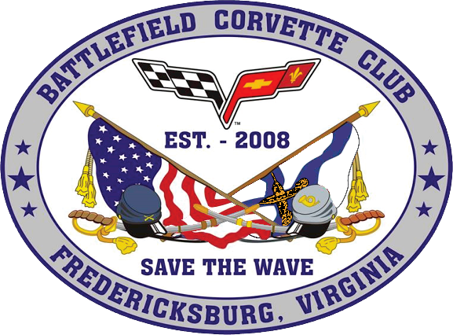

**Battlefield Corvette Club**

**Annual All Corvette Cruz-In**

**Radley Chevrolet**

**Fredericksburg, VA**

**REGISTRATION FORM**

|  |  |  |  |
| --- | --- | --- | --- |
| **NAME** | | | |
| **ADDRESS** | | | |
| **CITY** | | **STATE** | **ZIP** |
| **PHONE** | **CLUB AFFILIATION** | | |
| **EMAIL ADDRESS** | | | |
| **YEAR** | | **MODEL** | **COLOR** |
| **PRE-REGISTRATION FEE $20 until 15 SEPTEMBER. After September 15 cost $30.**  **PLEASE MAKE CHECKS PAYABLE TO - BATTLEFIELD CORVETTE CLUB**  **MAIL REGISTRATION FORMS AND PAYMENT TO –**  **BATTLEFIELD CORVETTE CLUB, PO BOX 8478, FREDERICKSBURG, VA 22404-8478** | | | |
| **HOLD HARMLESS AGREEMENT** – **ENTRANTS AND PARTICIPATES BY EXECUTION OF THIS FORM, RELEASE AND DISCHARGE THE BATTLEFIELD CORVETTE CLUB AND RADLEY CHEVROLET, THEIR OFFICERS, DIRECTORS, MEMBERS, EMPLOYEES AND ANYONE ELSE CONNECTED WITH THE PRESENTATION OF THIS CAR SHOW, FROM ANY AND ALL KNOWN AND UNKNOWN DAMAGES, INJURIES, LOSSES, JUDGEMENTS AND/OR CLAIMS FROM ANY CAUSES WHATSOEVER THAT MAY BE SUFFERED BY ANY ENTRANT OR PARTICIPANT TO PERSON OR PROPERTY.**  **ALCOHOL IS NOT PERMITTED DURING THE SHOW** | | | |
| **SIGNATURE** | | | **DATE** |