Supported by:
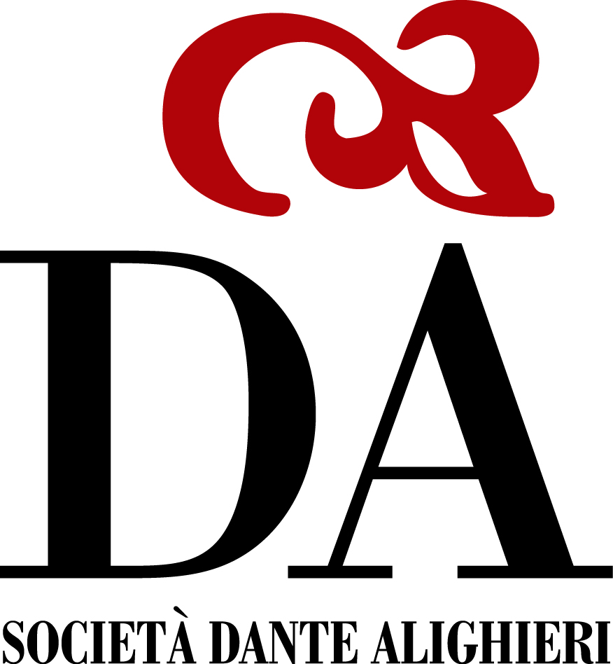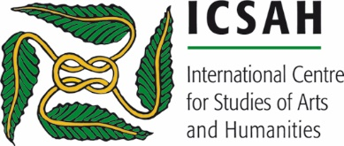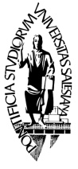
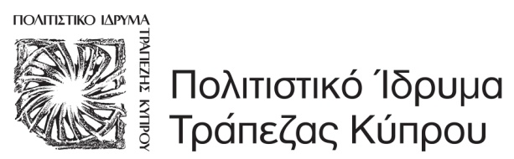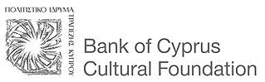

CALL FOR PAPERS

The victim as a cultural expression
Representation, Perception, Symbolism

2nd International Conference on Arts and Humanities,
5-8 June 2018, Nicosia, Cyprus
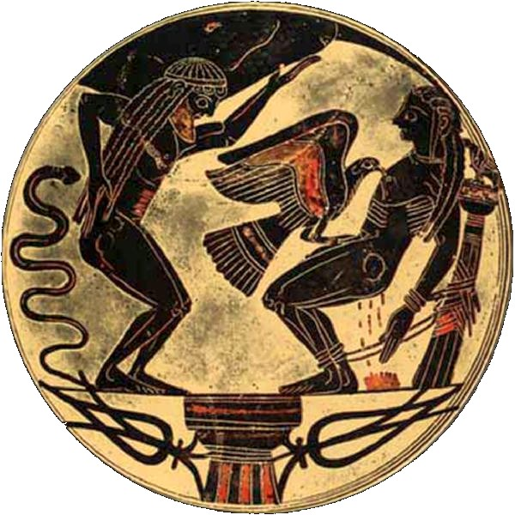

The 2nd International Conference on Arts and Humanities is an event organized by the International Centre for Studies of Arts and Humanities (ICSAH) and the Dante Alighieri Society Nicosia that aims to explore the image of the victim throughout the human history. The conference is to be held in 5-8 June 2018 in Nicosia, Cyprus.
We warmly welcome all papers broadly relevant to the subject without predefining chronological and territorial limitations, as the major goal of the conference is to address questions that involve more than one research field and promote multidisciplinary dialogue and cooperation. The papers will be published online and in a dedicated volume of Conference Proceedings.
Abstract. The image of the victim has always inspired greatly the human imagination and creativity throughout the history of mankind. Whether the victim is a fruit of religious persecutions, genocides, war or even of social inequality, its representation have had a diachronic symbolic and moral value in human societies in different cultural and historical backgrounds.
We invite proposals study all aspects of victim manifestation in literature, art, history and philosophy in order to highlight the variations, similarities and particularities of this figure in different cultural and disciplinary contexts. We encourage also papers that accentuate on the conception, meaning and symbolism of the victim as an icon and a force that transcends the barrier of time and embraces the very essence of the human being.

About ICSAH. The International Centre for Studies of Arts and Humanities is a non-profit, interdisciplinary organization dedicated to the research, study and education in a vast range of disciplines in the field Arts and Humanities. The mission of the organization is to:
- Promote the worldwide understanding, study and teaching across a range of disciplines of the Arts and Humanities, including, but not limited to
- Ancient, Medieval, Modern and Contemporary History
- Ancient and modern languages and literature
- Classics, Philosophy
- Religions and History of Religions
- Anthropology and ethnic studies
- Archaeology
- Visual arts
- Performing arts, including theatre, dance, music
- Those aspects of social sciences which have humanistic content and employ humanistic methods
- Cultural heritage
- Provide additional forums for the exchange of ideas regarding Arts and Humanities in schools, Universities, libraries, museums and other contexts
- Support the interchange of research and the scholarships of knowledge, teaching and service in the Humanities through conferences, publications and relative activities

Submission rules: To submit a proposal for a paper of approximately 20 minutes or a poster, please send an abstract of 350 words or less to icsah.eu@gmail.com by April 30th, 2018. The proposed contributions should not have been previously published or accepted for publication elsewhere. Abstracts should include a title, a summary of the presentation, name of the author/s, institutional affiliation and email.
Conference languages: English, French, Italian.
For further information about the conference, please see our website www.icsah.eu/ Please address any further enquiries to icsah.eu@gmail.com

