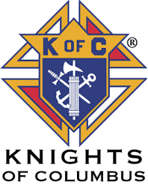
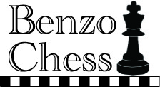
2nd Francis Finnegan Open
Chess Tournament!

Site: St. James Catholic Church
W220 N6588 Town Line Rd.
Menomonee Falls, WI 53051
A Charitable event!

When: Saturday October 26th 2019.
Onsite Registration from 8:30 am – 9:30 am.

Entry Fees: All sections, $25 by October 24th, after October 24th is $30.
Online registration is $23 by October 24th. (Check benzochess.com for online registration)
This is a non rated tournament so no membership required!

Food: Complimentary Breakfast with entry, Lunch will be available after round 1.

Time Control: Game in 30 minutes. If using a digital clock, Game in 30 minutes with 5 second delay.

Rounds: 1st round at 10:00 am, 2nd round at 11:30 am, 3rd round at 1:00 pm,
4th round at 2:30 pm

Prizes: Open section, 1st $200, 2nd $125 and 3rd $90.
K-12 section, Trophies to top 3, medals to scores of 2 points and up.

Advance entries: Kevin Klandrud (Make check payable to Knights of Columbus)
2930 smith drive, Brookfield WI 53005
Have questions? Ask Ben at (262) 506-4203 or send an E-mail to benzochess@gmail.com
Check out benzochess.com for signing up online
--------------------------------------------------------------------------------------------------------------------
Name______________________________________________Phone:_____________________
Address:_________________________________ City ___________________ State _________
Zip____________ USCF ID#(If you have one)_______________________________________
Rating(if you have one)____________Email_________________________________________
Need a bye? which Round: Please circle Section playing in: K-12 ---------Open!
Only one Half point byes available in first 3 rounds.

