“The Child” designed by Allison Hoffman

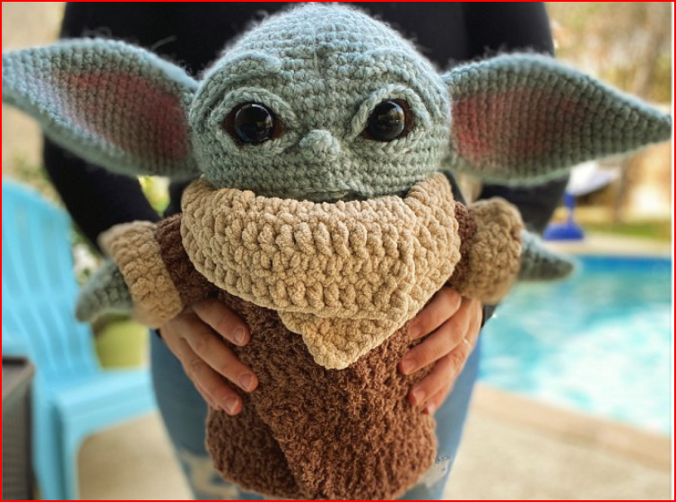

This is the original list of supplies from the designer, however any super bulky #6 and bulky weight #5 yarn can be used for this project. We have several to choose available at the shop.
The Yarn Cloud will also have the stuffing, safety eyes, button and crochet hooks for purchase and will provide the brown felt and glue at no cost during the CAL.

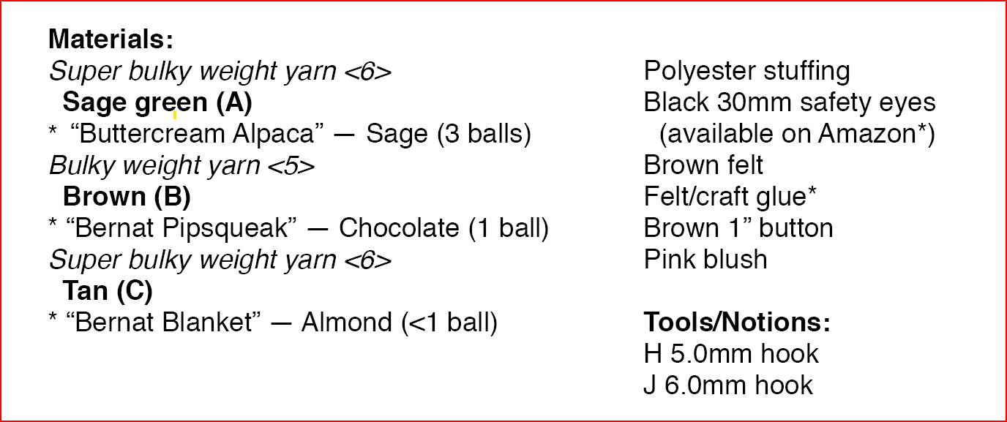
Finished size: 