The Child "Baby Yoda"

[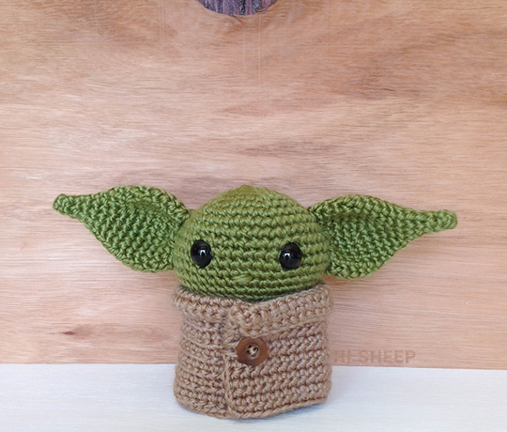](https://1.bp.blogspot.com/-ulCSt08sgi4/Xf_MGt8cjGI/AAAAAAAAAqo/Fg7VeBcwVSwKS3qYvClBbpSyEyZmJ-cqACLcBGAsYHQ/s1600/BabyYoda-Patron-Portada.jpg)

To make baby yoda we will need: 3 mm crochet hook, stitch marker, tapestry needle, stuffing, a brown button and yarn (green 25 g, dark brown 15 g, light brown 20 g). This cutie is going to measure 10 cm / 3,9 inch tall and 19 cm / 7,4 inch wide. May the force be with you!  
  
  
ABBREVIATIONS [(U.S.)](https://hisheepok.blogspot.com/2018/09/conversion-us-to-uk-terms.html):  
  
R: round  
ch: [chain](https://hisheepok.blogspot.com/2018/07/chain.html)  
mr: [magic ring](https://hisheepok.blogspot.com/2018/07/magic-circle.html)  
sl st: [slip stitch](https://hisheepok.blogspot.com/2018/07/slip-stitch.html)  
sc: [single crochet](https://hisheepok.blogspot.com/2018/07/single-crochet.html)  
inc: [increase](https://hisheepok.blogspot.com/2018/07/increase.html)  
dec: [decrease](https://hisheepok.blogspot.com/2018/07/decrease.html)  
**: repeat to the end of round  
[...] total stitches at the end of round  
  
  
HEAD:  
  
R1: 6 sc in mr  
R2: *sc inc* [12]  
R3: *1 sc, sc inc* [18]  
R4: *2 sc, sc inc* [24]  
R5: *3 sc, sc inc* [30]  
R6: *4 sc, sc inc* [36]  
R7: *17 sc, sc inc* [38]  
R8: *18 sc, sc inc* [40]  
R9: *19 sc, sc inc* [42]  
  
Eyes between R10-11  
  
R10-12: 42 sc  
R13: *19 sc, sc dec* [40]  
R14: *18 sc, sc dec* [38]  
R15: *17 sc, sc dec* [36]  
R16: *4 sc, sc dec* [30]  
R17: *3 sc, sc dec* [24]  
R18: *2 sc, sc dec* [18]  
R19: *1 sc, sc dec* [12]  
R20: *sc dec* [6]  
  
Close.  
  
With a little green yarn make a nose about 3 stitches wide between R12-13.

[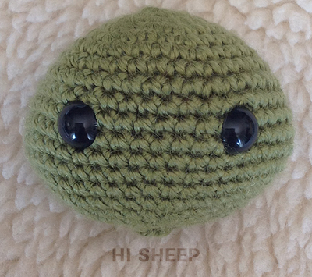](https://1.bp.blogspot.com/-fzSivbCebcY/Xf_M1IlzaBI/AAAAAAAAAqw/Rc7slvAwAdcDLzwC9gbB5c9CIoOG71AmQCLcBGAsYHQ/s1600/BabyYoda-Patron-01.jpg)

EARS:  
  
Make two.  
  
R1: 4 sc in mr  
R2: 3 sc, sc inc [5]  
R3: 4 sc, sc inc [6]  
R4: *2 sc, sc inc* [8]  
R5: *3 sc, sc inc* [10]  
R6: *4 sc, sc inc* [12]  
R7: *3 sc, sc inc* [15]  
R8: *4 sc, sc inc* [18]  
R9: *5 sc, sc inc* [21]  
R10: *6 sc, sc inc* [24]  
R11-13: 24 sc  
R14: *6 sc, sc dec* [21]  
R15: *5 sc, sc dec* [18]  
  
Leave a tail to sew, just a bit curved around the middle and a little more around the top, between R6-13 of the head.

[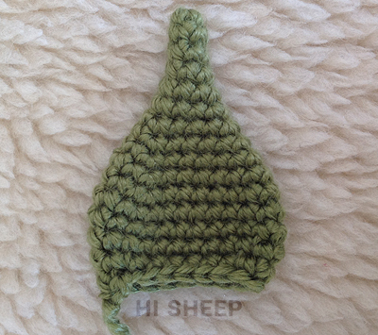](https://1.bp.blogspot.com/-mdk0u7W4cJs/Xf_M2i_HyrI/AAAAAAAAArg/gG4UqVGMvugYUQO6VpG-gY6EGey-nmyfACEwYBhgL/s1600/BabyYoda-Patron-02.jpg)[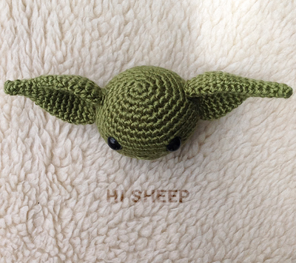](https://1.bp.blogspot.com/-_9schPWYl-U/Xf_M3Kny_sI/AAAAAAAAArc/TfKvj2fNeKsHzdQkV1HnMD1RZEtdH_prACEwYBhgL/s1600/BabyYoda-Patron-04.jpg)

[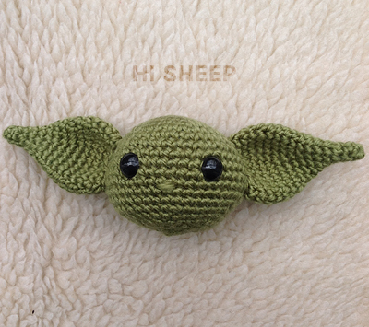](https://1.bp.blogspot.com/-YcnYoXimoZ4/Xf_M2j2rK7I/AAAAAAAAArY/3rCzz6sMb1w8rWo31NGoFTMrKRkGG7JigCEwYBhgL/s1600/BabyYoda-Patron-03.jpg)

BODY:  
  
R1: 6 sc in mr  
R2: *sc inc* [12]  
R3: *1 sc, sc inc* [18]  
R4: back loop only 18 sc  
R5: *2 sc, sc inc* [24]  
R6-8: 24 sc  
R9: *10 sc, sc dec* [22]  
R10: *9 sc, sc dec* [20]  
R11: *8 sc, sc dec* [18]  
R12: *7 sc, sc dec* [16]  
R13: *6 sc, sc dec* [14]  
  
Leave enough to sew to the head. Place the body so it looks wider from the side than the front.

[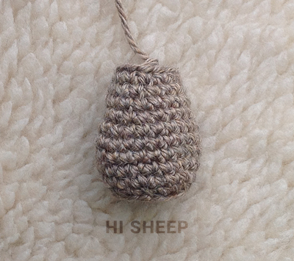](https://1.bp.blogspot.com/-T7jWLKotAtA/Xf_M4HghAKI/AAAAAAAAArc/pETc3TTMoGYETqaO4O6swpi-7I5C2g7wACEwYBhgL/s1600/BabyYoda-Patron-05.jpg)

ARMS:  
  
Make two.  
  
With green.  
  
R1: 6 sc in mr  
R2: 6 sc  
  
[Change color](https://hisheepok.blogspot.com/2018/10/color-change.html) to brown.  
  
R3-6: 6 sc  
  
Leave a tail to sew to the body between R13.

[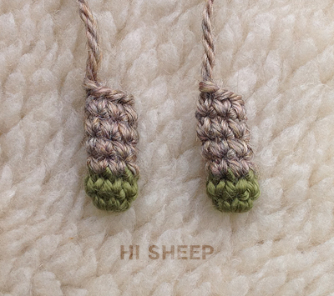](https://1.bp.blogspot.com/-EjpOVSj2IkA/Xf_M4Dhb4ZI/AAAAAAAAArk/B2QALdAmIJ0zU7o6dHdy3cfX_YyVeDEHQCEwYBhgL/s1600/BabyYoda-Patron-06.jpg)

FEET:  
  
Make two.  
  
Foundation: 2 ch  
V1: 1 sl st, 1 ch  
V2: 1 sl st, 1 ch  
  
Leave enough yarn to sew to the bottom of the body on R4.

[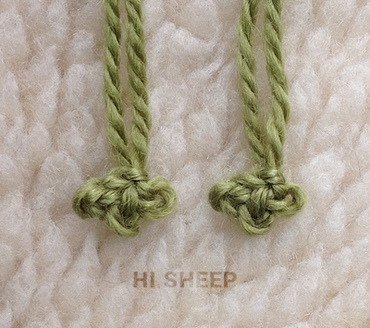](https://1.bp.blogspot.com/-0f_hJI8ZNZI/Xf_M4srcLoI/AAAAAAAAArc/nG2g31EAJMwmICmDoSgj0N1DvwDIYEhfQCEwYBhgL/s1600/BabyYoda-Patron-07.jpg)

CAPE:  
  
Foundation: 46 ch  
V1: 45 sc, 1 ch, turn [45]  
V2: 22 sc, sc dec, 21 sc, 1 ch, turn [44]  
V3: 10 sc, sc dec, 20 sc, sc dec, 10 sc, 1 ch, turn [42]  
V4: 9 sc, sc dec, 20 sc, sc dec, 9 sc, 1 ch, turn [40]  
V5: 40 sc, 1 ch, turn [40]  
V6: 40 sc, 1 ch, turn [40]  
V7: 20 sc, sc inc, 19 sc, 1 ch, turn [41]  
V8: 41 sc, 1 ch, turn [41]  
V9: 41 sc, 1 ch, turn [41]  
V10: 20 sc, sc inc, 20 sc, 1 ch, turn [42]  
V11: 42 sc, 1 ch, turn [42]  
V12: 42 sc, 1 ch, turn [42]  
V13: 20 sc, sc inc, 21 sc, 1 ch, turn [43]  
V14: 43 sc, 1 ch, turn [43]  
V15: 43 sc, 1 ch, turn [43]  
V16: 21 sc, sc inc, 21 sc, 1 ch, turn [44]  
V17: 44 sc, 1 ch, turn [44]  
V18: 44 sc [44]  
  
Hide loose ends.  
  
Fold the first 3 rows. Sew a button on the right side under the folding and on the opposite side we'll make a loop with a a bit of yarn securing it within the inside of the cape.

[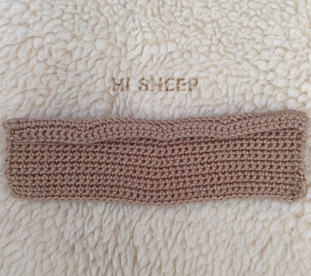](https://1.bp.blogspot.com/-SHbZ5_YJ4NQ/Xf_M5YYKKHI/AAAAAAAAArg/29bmTBGJDqANYDoLvfiNOB7eDyjRDq02wCEwYBhgL/s1600/BabyYoda-Patron-08.jpg)[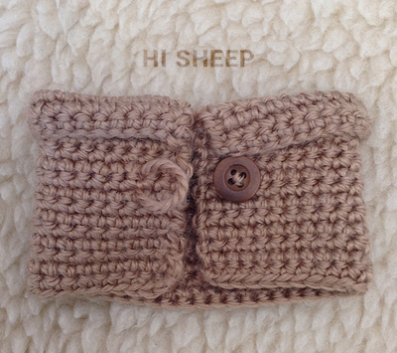](https://1.bp.blogspot.com/-0_Sp45xGRwc/Xf_M5_xi92I/AAAAAAAAArk/qIRRziTMgH43LnqkD-4kzx-k8g35db4lgCEwYBhgL/s1600/BabyYoda-Patron-09.jpg)

 A baby Yoda you now have!