Glorybound Publishing 439 S. 6th St. Camp Verde, AZ 86322
www.gloryboundpublishing.com (Publishing company website)
https://godbookmarketplace.net (Christian book marketplace hub)
https://bookmarketplace.net (Book Marketplace hub)
Sheri@bookmarketplace.net (E-mail address)
Bringing it all Together
Finally--Everything in one place under one topic. We Connect Book titles [Case-bound Paperback, Audio, Kindle, Case-bound] with sales outlets [Amazon, Personal, Other]
Author websites [Ministry and Business] YouTube Channels & Blogs
Registration for Book Marketplace Net and/or God Book Marketplace Net
Several topic specific book marketing websites to assist authors to sell their books. We link all types of books, websites, and youtube channel putting them in one place on high traffic websites. Presently we have 11 active marketing websites. See the main hub websites for a current list. Book titles are placed on sites which provide best exposure according to genre.
The two main hubs are https://bookmarketplace.net and https://godbookmarketplace.net
Registration is quarterly. The next quarter starts the payment cycle. [1] January 1-March, [2]April 1-June, [3] July1-Sept. [4] Oct 1-December. We do not retain your credit card or numbers. Each payment is a one-time payment for services. Payment is for 6 months or 12 months due prior to services being rendered.
Name:

Address:

Cell Phone:
Do you wish to receive contact with text or email? ___________
Email:
Author/company website:
You Tube Channel:
Blog:
Level Desired: (Pay on the hub websites or directly
Level 1
1 for 6 months $60 ($10 per month)
1 for 12 months $110 ($10 per month with 1 month free)
(Sheri Hauser Zell is below if you chose to use this option)
Level 2
2 for 6 months for 6 months $300 ($50 per month)
2 for 12 months for 12 months $550 ($50 per month with one month free)
(Sheri Hauser Zell is below if you chose to use this option)
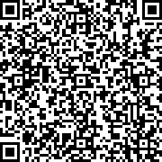
__________________________________________________________________
Specifics of Membership:
Level 1 Membership
1-3 books by the same author on 2 websites for $10 a month [$60 for 6 months or $110 for 12 months with 1 free month + tax.]
Included in the plan: The book is listed in 2 categories with the cover and a summary. We will connect the author’s sales outlet, personal website, Facebook page, or email.
Author Responsibility: Purchase the plan and complete the forms. We need the web address to the place where the book is sold. Authors may choose to have us connect directly to Amazon, other outlets, or mail books directly.
___________________________
Level 2 Marketing Plan
1-3 books by the same author up to 4 website viewing (may be several pages on same website) for $60 a month [$360 for 6 months or $660 for 12 months with 1 free month.]

Included in the plan: The book(s) is listed with the cover and a summary. We connect the sales outlet, personal website, Facebook page, or email. This level provides an option to attach a link to a YouTube video and 250 Business Cards on upgraded card stock. The business cards arrive with a Steel Engraved Business Card Holder. Make an impression even before you hand out your card with a custom initial laser engraved business card holder. The steel case has a flip-open top. May specify two or three initials.
Author Responsibility: Purchase the plan and complete the forms. We need the web address to the place where the book is sold. Authors may choose to have us connect directly to Amazon, other outlets, or mail books directly. The authors must provide links to the YouTube video and indicate which initials they would like on their business card holder.
__________________________________
Book #1
Type of Binding? (Paperback, E-book, casebound, audio) _______________________________
Title :____________________________________
Author: __________________________________
Artist: (If you have one) _______________________________________
I certify That I own the copyright to the book: _______________
Year of publication: __________ ISBN: _________________ Page Count: _________
Where do you want us to link the sales? We do not sell books on the website but provide direct links to your outlet.
(Amazon?) ____________________________
Do you want us to take the cover and book summary from Amazon or your outlet? ________
Book #2
Type of Binding? (Paperback, E-book, casebound, audio) _______________________________
Title :____________________________________
Author: __________________________________
Artist: (If you have one) _______________________________________
I certify That I own the copyright to the book: _______________
Year of publication: __________ ISBN: _________________ Page Count: _________
Where do you want us to link the sales? We do not sell books on the website but provide direct links to your outlet.
(Amazon?) ____________________________
Do you want us to take the cover and book summary from Amazon or your outlet? ________
Book #3
Type of Binding? (Paperback, E-book, casebound, audio) _______________________________
Title :____________________________________
Author: __________________________________
Artist: (If you have one) _______________________________________
I certify That I own the copyright to the book: _______________
Year of publication: __________ ISBN: _________________ Page Count: _________
Where do you want us to link the sales? We do not sell books on the website but provide direct links to your outlet.
(Amazon?) ____________________________
Do you want us to take the cover and book summary from Amazon or your outlet? ________

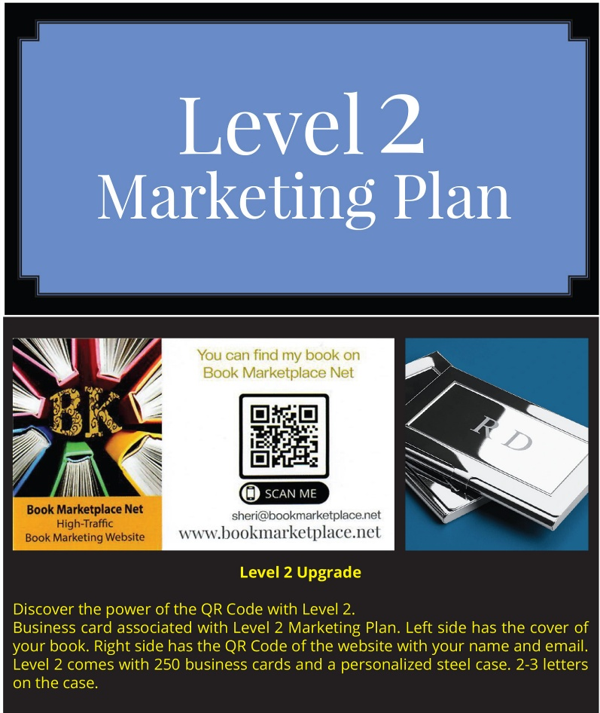
Level 2 questions:
Video link (if indicated) _____________________
You tube link (if indicated) _________________________

Business Card information:
2-3 initials go on the case of the business cards. There will be an order of 250 cards delivered to the address indicated at the start of this form. We put the QR code to your primary website (where the books are shown on our websites) on one side and your book cover on the other side.
Which book do you want to use? _______________
Do you want an email on the card? ___________________________
Do you want your personal website on the card? __________________________
Do you want a phone number on the card? __________________________

Contract for God Book Marketplace. Net & Book Marketplace.Net
This contract is between www.godbookmarketplace.net & www.bookmarketplace.net [represented by Sheri Hauser as listed above] and the Author.
Author name: ___________________________________
The Author verifies the book is their original work. The Author is to set the price of the book, E-book, audio book, or music. The Author is responsible for ensuring the sales outlet is viable, and copies of the work are available for sale when the contract is digitally signed.
The Author may choose to sell by KDP [Amazon], and our hub websites will set up a direct link to the work.
The Author may select to mail copies directly to the customer via a link provided [website, Face Book, or email].
Filling orders within a week of the customer’s order is recommended. Unfilled orders will result in forfeiting contract obligations, and the Author’s book will be removed from hub websites. Money will not be refunded for failing to promptly fulfill a customer’s order. The Author may move up the levels at any time after 2 months of the contract. All payments will be credited toward the next level. All of the book titles must be wholesome content or suitable for those under the age of 18 to be posted on the God Bookmarketing website.
Number of Books: For 1 to 3 books by the same author according to number of websites according to the plan selected.
[1] January1-March, [2] April 1-June, [3] July 1-Sept, [4] Oct 1-Dec]. The contract begins at the time of the payment for the quarter in which the contract is signed.

Date Signed: _________________________
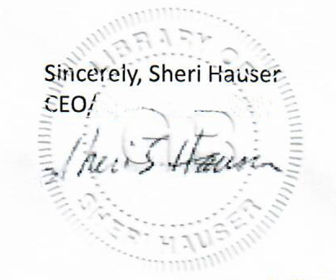
Sheri Hauser
Glorybound Publishing
439 S. 6th St. Camp Verde, AZ 86322

Please return to sheri@bookmarketplace.net

