

# VOLUNTEER APPLICATION

|  |  |  |  |  |
| --- | --- | --- | --- | --- |
| **Last Name** | **First Name** |  | **Middle Initial** |  |
| **Address** | **City** | **State** | **Zip Code** |  |
| **Cell Phone** | **E-mail Address** |  |  |  |
| **Date of Birth**  **Emergency Contact:** |  |  |  |  |
| **Name** | **Relationship** |  | **Phone Number** |  |

**Employer’s Name/School’s Name Occupation/Academic Major**

# Are you certified in CPR or First Aid? YES NO If yes, date certification expires:

**Please list any other special skills, training, hobbies or golf experience:**

# How did you hear about Urban Golf Of Greater St. Louis?

**Volunteer Experience:**

Position: Position:

Organization: Organization:

Date: Date:

# When are you available to volunteer?

Weekday afternoons

Weekday evenings

Weekend mornings

Weekend afternoons

# What areas are you interested in volunteering?

Golf Instruction Marketing Assistance (Social Media, Website,)

Fundraising Special Events/ College / Post Secondary Prep

Mentoring Office/Administration

Tutoring Board of Directors

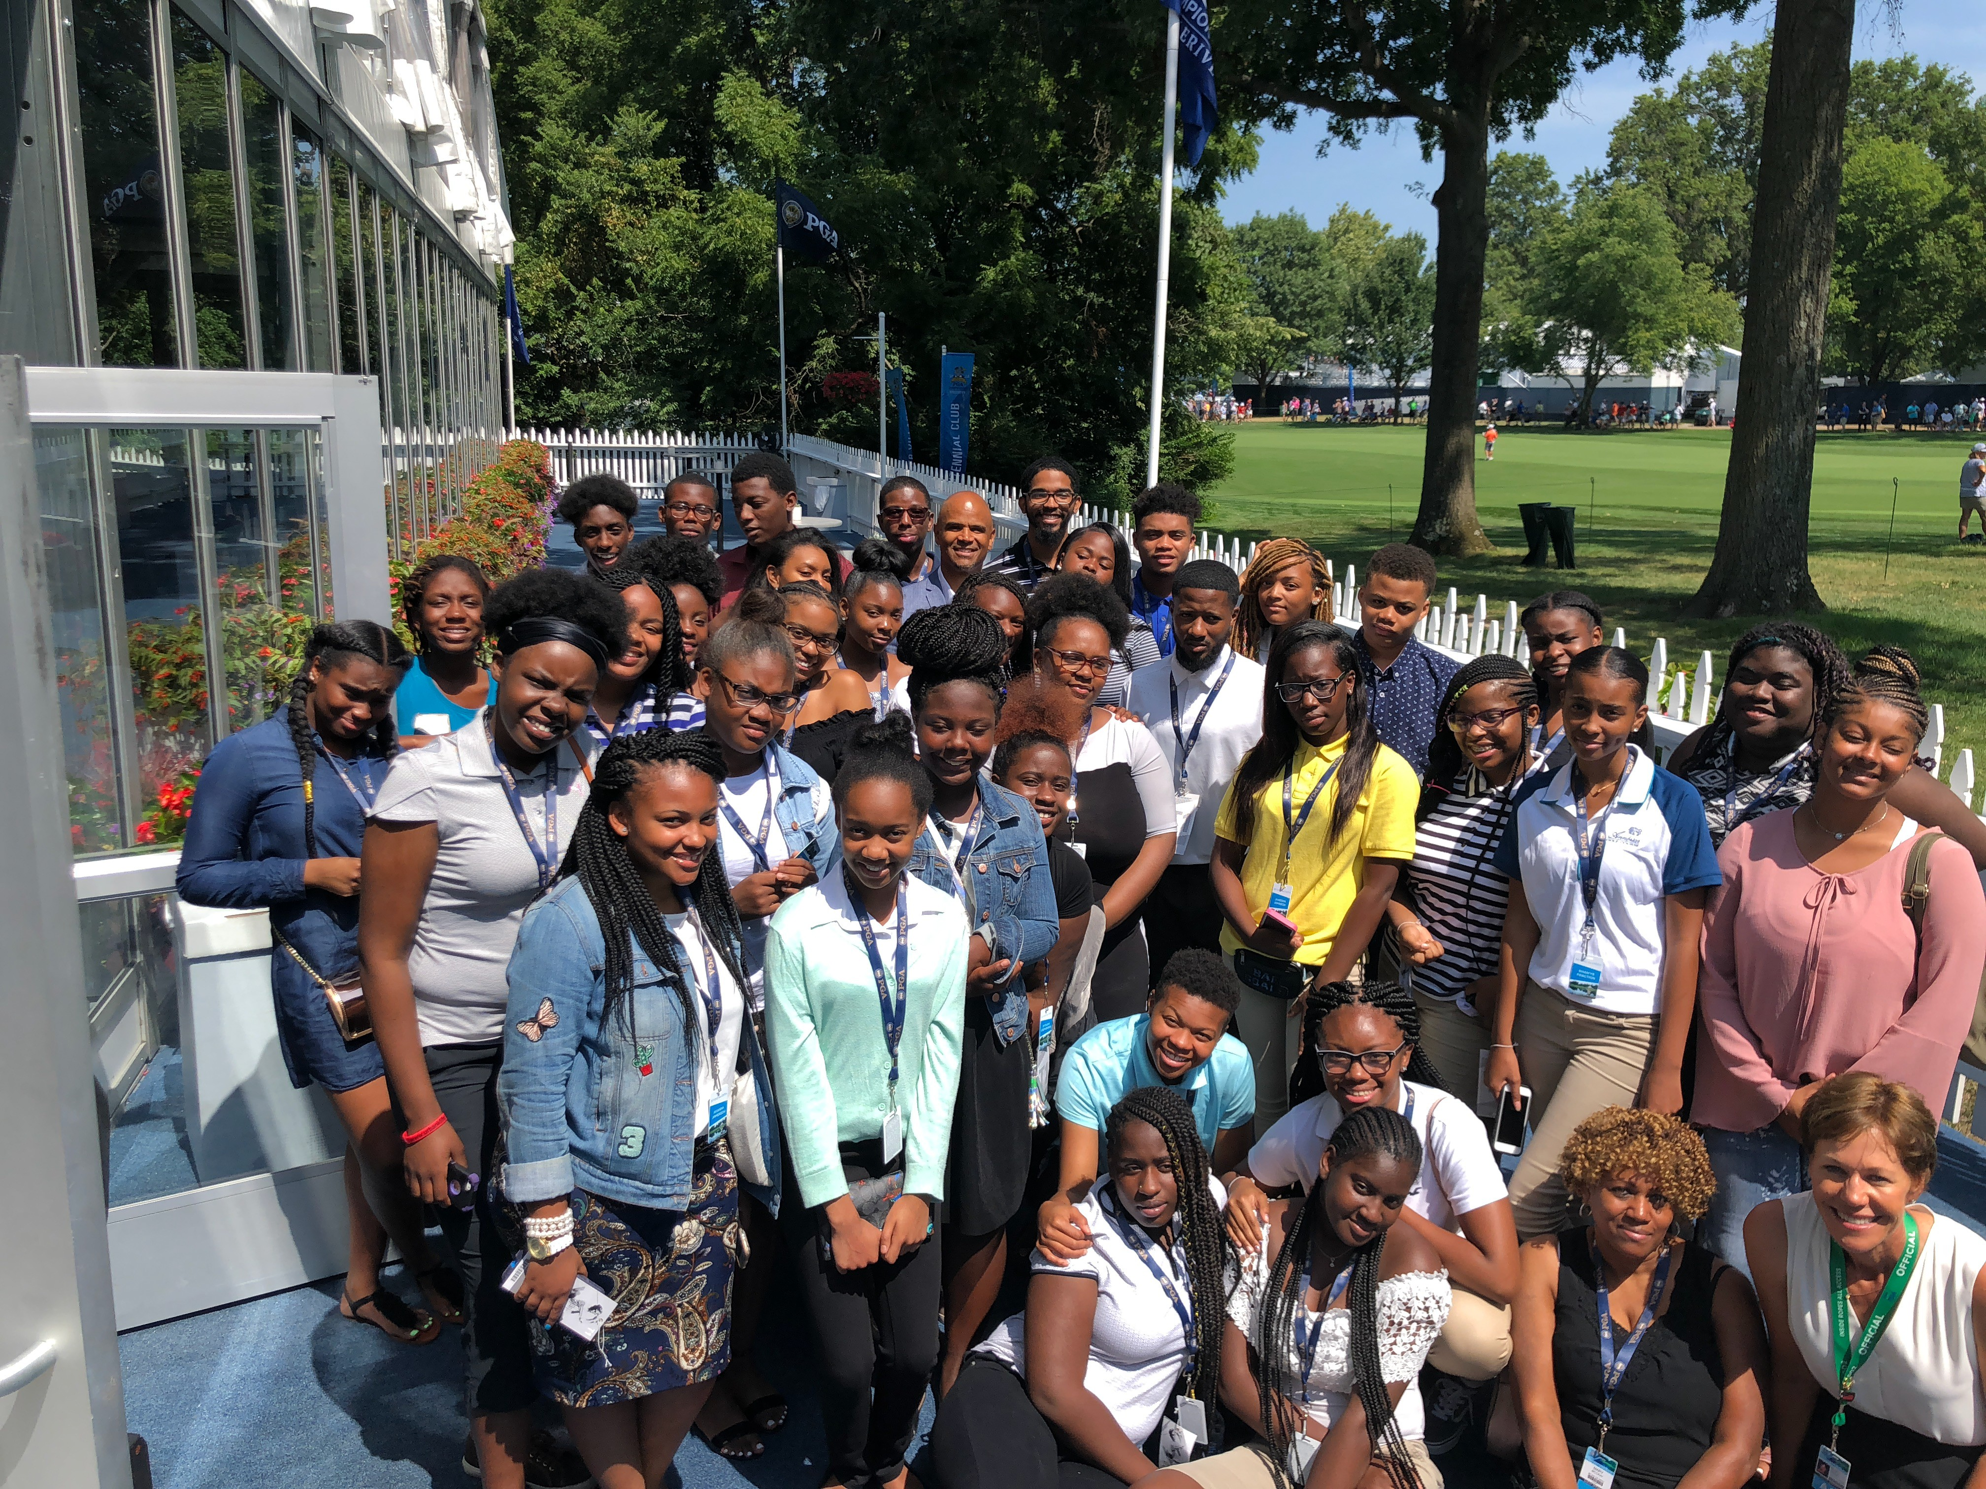

**Shirt Size (please circle):** Men’s Small Men’s Med Men’s Lg Men’s XL Men’s XXL Women’s XS Women’s Small Women’s Med Women’s Lg Women’s XL

**What interested you in UGOLF? Is there an aspect of the program that motivates you to be a part of this organization?**

**What would you like to get out of your volunteer experience? What would make you feel like you have been successful?**

**What have you enjoyed most about your previous volunteer position(s)?**

**Please list two professional and/or personal references other than relatives who would be willing to serve as personal references. References will remain confidential.**

1.

Name

Phone number

E-mail Address

Street Address City State Zip Code

2.

Name

Phone Number

E-mail Address

Street Address City State Zip Code

## Acknowledgement

Please initial

, I understand that a condition for my status as an employee, volunteer or intern with Urban Golf Of Greater St. Louis (UGOLF) now or in the future depends, in part, on the results of a criminal background check. I have read, understand and agree to be subject to the disqualification policy of UGOLF.

Date of Birth:

/ / (Month) (Day) (Year)

Have you ever been convicted of a crime and are there any legal charges pending against you?

yes no

If yes, please explain:

## Medical Care Information

If you require special prescription or non-prescription medication during program hours about which you would like to make us aware, or if you have any other medical condition about which you would like to make us aware, please advise below.

In case of emergency call Dr. _ Phone:

## Website

Urban Golf of Greater St. Louis (UGOLF) has developed a new website and would like to include actual photos from its programs. If you DO NOT want your photo to appear on the site, please sign here: . If we have a special request to identify you (e.g., include name with photo – because of an award of special recognition), we will contact you for that permission. Otherwise pictures will not include names.

I, THE UNDERSIGNED, FOR MYSELF, MY HEIRS, EXECUTORS AND ADMINISTRATORS, HEREBY AGREE TO INDEMNIFY AND HOLD UGOLF AND THEIR RESPECTIVE OFFICERS, DIRECTORS, EMPLOYEES, AGENTS, REPRESENTATIVES AND VOLUNTEERS HARMLESS FROM AND AGAINST ANY CLAIMS, DEMANDS OR CAUSES OF ACTION WHATSOEVER, INCLUDING, WITHOUT LIMITATION, COURT COSTS AND EXPENSES AND ATTORNEYS’ FEES, ARISING OR ALLEGED TO HAVE ARISEN ON ACCOUNT OF (I) THE INVESTIGATION OF MY BACKGROUND IN CONNECTION WITH MY APPLICATION TO BECOME A UGOLF VOLUNTEER/STAFF MEMBER; AND (II) MY ACTS OR OMISSIONS AS A TFTSTL VOLUNTEER OR STAFF MEMBER, INCLUDING, WITHOUT LIMITATION, PERSONAL INJURY AND/OR DEATH OR LOSS OR DAMAGE TO PROPERTY. THE FOREGOING INDEMNITIES SHALL SURVIVE MY APPLICATION AND MY PARTICIPATION, IF ANY, IN THE UGOLF PROGRAM.

I hereby authorize any organization affiliated with Urban Golf Of Greater St. Louis to investigate my background as necessary for the consideration of my application.

I further authorize all persons, schools, companies, organizations, credit bureaus, and law enforcement agencies to supply all information concerning my background and to furnish reports thereon and I hereby release them and any organization affiliated with Urban Golf Of Greater St. Louis from any and all liability and responsibility arising from their doing so.

I certify that the answers given by me to all questions on this application and any attachments are, to the best of my knowledge and belief, true and correct and that I have not knowingly withheld any pertinent facts or circumstances. I understand that any omission or misrepresentation of fact in this application may result in refusal of or separation from volunteer service upon discovery thereof.

Applicant’s Signature Date