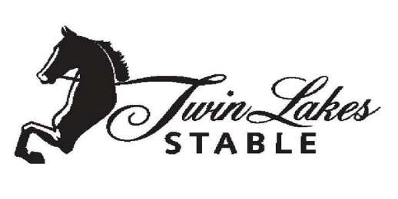
CANCELLATION POLICY
Effective January 1, 2017 you must cancel your lesson at least 24 hours prior to your lesson time to avoid a $20.00 cancellation charge. If you must miss your scheduled lesson for any reason, other than sickness or emergency, you will be charges if you do not contact the barn 24 hours in advance. Lessons cancelled before 12 hours before are eligible for make-up lessons but will still be charged cancellation fee. Lessons cancelled less than 12 hours before are NOT eligible for make-up lesson but will still be charged cancellation fee. This cancellation policy applies to single pay lessons as well as monthly pay lessons. ANY rider who fails to attend his or her lesson without notice is considered a “NO-SHOW” and will be charged the full lesson price (due and payable at the next lesson). The cancellation charge is due and payable on (or before) the next lesson. Your credit card will be charged for cancellation fee.
MAKE-UP POLICY
Lessons missed due to illness, injury or severe weather may be made up within 30 days of the missed lesson. Lessons can be made up during regular business hours. There is no make-up lesson for missed lessons due to “NO-SHOWS”. There are no refunds on lessons. If you schedule a make-up lesson and cannot make it, you must call and cancel, or you forfeit the make-up lesson. **Make-up lessons are in addition to your regular monthly lessons.**

_____________________________________ ________________________
Rider/Guardian Signature Date

_____________________________________
Print Name
PHOTO RELEASE FORM
Here at Twin Lakes we are very proud of our students, and their families, and from time to time will use their picture(s) on our website, Facebook page or other advertising media. At NO time will we divulge private information.
______ I/WE DO permit TLS to use photos or other images of my child as described above.
______ I/WE DO NOT permit TLS to use photos or other images of my child as described above.

