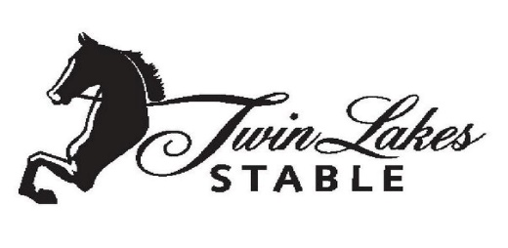
CREDIT CARD AUTHORIZATION

I, ______________________________________, authorize Twin Lakes Stable to charge my credit/debit card, plus a 3.5% credit card fee, indicated below on the 5th of each month if my payment has not been received for lessons, training, show fees, cancellation fees or boarding in the form of cash or check.
If for any reason I have to have a vet or farrier out for my horse and I do not pay prior, or within 3 days, of vet/farrier visit, I authorize Twin Lakes Stable to charge my credit/debit card for payment, plus a 3.5% credit card fee.

Billing Address ______________________________ Phone #__________________________

City, State, Zip ______________________________ Email___________________________

CREDIT CARD
___ Visa ___ Mastercard ___ AmEx __ Discover

Cardholder Name ___________________________________________
Credit Card Number _________________________________________
Exp. Date _______________
CVV Code ______________
Zip Code ________________

SIGNATURE _____________________________________ DATE___________________

_____ I understand that this authorization will remain in effect until I cancel it in writing, and I agree to notify Twin Lakes Stable in writing of any changes in my account information or termination of this authorization at least 15 days prior to the next billing date. Termination of this authorization is only for clients choosing to discontinue lessons, training or boarding with Twin Lakes Stable. If the above noted payment dates fall on a weekend or holiday, I understand that the payments may be executed on the next business day. In the case of a credit card transaction being declined for any reason I understand there will be a $50 inconvenience fee or 15% late charge, whichever is greater, added to my bill. I certify that I am an authorized user of this credit card and will not dispute these scheduled transactions with my bank or credit card company: so long as the transactions correspond to the terms indicated in this authorization form.

