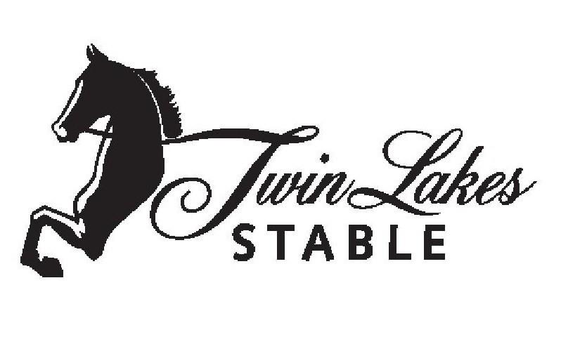
Code of Conduct
TLS Adult & Youth Competitors
Twin Lakes Stable has always been known for our GREAT camaraderie between one another and our competitors.

MISSION STATEMENT
TLS Equestrian Programs are designed to create an educational and competitive experience within an atmosphere of sportsmanship. TLS strives to develop and realize individual and team potential by promoting high standards of competence, character, civility and citizenship.

EQUESTRIAN CODE
Given our belief that Equestrian competition provides a unique opportunity for the development of physical conditioning, athletic skill, and character traits, we expect TLS equestrians to strive for the following:
Competence
- To develop the skills necessary to participate competently as an equestrian.
- To demonstrate knowledge of the rules and conventions as an equestrian.
- To demonstrate knowledge of the strategies in and out of the show arena.
- To demonstrate a level of physical conditioning and fitness sufficient to participate competently in and out of the show arena.
- To demonstrate knowledge of healthy behaviors including nutritional issues.
- To understand the necessity of abstaining from the use of tobacco and other drugs in order to achieve the positive benefits of athletics and beyond.
Character
- To be dependable in fulfilling obligations and commitments.
- To accept responsibility for consequences of actions; to not make excuses or blame others.
- To strive to excel.
- To be committed.
- To persevere, give 100% effort and not give up in the face of setbacks.
- To demonstrate truthfulness.
- To control anger and frustration and refrain from displays of temper and bad language.
- To accept losing and winning graciously; by congratulating opponents and by not sulking or displaying other negative behaviors.
Civility
- To practice good manners in and out the ring.
- To refrain from “trash talk” and other put-downs of opponents and teammates, especially when representing Twin Lakes as this could result in expulsion from current competition and without refund.
- Continuous negative talk can result in suspension and/or expulsion from Twin Lakes Stable indefinitely.
- To treat all persons respectfully, regardless of individual differences and to show respect for legitimate authority (e.g., Coaches, Trainers, Instructors).
- To be fair and treat others as one wishes to be treated.
- To listen to and try to understand others.
- To be compassionate and sensitive to others.
- To actively support teammates and others
Citizenship
- To be faithful to the ideals of the Equestrian sport including sportsmanship.
- To keep commitments to the team.
- To show team spirit, encourage others and contribute to good morale.
- To put the good of your team ahead of personal goals.
- To set a good example for barn-mates, younger equestrians, supporters, and the entire Saddlebred community.

PARENT CODE (for riders under 21)
Parents play a vital role in the development of student athletes and the success of Twin Lakes’ program. Therefore, we expect parents to do the following:
- Be a positive role model through their own actions to make sure their child has the best equestrian experience possible.
- Be a “TEAM” fan, not a “MY KID” fan.
- Weigh what children say; sometimes they will tend to slant the truth to their advantage.
- Show respect for the opposing competitors, coaches, spectators and support groups.
- Be respectful of all officials’ decisions.
- Don’t instruct your children before or after a class, because it may conflict with the trainer/coach’s/instructors plans and strategies.
- Praise student-athletes in their attempt to improve themselves as students, as young equestrians and as people.
- Gain an understanding and appreciation for the rules of the sport.
- Recognize and show appreciation for an outstanding ride by either teammate or a student from another stable.
- Help their child learn that success is experienced in the development of their skills and that they can feel good about themselves, win or lose!
- Take time to talk with Coaches/Instructors in an appropriate manner, including proper time and place, if there is a concern. Be sure to follow the designated chain of command and go right to the source (Coach). Refrain from voicing concerns, trash talk, negativity, bad mouthing, etc. to other parents, teammates, etc. This will not be tolerated and will result in suspension or expulsion from TLS and without refund.
- Please reinforce our tobacco and other drug-free policies by refraining from use of any such substances before and during competition.
- You will also be responsible for behavior and actions of additional friends, family members, etc. that are invited to attend horse shows.

Safety
- In any situation we believe in safety first and foremost. Your coaches, trainers and instructors always have the rider’s best interest in mind.
- Just like people, horses can have bad days too. Should a situation arise where a horse and/or rider are out of control and your trainer feels you are at risk, trainer will remove you or your child from a situation that may digress.
- Trainers have the right to remove horse/rider from class without refunds or re-dos.
- If you are removed from a class, the most important thing to remember is to learn from the situation at hand.
- As a TLS rider, we like to take these situations in stride. Rise above the occasion and show your positive and willing attitude as the proud TLS equestrian that you are.

NOTE: For your safety, as well as the safety for your horse and others we are a NO TOLERANCE team and barn. We expect every Equestrian Adult & Child athlete in our program to abide by all the rules and regulations developed for each individual and individual team. For any violation of the Code of Conduct or any other rule or regulation of the TLS, equestrian athlete may be subject to discipline, including, but not limited to, exclusion from extracurricular activities, suspension, and/or expulsion, consistent with rules, regulation and TLS policies.

I, _____________________________, have read the Code of Conduct put forth by Twin Lakes Stable and agree to abide by such rules. As a rider, and/or parent, I understand the consequences of not abiding by Twin Lakes’ Code of Conduct and will not engage in trash talk, and/or slander, should I be expelled or asked to leave.

________________________________ _________________________________
Rider Parent (if under 18)

