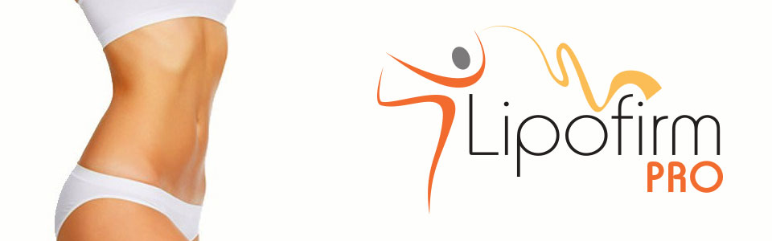

Post AFTERCARE Treatment Advice

“ To achieve the maximum results from your LipoFirm Pro Body or Face Contouring treatment, The Denwood Clinic in conjunction with LipoFirm Pro recommend the following”…

- Avoid Alcohol and Caffeine 24 hours PRIOR to your treatment
- Moderate exercise is beneficial
- Avoid heavy foods for 24 - 48 hours POST treatment
- A ‘clean’ diet is recommended for at least 5 hours POST treatment
- Avoid alcohol for at least 24 hours POST treatment
- Avoid heat treatments, i.e. Sunbeds, Steam or Saunas for 24 hours POST treatment
- Drink at least 2 litres of WATER per day, if possible for the ENTIRE course of your LipoFirm treatment
- You may experience an increased passing of urine and it may also be stronger and darker in colour as toxins, fat and cellulite are broken down and exit the body
- The healthier your body is – the better the LONGTERM results!

Things to avoid – to help prolong the effects of your LipoFirm body and face treatment(s);

- Refined sugars – sweets, chocolate, cakes and sweeteners
- Refined carbohydrates – Potatoes, white bread, white pasta, white rice
- Fizzy / sugary drinks

Things to enjoy!

- Still water – Flavour naturally with lemon / lime / cucumber
- Fruit and vegetables
- Lean protein – Fish, white meat, red meat
- Complex Carbohydrates – Brown bread, brown pasta, brown rice, sweet potatoes

The cell metabolism within the fat cells that have been treated has been INCREASED, so, for long-term results it is advised to support the treatment with a healthy diet outside of the clinic.

The Denwood Clinic, 22b Cooke Street, Bentley, Doncaster, DN5 0DA Tel: 01302 874928 www.thedenwoodclinic.co.uk
