St. Paul’s Lutheran Church
22163 Sumac Road
Neola, IA 51559-5069

Saving a seat for you and your family.
The peace of the Lord be with you always.

ST. PAUL’S LUTHERAN CHURCH
(Boomer Township)

Join us for worship Sunday mornings at 9:30
*the church is open for services or you can join us virtually through our facebook page*
Bible study will be held Sunday mornings at 8:00 in the church basement

Pastor Mary Findlay
22163 SUMAC ROAD, NEOLA, IA 51559
Telephone: (712) 545-3123
Email: stpsecretary3123@gmail.com
Facebook: @STPaulNeola
Website:stpaulsneola.church
Josh Bracker, Cong. President

If you are not receiving emails and would like to send an email to stpsecretary3123@gmail.com

The Mission Of St. Paul’s Lutheran Church
Share the Good News of Jesus Christ and to make disciples of all nations.
therefore, with God’s help, we will:
Proclaim Christ in word and deed;
Invite the unchurched to “Come and See Jesus”;
Commit ourselves to discipleship through Bible study, worship, prayer, Christ-like servanthood and fellowship;
Open ourselves to the Holy Spirit’s leading, so that whatever we do, we do in Jesus’ name.
Amen

The COVID-19 guidelines are always changing. We are requiring all people to wear a mask while in the church building, while also encouraging social distancing. The pews have been taped off to avoid close contact. The bulletins are placed in the pews, the offering baskets are in the front to avoid passing them around, and communion is being done differently to avoid contact. Please respect these guidelines. We are doing our best to keep everyone safe and healthy. If you are not comfortable following these guidelines or attending service please join us online or live on Facebook. If you do not have access to the online streaming or would like any other assistance please contact Pastor Mary Findlay.

Easter will be April 4th. The council will meet March 4th to decide on plans for service. Please keep an eye out for more information regarding this year’s service.
Prepare yourself for worship. Take some time to read the passages we will be hearing Sunday,

March 7, 2021: Reader this week is ...
First Lesson: Exodus 20:1-17 Bruce Bracker
Psalm: 19
Second Lesson: 1 Corinthians 1:18-25 communion Sunday
Gospel:John 2:13-22

March 14, 2021: Reader this week is ...
First Lesson: Numbers 21:4-9 Monte Bracker
Psalm:107: 1-3, 17-22
Second Lesson:Ephesians 2: 1-10
Gospel:John 3:14-21

March 21, 2021: Reader this night is ...
First Lesson: Jeremiah 31: 31-34 Julie Jenson
Psalm: 51: 1-12
Second Lesson:Hebrews 5: 5-10 communion Sunday
Gospel: John 12:20-33

March 28, 2021: Reader this week is ...
Procession with Palms: Mark 11:1-11
First Lesson: Isaiah 50:4-9 Teri Andersen
Psalm: 31:9-16
Second Lesson: Philippians 2:5-11 Palm Sunday
Gospel:Mark 14: 1-15: 47

April 1, 2021: Reader this evening is...
First Lesson:Exodus 12:1-14
Psalm:116:1-2, 12-19 Harriette Andersen
Second Lesson:1 Corinthians 11:23-26
Gospel: John 13: 1-17, 31-35 Maundy Thursday

April 2, 2021: Reader this evening is...
First Lesson:Isaiah 52:13- 53:12
Psalm: 22 Julie Jenson
Second Lesson:Hebrews 10: 16-25
Gospel:John 18: 1-19: 42 Good Friday

April 4, 2021: Reader this week is ...
First Lesson: Genesis 17: 1-7, 15-16 Steve Andersen Psalm: 22: 23-31
Second Lesson:Romans 4:13-25 Easter Sunday
Gospel:Mark 8:31-38

My brothers and sisters in Christ,

Isaiah 43: 1-4

But now, this is what the LORD says- he who created you, Jacob, he who formed you, Israel: "Do not fear, for I have redeemed you; I have summoned you by name; you are mine. ²When you pass through the waters, I will be with you; and when you pass through the rivers, they will not sweep over you. When you walk through the fire, you will not be burned; the flames will not set you ablaze. ³For I am the LORD your God, the Holy One of Israel, your Savior; I give Egypt for your ransom, Cush and Seba in your stead. ⁴Since you are precious and honored in my sight, and because I love you, I will give people in exchange for you, nations in exchange for your life.

SERMON:

I have heard this passage of scripture read in the hospital for someone who was ill, and at a funeral. On each occasion we are reminded that we are loved that God is at our side each day of our lives. It seems though we forget God’s promises, that the noise of the world seems to drown out his eternal truths. Why? On Ash Wednesday I recounted a story from the life of Henri Nouwen, who spent most of his life really coming to grips with who Jesus was and that focusing on the Lord was the essence of our spiritual lives. The haunting question that he faced, and the one that we all need to answer is: “And you, who do you say that I am.? This is the question Jesus himself asked his disciples. It is both thought provoking and uncomfortable question because we are called to answer it truthfully. Who do you say Jesus is? Is he our Lord and Savior? Or is he a nice man, who lived a righteous life? For Christians, this question should be easy to answer—of course Jesus is the center of our very existence. But is he? During the Lenten season reflect on this and repent for placing Jesus in the margins. Seek his face, listen for his voice.

Blessings to you,
Pastor Mary Findlay

St. Paul’s will be celebrating their 140th year anniversary this summer. If you would like to help with this event in any way please contact Ramona Bracker at 1956bracker@gmail.com.

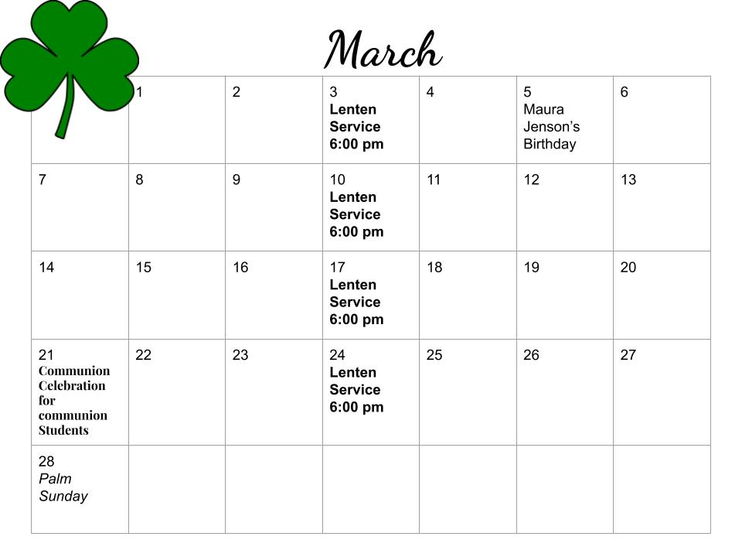

ST. PAUL’S LUTHERAN CHURCH
Meeting Minutes
February 11, 2021
This is the meeting of St Paul’s Lutheran Church held on Thursday, February 11th, 2021 in the basement of the church. Council members present: Josh Bracker, Julie Jenson, Ruben Valdez, Steve Andersen, Dale Stephens, Bob Gregory, and Rashelle Wohlers.
Not present: Jim Jenson and Ava Bracker.
Also present: Nancy Hedegaard and Pastor Mary Findlay
Josh, as President, conducted the meeting
Opening Prayer by Pastor Mary Findlay

Nate (IT) spoke about progress on the website and the sound system for the church
Call Committee:
came with updated Pastor Description and changes to the Constitution

Council Minutes:
motion by Dale, 2nd by Steve to approve the previous month’s minutes – all in favor – motion passes

Josh spoke with Lorene Jensen’s family about the memorial bench – they will cover the difference between the memorial money and the cost of the bench including shipping
Treasurer’s Report:
motion to approve the Treasurer’s Report by Steve, 2nd by Ruben – all in favor – motion passes

Pastor’s Report:
Motion to approve the Pastor’s Report by Julie, 2nd by Bob – all in favor – motion passes

February Discussion:
Need to do a property assessment in the spring including condition of roof, sidewalks, etc.
Need to have insurance company (Brotherhood Mutual) come to raise the value of what is insured (property, contents, etc.)
Announcements and Communications Protocol of when to cancel in-person church – it was decided that if there is a windchill of -10°F to cancel – notification will be made via Facebook, email, TV, and phone calls – the deadline to make the decision to cancel church is 6:00 PM on Saturday evening – snowfall amounts to cancel will be determined at another time – there will be two people to make phone calls notifying people that may not have internet access that church is cancelled – Pastor Mary will email the council a contact list of phone numbers
A suggestion from the Annual Meeting was to form a Christian Defense Fund – the Thomas More Society in Omaha is a possibility – currently, we donate $400 to Wings of Hope, Samaritans’ Purse, Bethany Lutheran Home (Alzheimer’s Unit), and Shriners on a monthly revolving schedule – more information will be gathered, and perhaps add an organization to that revolving list
An idea of sending out a questionnaire to all members was presented - all council members are tasked with coming up with 10 questions to put on this questionnaire and bring them to the next meeting
The Church’s 140th Anniversary is this year – Possibly a church picnic and a final recognition for Pastor Norm? Do an outside service with Offering going to a specific charity? Add how would you like to celebrate the church’s 140th to have on the questionnaire? Motion by Dale, 2nd by Steve for the celebration to be on 7/11/2021 - Josh will ask Ramona Bracker if she will be in charge of the celebration.
Mary and Gary Findlay are the point of contact between Nate (IT) for the church website, sound system, etc - that way he doesn’t receive emails from multiple people
Emily Pruett, Church Secretary, is due in May – known duties are newsletter, weekly bulletins, slide show for church service – Gary Findlay has offered to step in if needed, as he will be on his terminal leave from work – Mary will talk to Emily to see what she has in mind about after this baby is born
Need to elect a VP – Motion by Dale, 2nd by Steve to have Jim Jenson be Vice President – all in favor – motion passes
Per Bob Gregory, we must spend $2K/quarter out of the endowments – he handed out the First Quarter 2021 Report
Spoke about summer camp opportunities this year – Okoboji is always a good choice, but are there any closer ones? Rashelle to get information on Calvin Crest in Fremont and Josh will get information about Camp of the Good Shepherd in Louisville
Vacation Bible School this year – any in the area that we could partner with or host one ourselves?
In the past, there was a blessing of seed/machinery – Should that be brought back?
Read the Bible from Good Friday to Easter – thoughts on doing that this year?
March 14, Dave Whitcomb will lead service – He is the pastor that ordained Mary
Pastor Mary will interview with pastors around Omaha after Easter to complete her certification
February 17th is Ash Wednesday – 6pm is the service – no supper to follow this year due to COVID
Where do we want the Lenten Offering to go? Minden Food Bank received the money last year
Josh will talk to Pastor Norm to make sure the Parsonage is done by May.
1st Thursday of the Month will be the new meeting night, so the next meeting will be March 4th
Meeting adjourned at 8:13 PM by everyone standing and saying the Lord’s Prayer.

