 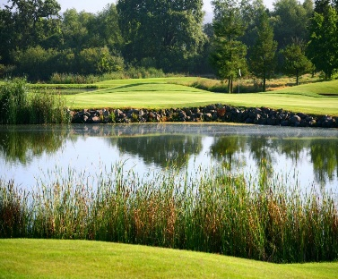  
2nd Annual Brandon Champion Memorial Golf Tournament   
FRIDAY, SEPTEMBER 9TH, 2022

Windsor Golf Club Golf Contests & Prizes  
 1:00pm “Shot Gun” Start Raffle  
 $150/pp Golf & Dinner Silent & Live Auctions  
 $50/pp Dinner Only No Host Bar

Register as Individual or Foursome (Please Print)  
**\*Email required for all golfers**

Name:_____________________________________ *Email:__________________________________________

Name:_____________________________________ *Email:__________________________________________

Name:_____________________________________ *Email:__________________________________________

Name:_____________________________________ *Email:__________________________________________

Teams will be formed by golf committee if you do not have a foursome  
  
Pay By Credit Card:

Type of Card:__________ Amount To Charge:_______________

Card #________________________________________________  
Expiration:___________ Cvv Code:___________

Name On Card: __________________________________________

Billing Address and Zip Code:___________________________________________________

**I cannot make golf, but would love to attend the Dinner and Auction:**# Guests:__________ @ $50/each Total:______________

Name(s):________________________________________________________________

_______________________________________________________________________  
  
Contact E-mail:_________________________________________

**SEND COMPLETED FORM WITH PAYMENT TO:**

Email: [jill.brandonchampionfndn@sonic.net](mailto:jill.brandonchampionfndn@sonic.net) with credit card information OR  
Mail with check to: Brandon Champion Foundation  
3360 Coffey Lane, Suite B  
Santa Rosa, CA 95403

Tax ID: 86-2246617  
NO REFUNDS

…