**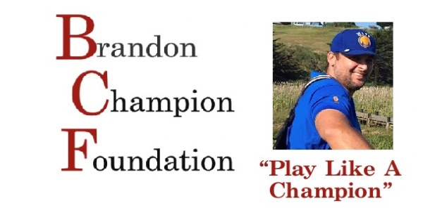  
  
~SPONSORSHIPS~  
  
$5,000 VIP TOURNAMENT SPONSOR**\*Personalized banner setup in event area  
*Name included on welcome banner  
*Tee sign with name at assigned hole  
*First selection of hole preference for sponsorship (#1 unavailable if serving food/drinks)  
*Name and logo in premiere location of program  
*Included in all social media and any advertising  
*One foursome to play in tournament and reserved table for dinner  
*Opportunity to provide giveaways at designated hole, 6’ table and 2 chairs provided  
  
**$2,000 PREMIERE TOURNAMENT SPONSOR**\*Name included on welcome banner  
*Tee sign with name at assigned hole  
*Hole Number Selection (#1 unavailable if serving food/drinks)  
*Name and logo included in event program  
*Included in all social media and any advertising  
*One foursome to play in the tournament and reserved table for dinner  
 *Opportunity to provide giveaways at designated hole, 6’ table and 2 chairs provided

Friday, September 9, 2022  
Windsor Golf Club

Please make checks payable to:  
Brandon Champion Foundation  
3360 Coffey Lane Suite B  
Santa Rosa, CA 95403



**$1000 LUNCH TOURNAMENT SPONSOR**  
*Tee sign with name at assigned hole*Name included in event program  
*Included in all social media  
*Provide lunch for all golfers at Hole #8

**$500 HOLE SPONSOR** Tee sign with name at assigned hole  
*Name included in event program  
*Included in all social media   
*Opportunity to provide giveaways at designated hole, 6’ table and 2 chairs provided

**Type of Sponsorship Participation (from above list): ___________  
Business Name: ______________________________**

**Contact Name:___________________________ Email: _______________________________**

**Email completed form to:** [**jill.brandonchampionfndn@sonic.net**](mailto:jill.brandonchampionfndn@sonic.net) **Tax #86-2246617**