**A.K.R.S.S. FAMILY REUNION 2026**

**Ashford-Knox-Robinson-Simpson-Smith**

**JUNE 5 - JUNE 8, 2026**

**Carnival Cruise Line (The Bahamas)**

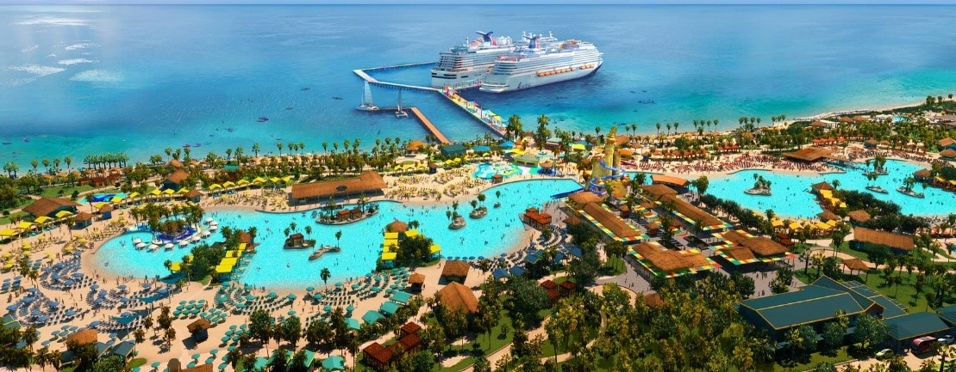

**Registration Fee includes the following:**

* **Hospitality Hour**
* **A.K.R.S.S Family Reunion Tote and Swag**

|  |  |
| --- | --- |
| **Reunion Itinerary** | |
| **Friday – June 5th** | **Saturday – June 6th** |
| * Embarkation Day: 10:00am – 3:00pm * A.K.R.S.S Meet & Greet: 5:00pm – 7:00pm (Family Reunion Tote and Swag) * Dinner: Lido Marketplace (Buffet) | * Breakfast (Dining Room): 9:00am * Cruise Activities (TBD): 10:00am – 5:00pm   + Bingo   + Live Show Performances   + Family Basketball Game * Captain’s Dinner: 6:00pm * Dive-In Movies at Carnival Seaside Theater: 8:00pm |
| **Sunday – June 7th** | **Monday – 8th** |
| * Celebration Key: 8:00am – 5:00pm * Dinner (Dining Room): 6:00pm * Night Call at the: TBD   + Bar, Casino, or Night Club | Disembarkation Day: 8:00am    **SAFE TRAVEL HOME A.K.R.S.S!** |

**What You Need to Know!**

**Theme: “*AKRSS Family Cruising Through the Bahamas”***

* AKRSS will be cruising from June 5-8, 2026
  + Set to sail on Friday June 5, 2026
  + Return to shore on Monday June 8, 2026
* Sailing from Miami, FL to the Bahamas
  + 1015 North America Way, Miami, FL 33132
* Passports are not required.
  + Government Issued ID is required for 16yrs of age & older
  + Birth Certificates required for anyone 15yrs of age & under
* For the reunion to be cost efficient for all, the 2026 committee has opted to letting you book your cabin rate directly with our assigned cruise line representative. This will allow carnival approved cruise credits, perks, or rewards to be used at the time of booking.
* ***Reservations for the cruise ship*** will need to be booked directly with our destined carnival representative.
  + Mention **“AKRSS”** when booking with the carnival representative.
  + A deposit will be required at the time of booking.
    - Deposits may vary between $50 - $200 per person depending on any special discounts Carnival may offer at the time of booking.
* ***Registration fees*** and ***forms*** will need to be sent to the AKRSS committee.
  + Do not forget to provide your T-shirt sizes
  + Youth Sizes (Small – X-Large) ~ Adult Sizes (Small - 5X)
    - ***Note:*** Sizes 2X - 5X will be an additional $2-$5 based on size
* As a family we will attend the Captain’s Dinner which is held on the second night of sail; it is semi-formal attire.
  + Let Us Coordinate (Shades of Greens)
  + Dinner time for AKRSS: 6:00pm
* Remember to bring swimwear for Celebration Key!
  + [Celebration Key Paradise](https://www.carnival.com/celebration-key?msockid=2d456895c3656f0c3c297d1ec20a6eac)

**REGISTRATION FORM**

**JUNE 5 - JUNE 8, 2026**

**Carnival Cruise Line (The Bahamas)**

**Please complete all fields on the form!**

|  |  |
| --- | --- |
| **Name** |  |
| **Address**  **City, State & Zip** |  |
| **Home Phone** |  |
| **Cell**  **Phone** |  |
| **Email** |  |
| **Ancestral Family** | Text BoxASHFORD Text BoxKNOX Text BoxROBINSON Text BoxSIMPSON Text Box SMITH |

***Important!*** List everyone who will be attending.

Please use a separate form, if needed, for more attendees.

|  |  |  |  |  |  |
| --- | --- | --- | --- | --- | --- |
| **First Name** | **Middle Initial** | **Last Name** | **Age** | **T-shirt Size**  **(Small, Medium, Large, etc.)** | **Youth or Adult**  **(please indicate)** |
| 1. |  |  |  |  |  |
| 2. |  |  |  |  |  |
| 3. |  |  |  |  |  |
| 4. |  |  |  |  |  |
| 5. |  |  |  |  |  |

|  |
| --- |
| **Accomplishments**  List family member and recent individual accomplishments (awards, degrees, recognitions, etc.) |
| 1. |
| 2. |
| 3. |
| 4. |

***REGISTRATION DETAILS:*** Separate payments will need to be submitted to the appropriate parties, please see applicable deadlines to ensure all final payments are made timely.

* **Registration(s) due in full by March 1, 2026, to the AKRSS committee**.
  + Make payments by checks/cashier checks, Zelle or Cash App**,** **NO CASH!**
    - **Zelle:  akrssfamily2024@gmail.com**
    - **Cash App: $AKRSSFAMILY or QR Code**

Make checks/money orders/cashier’s checks payable to:

**Anthony Jackson**

**1626 W Pollack St**

**Phoenix, AZ 85041**

On the **Memo Line** write**: AKRSS Reunion 2026**

* A$30 Fee will be accessed for any returned checks.
* Mail all registration forms along with checks or email to: **akrssfamilyreunion@gmail.com**
* **Carnival Cruise Line FINAL PAYMENTS due in full by March 15, 2026.**
* **Carnival Representative:** Teddy (Gianni) Gilabert
* **Toll Free:** 1-800-819-3902 Ext 82640
* **Local:** 305-599-2600 EXT 82640
* **Email:** [tgilabert@carnival.com](mailto:tgilabert@carnival.com)
* **Note:** Mention “**AKRSS”** when booking with the carnival representative**.**

**Note:** Sizes 2X - 5X will be an additional $2-$5 based on size

|  |  |  |  |  |
| --- | --- | --- | --- | --- |
| **Registration Type** | **# of Registration(s)** | **Cost Per Person** | **T-Shirts** | **= Total Amount** |
| **Example** | **3** | **X $70.00** | **X $8.00** | **$234.00** |
| Adult(s) |  | X $70.00 | X $8.00 |  |
| Youth (4-11) |  | X $50.00 | X $8.00 |  |
| Kids 3 & under |  | Free | X $8.00 |  |
| **Grand Total =** | | | | **$** |