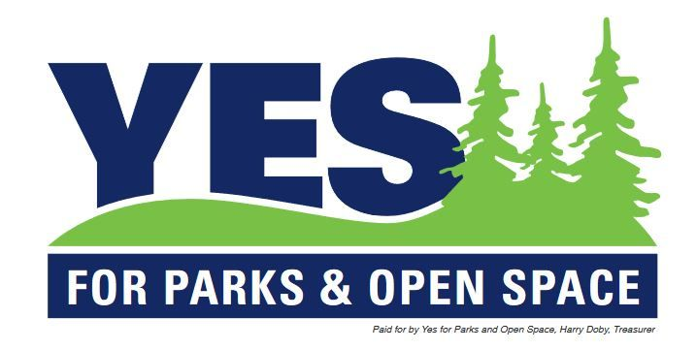

Contact:

Colette Carey

EJ Reilly & Associates

(303) 875-7275

ccarey@ejreillyandassoc.com

***Developers continue to run the city of Denver***

**FOR IMMEDIATE RELEASE - DENVER, CO (October 11, 2021)** For a City supposedly neutral on 301 vs. 302, a myriad of examples prove otherwise. The most glaring and critical are statements in the current Blue Book that misrepresent the fiscal impact statements about 301 and 302. Misstatements that the City refuses to correct – while amazingly finding the time to compound the misstatements about 301 with a favorable amendment of the misstatements for ballot measure 302.

Representatives from YES for Parks and Open Space have demanded - both verbally and in writing - that the City correct the crucial misstatements in the Blue Book, to no avail and to no answer.

* The Blue Book descriptions on 301 and 302 show clear bias by the City.
* The first fiscal description for 302 said that it "does not reference the need for a special election" -- this is not true.
* The first fiscal description for 302 said “any election would not be held until the next regularly scheduled election” -- this is not true.
* The City continued the deception by amending the fiscal description for 302 by saying "this initiative requires no financial obligations since the initiative does not impact a City held easement and would not require a future election" - this is not true.
* In contrast to its handling of 302, the City’s fiscal impact statement for 301 continues to be a one-third page description of supposed potential fiscal impact of over $1 million.

In truth, the fiscal impacts of 301 and 302 are identical.

* Both measures require an election for proposed development on designated park land.  The City's fiscal description on 302 intentionally misleads voters on this fact.
* Both measures require an election for proposed development on land held under a conservation easement for which a tax credit is granted.   The City's fiscal description on 302 intentionally misleads voters on this fact.

This is just the latest example of a City administration that has proved their desire to develop the land from the very beginning of the process:

* The developer purchased the land in August of 2019 while it was still subject to a perpetual open space and recreational conservation easement that prohibits any development on the land.
* Immediately upon the purchase, the City began meeting with and working with the developer on plans to develop the land.
* On November 2019, The City entered into an agreement with the developer to hold off enforcement of the conservation easement for 3 years so that the City and the developer could develop a public narrative supporting breaking the easement for development
* The true nature of the relationship between the City and the developer is established in an email in which Executive Director of the City Planning and Development Department, Laura Aldrete, refers to the developer as the City’s “client.”
* Despite the fact that the land cannot be legally developed, City has been conducting an expensive planning and development process, spending hundreds of thousands of taxpayer dollars on third-party consultants and using well over a thousand hours of City employee time.

###