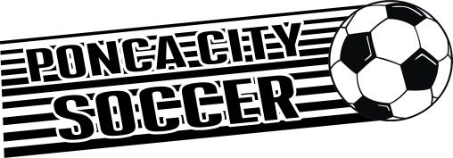

Ponca City Soccer, Inc. PO Box 2572 Ponca City, OK 74602

Dear Participant,

Thank you for participating in the “Vinyl Sign Drive” at the Ponca City Soccer, Inc. (PCS) Complex. By placing a vinyl sign at the complex, not only are you showing support for Ponca City Soccer, Inc., but you are also advertising your business at a well trafficked location--well over 800 people per weekend during the season!!!

Your vinyl sign will be displayed for an entire soccer year. Your sign will be displayed during our spring and fall seasons. If you would like to continue to keep the sign at the complex, we will bill your business the prearranged cost each February before the beginning of our spring season.

The signs are to be made of vinyl only, with a maximum size of 4x6, NO tobacco or alcohol related advertisements allowed. PCSI has the right to reject any sign design submitted for any reason.

The costs of the signs are as follows:

4x6 = $425

3x5 = $325

We sincerely appreciate your continued support of Ponca City Soccer, Inc.

Paul Robbins Ponca City Soccer, Inc. – President 405-651-5793

Jennifer Schaefer

PSCI-Multimedia Advisor

580-362-7261

herby agrees to place a vinyl sign at the Ponca City Soccer, Inc. Complex under our guidelines at the cost agreed upon. PCSI will bill my business each February and upon payment, the sign will be put up at the PCSI Complex.

Date: Signature: .

Name or slogan to be placed on sign: .

Background Color (circle one): White Blue Red Yellow Green Black

Lettering color (circle one): White Blue Red Yellow Green Black