

MLMW Participant Handbook

Information

Deadly Inspiring Youth Doing Good Aboriginal & Torres Strait Islander Corporation

ICN: 8494 | PO Box 267 Edge Hill Qld 4870 | whichway@diydg.org.au

|  |  |
| --- | --- |
| Title | MLMW Participant Handbook |
| Full title | 1343 MLMW Participant Handbook, rev 3 |
| Document type | Information |
| Document number | 1343 |
| Root policy | Feedback Complaints & Appeals |
| Revision number | 3 |
| Developed by | Executive Team Members |
| Approved by | Board Members |
| Approved date | April 26, 2020 |
| Group owner | Programs |
| Next Review | March 04, 2030 |
| Current as of |  |
| Last saved by |  |
| Current as of |  |
| File name & path |  |
| File name |  |

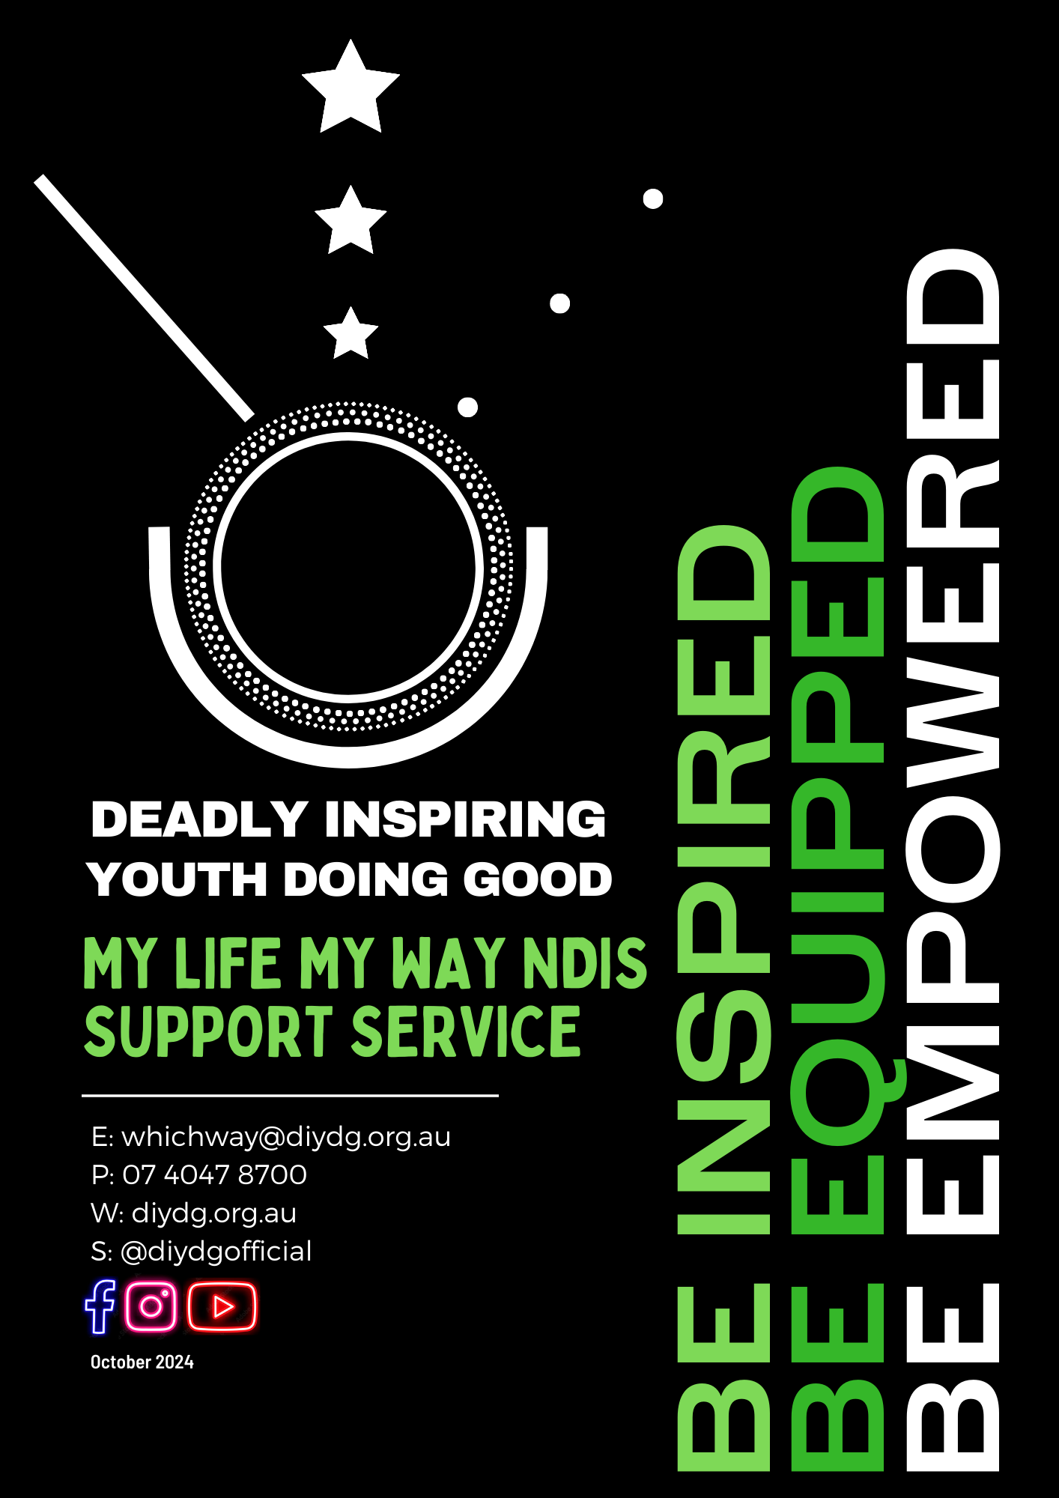

**Table of Contents**

Section 1: Language Interpreting Services 5

Understanding the NDIS 5

Planning for an Interpreter 5

For people with hearing or speech loss 5

Section 2: Words We Us and What They Mean 6

Section 3: Our Organisation 7

Welcome to DIYDG 7

About Us 7

Our Vision 7

Our Mission 7

Our Values 8

Organisation Structure 8

Our Services 10

Access and Entry Requirements 10

Section 4: Working with you 11

Contacting Us – Your Contact Person 11

Participant Assessments and Choices 11

Communication with participants 13

Interpreter Services 13

Accessing Services 13

Management of Budgets, Statements and Fees 13

Service Agreement 14

Re-negotiating an Agreement 14

Withdrawal from our Service 14

Transition and Re-entry 14

Participant Service Suspension and Leave 15

Data Security/Archiving Participant Files 15

Participant Access to Personal Records 15

Participant Assistance with Medication 16

Smoking 16

Money and Property Assistance 16

Participant Authority to Hold Key/s 17

Gifts 17

Will 17

Section 5: Charter of Rights 18

Your Rights 18

Your Responsibilities 18

Our Responsibilities 19

NDIS Code of Conduct 19

Conflict of Interest 20

Consent 20

Privacy Statement 21

What is a Guardian? 21

Your Advocacy Rights 21

Section 6: Your Safety and Well-Being 23

Abuse 23

Family Assistance 23

Continuity of Support 24

What will happen if your worker is absent? 24

Emergency and Disaster Planning 24

Vaccinations 24

Infection Management 25

Critical Incident 25

Risk-Taking 26

Risk Assessment 26

Work Health and Safety 26

Networking 27

Legislation and Standards 27

Section 7: Complaints and Feedback 28

Complaints and Feedback 28

Your Voice 29

Continuous Improvement 29

Section 8: NDIS Practice Standard and Quality Indicators (Abbreviated version) 30

1. Participant Rights and Responsibilities 30

2. Provider Governance and Operational Management 31

3. Provision of Supports 31

4. Provision of Supports Environment 32

Section 9: Additional Standards 34

Child Safe Standards 34

Standard 1. Child safety is embedded in our organisational leadership, governance and culture 34

Standard 2. Children participate in decisions affecting them and are taken seriously 34

Standard 3. Families and communities are informed and involved 34

Standard 4. Equity is upheld, and diverse needs are considered 35

Standard 5. People working with children are suitable and supported 35

Standard 6. Processes when responding to complaints of child abuse (or other concerns) are child-focused. 36

Standard 7. Staff are equipped with knowledge, skills and awareness to keep children safe through continual education and training 36

Standard 8. Physical and online environments minimise the opportunity for abuse or other kinds of harm to occur 36

Standard 9. Implementation of Child Safety Standards are continually reviewed and improved 37

Standard 10. Policies and procedures document how the organisation is child safe 37

Section 10: NDIS Quality Safeguards and Commission 38

What is the NDIS Commission 38

How to contact the NDIS Commission 38

Section 11: Stay Connected 39

# Section 1: Language Interpreting Services

All information in this section is from the NDIS Quality and Safeguards Commission website. For more information please visit: www.ndiscommission.gov.au/languages/language-interpreting-services

Interpreting services allow the transfer of communications from a person’s preferred spoken language into English. Interpreting services are delivered by The Translation and Interpreting Services (TIS) National, on behalf of NDIS.

TIS National contract more than 3,000 certified interpreters across Australia, in more than 160 different languages.

|  |  |
| --- | --- |
| **TIS National Direct** | 131 450 |
| **NDIS** | 1800 800 110 |

## Understanding the NDIS

NDIS participants and carer are not charged for language interpreting services.

The interpreters’ role is to interpret spoken words only.

This means they are unable to give you advice about the NDIS

## Planning for an Interpreter

NDIS Planners, Early childhood Early Intervention Services and Local Area Coordination Services can help you to get an interpreter.

You can bring a family member or friend who speaks English to your meeting, but the NDIS will also give you an interpreter.

Where possible, on-site interpreters will be booked to join you NDIS face-to-face meetings, while over the phone interpreter services will be used for short, simple communications.

## For people with hearing or speech loss

If you are Deaf, hard of hearing, or have speech or communication difficulty please contact the National Relay Service (NRS).

|  |  |
| --- | --- |
| **TTY/Voice** | 133 677 |
| **Speak and Listen** | 1300 555 727 |
| **SMS Relay: Message** | 0423 677 767 |

# Section 2: Words We Us and What They Mean

|  |  |
| --- | --- |
| **Keyword** | **Meaning** |
| **DIYDG** | Us, Deadly Inspiring Youth Doing Good |
| **Participant** | You. |
| **Participant Nominee, Representative or Advocate** | This could be your family, anyone who takes care for you, or someone who speaks up for you and advocates for your needs. |
| **Support Worker/s** | A DIYDG worker who helps you with things like daily tasks, getting out in the community, and reaching your goals. |
| **Staff or Worker/s** | This is everyone who works at DIYDG. The CEO, senior management, employees, contractors, other service providers, or organisational volunteers. |
| **Management Team** | Program Managers and Coordinators. It also includes the CEO and DIYDG executive team. |
| **Workplace or environment** | Service delivery, including in your home, during transport, community spaces, public spaces or other facilities. |
| **Service/s** | Services and activities that we deliver which are related to a service agreement and support plan we create with you. |
| **Service Agreement** | A written plan that states what supports DIYDG will give you and how we will work together. |
| **We, us and our** | Means the legal entity who, and the highest authority of, DIYDG |

# Section 3: Our Organisation

## Welcome to DIYDG

This handbook explains the disability services we provide and how they may assist you in achieving your goals. Importantly, this handbook explains how we partner with you to meet your support needs.

## About Us

Welcome to DIYDG, My Life My Way NDIS Services – where we believe that every individual deserves to live life on their own terms. Based in the heart of Cairns, our mission is to create a supportive, connected community that embraces diversity, nurtures cultural connections, and champions personal independence.

At the core of our approach is the DIYDG framework of **Inspire, Equip, and Empower**:

* **Inspire:** We ignite a passion for self-belief and possibility. By sharing success stories, celebrating cultural heritage, and highlighting each person’s unique strengths, we foster an environment where inspiration leads to action.
* **Equip:** We provide tailored support plans that offer practical tools, resources, and skill-building opportunities. Our team collaborates closely with clients and local organizations to ensure everyone has the essential supports needed to navigate daily challenges and explore new opportunities.
* **Empower:** We enable individuals to take control of their lives. Through building confidence and fostering community connections, we empower our clients to overcome obstacles and pursue their personal goals, ensuring they live life on their own terms.

Our experienced and compassionate team is dedicated to making community access and cultural connections more than just services—they’re the foundation of a fulfilling, independent lifestyle. Whether you’re seeking to expand your network, engage with local cultural groups, or simply explore new possibilities, we’re here to support you every step of the way.

Join us at DIYDG, My Life My Way NDIS Services, and experience how our framework can help you build a vibrant, empowered future. Together, we’ll inspire, equip, and empower you to live your life your way.

## Our Vision

Our Vision is that one day every young person will discover their power to make a difference.

## Our Mission

Our Mission is to Inspire, Equip and Empower young people to take action and change the world.

## Our Values

**Family -** We believe that family is the foundation of our spirit and identity. We create a sense of family and community within our organisation to provide connection and belonging for young people, their families and wider community. We believe that a strong support system is crucial for personal and collective growth.

**Leadership -** We believe that young people have the power to create positive change in the world. We empower our youth to develop resilience, leadership skills, and achieve their goals. We encourage them to become leaders in their communities and inspire others to take action.

**Opportunities -** We believe that every young person deserves equal access to opportunities to pursue their passions and dreams. We strive to provide a safe and supportive space where young people can explore new experiences, take risks, and challenge themselves to grow.

**Wellbeing -** We believe that true empowerment requires a holistic approach to wellbeing. We prioritise physical, mental, and emotional health, and encourage our youth, their families and wider community to prioritise self-care and self-awareness. We believe that a healthy spirit creates a foundation for personal and collective success.

**Growth -** We believe that growth is a lifelong journey. We foster an environment where young people, their families and wider community can learn, explore, and thrive. We encourage our youth to embrace their unique strengths and identities, and to support one another in their personal and collective growth.

## Organisation Structure

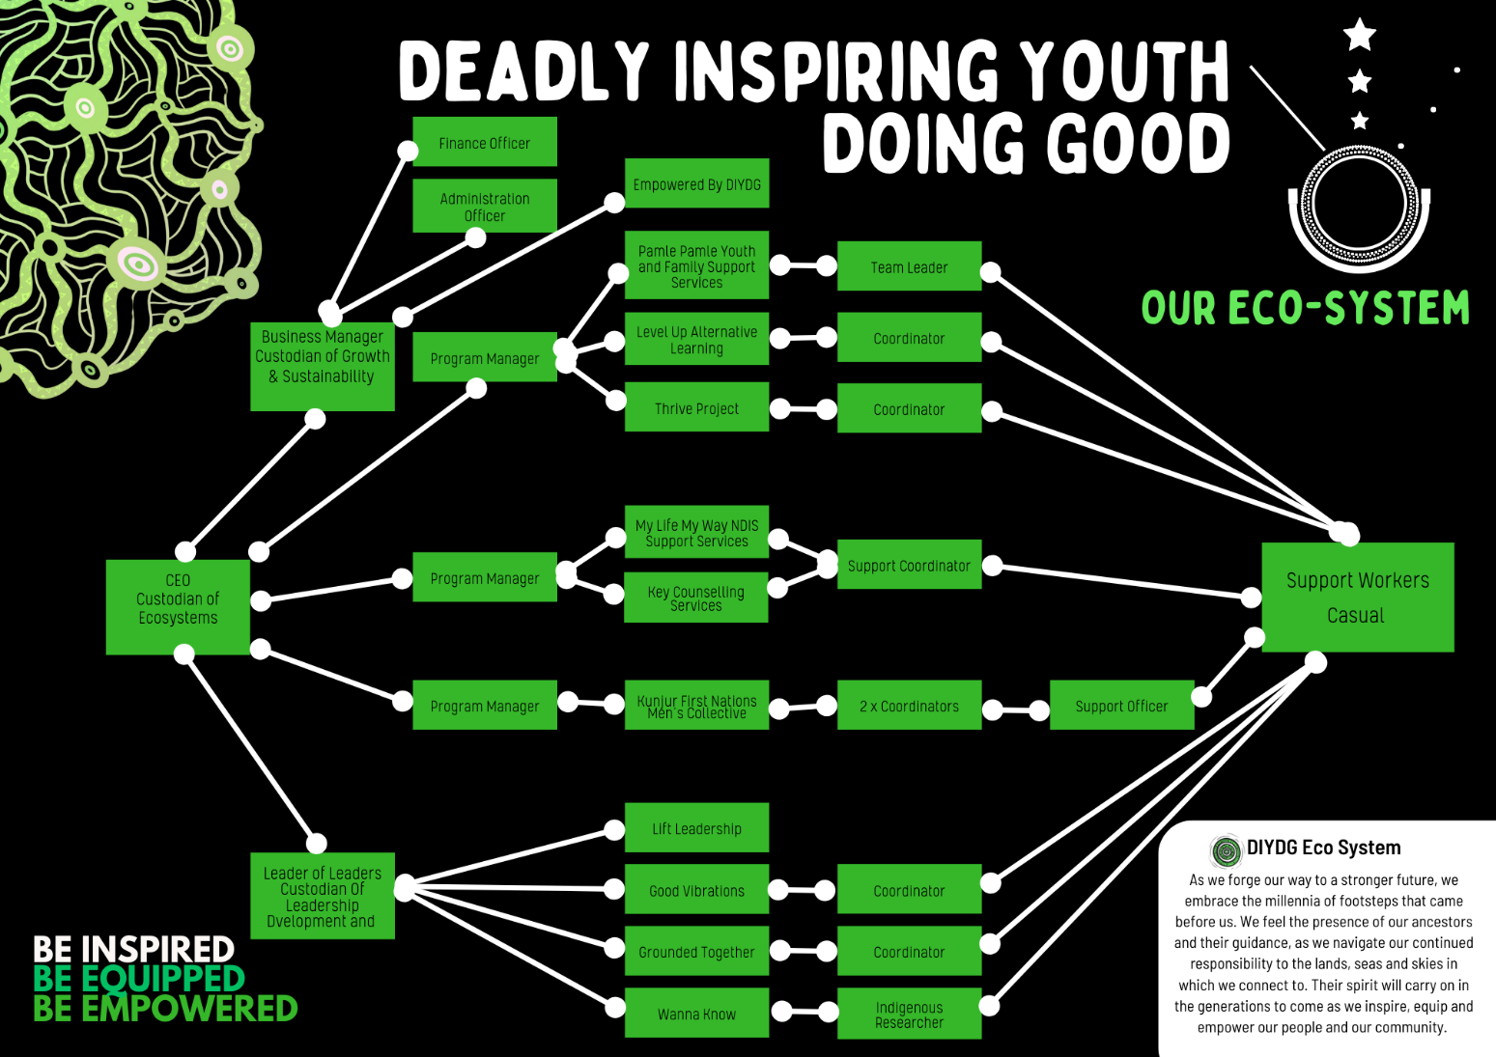

**At Deadly Inspiring Youth Doing Good (DIYDG), our ecosystem is much like a strong and enduring tree deeply rooted in Country and community. Every aspect of our work is interconnected, with each element playing a vital role in nurturing, growing, and sustaining our mission to empower young people and families.**

**Roots Anchored in Connection**  
Our roots are our relationships with Country and community. These connections ground us, drawing strength and wisdom from the land, culture, and the people we serve. They provide the stability and nourishment that enable us to stand strong through every challenge.

**The Fertilisers of Our Mission**  
Our supporters, collaborators, and advocates are the fertilisers of our ecosystem. They enrich our soil, nurturing our growth and ensuring we have the resources needed to thrive. Whether through funding, partnerships, or shared knowledge, these contributions are the lifeblood of DIYDG.

**Rainy Days and Cloudy Skies**  
Like any ecosystem, we face challenges—our rainy days and cloudy skies. These moments test our resilience, but they also bring the water and lessons we need to grow stronger. No matter the storm, we emerge more capable and determined, ready to face the next season.

**Cycles of Growth and Survival**  
Our ecosystem follows the cycles of the seasons. There are times when we are abundant and fruitful, bursting with growth and success, reaping the rewards of our efforts. There are also times when we are in survival mode, conserving energy, and focusing on our core mission to sustain ourselves through leaner periods. Both cycles are vital to our ecosystem, ensuring we endure and adapt.

**Sharing the Fruits of Our Labor**  
Just as the tree provides shade, food, and shelter to the animals that depend on it, DIYDG’s work benefits our community. Young people, families, and partners reap the rewards of our efforts, finding healing, empowerment, and opportunity within our ecosystem.

**A Living Connection**  
Our ecosystem is a living, breathing connection between people, place, and purpose. Rooted in the wisdom of our ancestors and nourished by the collective energy of our community, we continue to grow, adapt, and thrive, ensuring that DIYDG remains a strong and fruitful tree for generations to come.

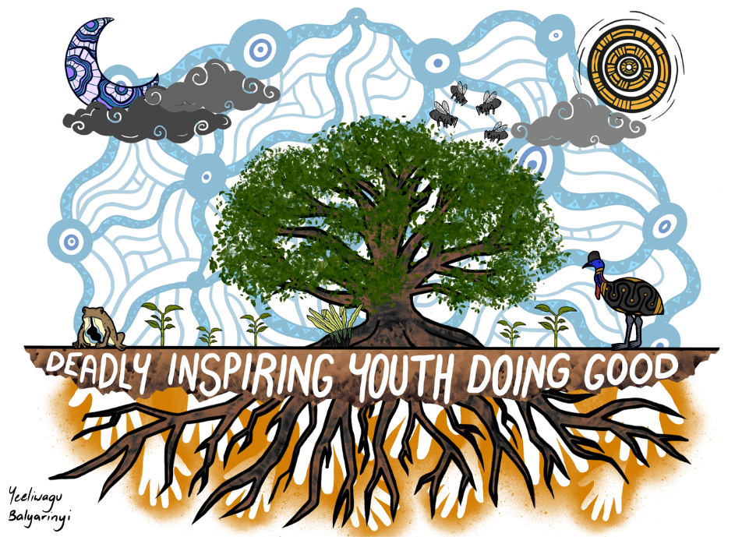

## Our Services

DIYDG offers support and services to people with disabilities. We are funded under NDIS to provide support and services to individuals.

Our current services we offer in our My Life My Way program, but not limited to the following:

* Assistance with Daily Living
* Access to Community, Social and Recreational participation
* Life Transition Planning including mentoring peer-support and individual skill development
* Skill Development and Training
* Assistance with Decision Making Daily Planning and Budgeting
* Access to Culturally Relevant Youth Activities including Bush Camps

## Access and Entry Requirements

To be eligible for the NDIS, you must:

* have a permanent and significant disability or a developmental delay
* be an Australian citizen, hold a Permanent Visa or a Protected Special Category Visa
* be under 65 years of age
* require support from a person or equipment to do everyday activities.

To be eligible for our NDIS services, you must:

* meet the NDIS eligibility criteria
* have an NDIS plan that identifies the services provided
* have an NDIS support plan that requires services that are included in our registration groups
* have funds available in your plan to pay for our services.

**Note**: We do offer a fee for service. Please let us know if you wish to pay the full fees.

# Section 4: Working with you

## Contacting Us – Your Contact Person

|  |  |
| --- | --- |
| **Contact Details:** | |
| **DIYDG Address** | 16-18 McCormack Street, Mooroobool, 4870 QLD |
| **DIYDG Phone**  **After Hours Contact** | 4047 8700  0422 009 419 / 0432 186 950 |
| **Email** | Mylife.myway@diydg.org.au |
| **Contact person** | Lenny Zillman, Support Coordinator |
| **Phone contact** | 0412 891 805 |
| **Email** | Lenny.zillman@diydg.org.au |
| **Emergency Contact** | Nicole Caelli, Program Manager – 0432 186 950 |
| **Email** | Nicole.caelli@diydg.org.au |

## Participant Assessments and Choices

You are at the centre of our services. We will partner with you to learn about your strengths and preferences to design the right supports for you.

We were hoping you could tell us what services you need and how and when you want them delivered. This holistic and collaborative approach ensures that DIYDG can meet your expectations. We will design a service that assists you to maintain and improving your lifestyle while increasing your independence and involvement in the community.

Your support (or service) plan is developed with you as its focus. We will create the plan in collaboration with you, your family or advocate, our team, and any other required support professionals. Assessments will be undertaken before you commence receiving service from DIYDG. Our Management team will conduct all assessments face to face with you, your family and/or advocate.

Your support plan will be person-centred and take an individualised approach. The plan will focus on you as an individual and be designed to promote your independence. We will record your unique skills and strengths, together with your goals and aspirations. The plan will be flexible and open to change, depending on your progress and other factors. DIYDG will regularly review your support plan to ensure that we are meeting your needs and personal requirements. We welcome your feedback regarding the services we provide you.

You can ask your support worker about your support plan. Whilst you are given a copy of this plan, you can seek more information and clarification from your support worker. If it is out of their capability to inform you, we will contact you to discuss your plan.

Below is the process that is taken to commence the development of the support plan:

1. DIYDG will perform assessments face-to-face with you, your family and/or advocate. Any specific access or entry requirements we have will be discussed with you.
2. Assessment interview time/s are arranged by telephone. Your advocate will be invited to be present (if applicable).
3. During your first meeting, the management team will explain our assessment process to you. They will provide information on collecting and using personal data, privacy, information-sharing, and confidentiality considerations. They will also remind you that an advocate can be arranged if you want one.
4. If you have specific communication needs, our management team will make the necessary arrangements to ensure these needs are considered. For example, interpreters and translated information can be provided. If you have a vision impairment or hearing loss, we will make the necessary arrangements for the essential support service during assessments.
5. The management team will inform you of your right to opt-out of sharing your personal information to meet government requirements.
6. The management team will review completed assessments. Identified areas of your independence and needs will form the basis of your care discussions.
7. Developing your support plan is a consultative process between all relevant parties. Here we will look at various areas related to your services, such as:
   1. Risks to you and in your environment
   2. Emergency and disaster management
   3. Mealtime management (if relevant)
   4. Your health needs, including comprehensive assessments, oral health and medication requirements
   5. How we can assist you in gaining vaccines or similar services
8. We will explain your support plan and give you time to review the plan. Let us know what needs changing, adjusting or if it works for you.
9. Once your plan has been determined and happy, we will ask you to sign off on it. You will be provided with a copy of your support plan.
10. DIYDG will regularly assess your support plan to check that your needs are being met.
11. Our Staff will collect information when they work with you. This information is entered into your record, so we have evidence-based information to check that our service delivery meets your current needs, interests and aspirations.
12. DIYDG will conduct regular assessments in the future with you to review your support plan and make sure the support you are receiving still meet your needs. This review will happen at least every year but may happen earlier if needed.
13. We can re-negotiate your service agreement to take into consideration any changes in your needs or circumstances, which may include a:
    * change to your support worker or representative
    * request to increase or decrease the number or types of service we provide.
14. You can opt-out of providing the information requested by government bodies such as the NDIS; please inform our staff if you want to opt-out.

## Communication with participants

Following our initial assessment of your communication needs, we will provide written, verbal or translated options to communicate with you on an ongoing basis.

If you prefer a communication method, please let our team know to arrange this for you. How you wish to communicate with us is recorded in your support plan and allows our staff to communicate how you wish.

## Interpreter Services

If you are from a non-English speaking background, we can engage an interpreter if you would like one. We will only engage an interpreter if we have your permission.

The interpreter will attend meetings with you and record all meeting information in your record. We can arrange for a telephone interpreter service in an emergency or a crisis.

## Accessing Services

The best way to receive information about all the services available to you is to speak to your DIYDG contact person. You are entitled to receive information regarding our services, and we want to provide you with the most appropriate ones.

## Management of Budgets, Statements and Fees

You will receive a NDIS funding package to pay for your disability support and support management. Your package lets you decide the type of disability support you need, who provides it and where it is provided. Thank you for choosing DIYDG as part of your support team. Our team will never offer you financial advice or information.

DIYDG will regularly inform you of the cost of the services being provided. We are transparent with our fee structure. When starting your service with us, we will provide you with a statement outlining your fees. We then will provide you with a statement each month that outlines your fees.

Fees may be changed during your service delivery, but you will be informed of this increase two weeks in advance.

**Please note**: There are annual changes in the NDIS Price Guide; these will automatically adjust your fees.

Before services are provided, we will inform you of:

* chargeable fees
* payment methods, i.e. direct debit, cheque, money order (please never pay a ${Staff Worker} directly)
* your budget (or the amount of money you can spend)
* methods for payment of fees.

If you are using the National Disability Insurance Agency (NDIA) to manage your funds, DIYDG will work with the NDIA.

## Service Agreement

Once DIYDG has been selected as your service provider, we will develop a service agreement with you, your family or your advocate (if required). This service agreement will list the schedule of supports, the responsibilities of DIYDG your responsibilities (as a participant), your emergency and disaster plan, our cancellation policy and the payment details. A copy of the signed agreement will be given to you and/or your family/nominee or advocate.

## Re-negotiating an Agreement

When your needs or circumstances change (e.g., support worker or advocate), or where you request an increase or decrease in the number or type of services, the re-negotiation of your DIYDG service agreement may be required. Our management team will advise you if this is the case and arrange for a revised service agreement to be prepared.

## Withdrawal from our Service

Should you wish to stop your DIYDG service please contact our management team immediately for this to be arranged.

DIYDG has the right to stop providing services to you if you do not meet your responsibilities. You will never be excluded from service provision because of a ‘dignity of risk’ choice. In all cases, we will speak with you and discuss the reasons for any withdrawal of service.

Where you agree, we will support you to find another service provider.

## Transition and Re-entry

Your needs and interests may change while working with our service, which may mean you need to transition (move) to another provider. DIYDG will assist and support you during this process. We will work with the other service providers to ensure your transition is smooth and meets your needs with your approval.

If you leave our service and want to return, we would be pleased for you to come back. You will need to:

* meet the program requirements to access funding, including prioritisation
* be placed on a waiting list (if no positions are currently available) and be contacted once a position is available
* undergo a risk assessment that reviews the risks relating to staying and leaving our service
* undertake a screening assessment
* agree to the conditions of the program
* pay any relevant fees.

During temporary absences, such as a hospital visit, our team will regularly contact you, your family or your advocate when planning your entry to or exit from our service. We will also assist you in contacting the hospital to book any appointments.

## Participant Service Suspension and Leave

When using our services, you may terminate or suspend services for any reason, and at any time, you just need to provide us with the length of notice which is included in your service agreement. You may request your services to be suspended, as per the terms of your DIYDG, service agreement.

Note: there is a *grace period* of six (6) weeks before the National Disability Insurance Scheme (NDIS) reviews your need to continue our services.

## Data Security/Archiving Participant Files

DIYDG’s data is password protected and stored on a secure online cloud server located within Australia. We regularly backup data to ensure record protection in case of a system crash or hard drive failure. Participant files are kept for seven years, as required by legislation. Aboriginal or Torres Strait Island participant files are stored indefinitely.

## Participant Access to Personal Records

DIYDG keeps personal records on our participants. At any time, you, or your advocate/guardian, can request access to see your personal information. Included below is the process we will follow to provide you with your personal information/records:

1. You, or your appointed advocate/guardian, request access to your records, verbally or in writing.
2. The management team will confirm your request within forty-eight (48) hours.
3. The management team will update you about the release of your information within seven (7) working days.
4. A reply to your request for information will be provided to you within two weeks of your original application.
5. Personal information is only released with the approval of the management team.
6. We will provide your personal information to the agreed person when consent is received.
7. The management team can assist you in understanding the information and will explain the terminology used.
8. On infrequent occasions, access to records may be denied. Denial is based on advice received from our legal representative. Should this situation arise, the denial will be discussed with you, your family and your advocate.

Participant Transport

During your initial meeting with DIYDG we will discuss your transport requirements. Together, we will determine the most appropriate transport services to meet your needs and if this is required as part of your package or as an additional service.

If you did not arrange transport as part of your service agreement, we could help. DIYDG can arrange to include transport services as part of your package or as an additional service. Contact our management team for assistance.

## Participant Assistance with Medication

The management team will discuss your medication requirements with you and then complete an assessment regarding your medication needs. If our Support Workers have any concerns regarding your ability to manage your medication safely, they will complete a Self-Administration of Medication Assessment.

If you need assistance with your medication, all oral medications will be provided in a Webster Pack (or another multi-dose-controlled medication pack).

During your assessment, our team will determine if you have any issues with taking medication and how we can arrange a medication plan to support you.

## Smoking

If you smoke, we ask that you please not do so while our Support Staff are performing their duties. We are committed to providing a safe workplace for our team.

## Money and Property Assistance

Your money, or other property, will only be used with you and for the purposes you request.

If you require DIYDG to provide financial assistance, you, your family or advocate must approve the arrangement and complete a Participant Money and Property Consent Form.

If your Support Plan requires DIYDG staff to be involved in handling your money, strict procedures will be followed to protect you from financial abuse. Your Service Agreement and Support Plan will outline the assistance you need relating to your money and property.

You, your family or your advocate should sign the Service Agreement and Support Plan. If you don’t want to sign the Service Agreement and Support Plan, we will record the reasons for future reference.

Our staff are not permitted to provide you with financial advice or information other than what is required under your Support Plan.

DIYDG undertakes an annual audit relating to your money and property supports and will provide you with a copy of this report.

## Participant Authority to Hold Key/s

If our staff need to hold your house key, or have access to a house code, to provide your services, the Authority to Hold Key Form will need to be completed by yourself and our management team on your admission to our service, or when the need arises.

When you no longer want us to hold your house key or know your house code, you will need to complete a Withdrawal of Authority to Hold Key Form. The management team will help you to do this.

## Gifts

DIYDG recognises that you may, on occasion, like to give a gift to a staff member. If you wish to give a gift, we prefer that it is something that can be shared by all staff e.g., flowers, a cake or chocolates.

Please NEVER offer or provide money to any DIYDG staff member.

## Will

The Support Staff of DIYDG are not permitted to advise you on making or changing your Will. Staff are not allowed to witness any legal documents, including a Will.

DIYDG do not store Wills on your records. If you require a representative to assist, we recommend you contact the Public Trustee who can arrange to manage your Will on your behalf.

# Section 5: Charter of Rights

## Your Rights

As an individual, you have many rights, and we support and assist you in identifying and exercising these rights to achieve your goals. DIYDG adopts a policy of non-discrimination regarding eligibility and entry to our services and when providing support services to you.

You have the right to:

* access supports that promote, uphold, and respect your legal and human rights
* exercise informed choice and control to maximise independence
* freedom of expression, self-determination and personal decision-making
* access supports that respect your culture, diversity, values and beliefs
* a support service that respects your right to privacy and dignity
* be helped to make informed choices which will maximise independence
* receive support that is free from violence, abuse, neglect, exploitation or discrimination
* receive supports which are overseen by strong operational management
* receive services that are safeguarded by informed and compliant risk and incident management systems
* receive services from workers who are competent, appropriately qualified and have expertise in providing person-centred supports
* advise consent to the sharing of information between providers during the transition
* opt-out of giving information as required by NDIS.

## Your Responsibilities

As individuals using our support services, we ask you a few essential things. The information below explains your responsibilities when using our services. We ask that you:

* respect the rights of Support Workers, to ensure their workplace is safe and healthy and free from harassment
* abide by the terms of your agreement with us
* understand that your needs may change, meaning your services may need to change
* accept responsibility for your actions and choices, even though some decisions may involve risk
* tell us if you have problems with the care or service you are receiving from us
* provide us with enough information to develop, deliver and review your support plan
* care for your health and wellbeing as much as you are able
* provide us with information that will help us to meet your needs
* provide us with a minimum of twenty-four (24) hours’ notice if you need to cancel your service
* remember that our Support Staff are only authorised to perform the agreed number of hours and tasks outlined in your service agreement
* participate in the safety assessments of your home
* ensure your pets are controlled during service provision
* provide a smoke-free working environment
* pay the agreed amount for the services provided
* tell us in writing (where able) and provide appropriate notice when you want to stop receiving our services
* inform a Support Worker (when asked) if you wish to opt-out of providing your information to government bodies such as NDIS.

## Our Responsibilities

DIYDG will:

* provide the supports that meet your needs at your preferred times
* regularly review the provision of your support with you
* communicate openly, honestly and promptly
* treat you with courtesy and respect
* discuss with you all decisions regarding your supports and how they are being provided
* listen to your complaints and feedback and address any problems that may arise
* provide you with twenty-four (24) hours’ notice if we need to change a scheduled support provision appointment
* keep your personal information confidential
* support your culture, community and any other needs
* implement policies and procedures to ensure your safety and the safety of others during service provision.

## NDIS Code of Conduct

DIYDG employees follow the NDIS Code of Conduct by:

* acting with respect for individual rights to freedom of expression, self-determination, and decision-making following relevant laws and conventions
* respecting your privacy
* providing supports and services safely and competently with care and skill, and acting with integrity, honesty, and transparency
* promptly taking steps to raise and act on concerns regarding matters that might have an impact on the quality and safety of supports provided to you
* taking all reasonable steps to prevent and respond to all forms of violence, exploitation, neglect, and abuse towards you
* taking all reasonable steps to prevent sexual misconduct towards you.

## Conflict of Interest

DIYDG is committed to ensuring that actions and decisions taken at all levels in our organisation are informed, objective and fair. A conflict of interest may affect how a staff member acts or their choices. Identified conflicts of interest require action to be undertaken by our organisation to ensure that personal or individual interests do not impact your or our services, activities or decisions.

DIYDG requires all staff to declare their involvement in external work-related activities to allow for discussion and management of the potential conflicts of interest with the management team. Declaration and management of a conflict of interest are handled by the Manager If you undertake other (new) work outside of our organisation, you must inform the management team immediately.

As a participant, please let us know if you feel a conflict of interest. We will provide you with a Conflict-of-Interest Declaration Form to complete.

In the event **you** declare or identify a conflict of interest, the management team will assess the conflict to determine if a conflict of interest exists (or there is a perception that a conflict exists). A meeting will be convened to discuss the conflict, and you may be asked to:

* contribute to the discussion, but abstain from voting or taking part in a decision on the matter
* observe but not take part in the meeting or decision-making
* leave the meeting during the discussion and before a decision has been made.

**All potential and actual conflicts will be recorded in the Conflict-of-Interest Register to oversee the identified and declared conflicts.**

You will be informed of the outcome of the review by the management team and, if there is a conflict, advised how our organisation will manage the conflict.

## Consent

When you provide consent, you give your permission or say that it is okay for something to happen. You must always fully understand why a person requires your consent. If you have any doubt about this, you should ask our management team or your advocate, for help.

You can withdraw your consent at any time. For example, the withdrawal of consent means if you are taking part in a particular program and decide that you do not like the program, you can tell us that you no longer want to participate in that program.

DIYDG Support Staff will need your consent to:

* read the information that service providers have about you and for us to provide any information about you to other service providers, your family or advocate
* collect data relating to you for funding bodies
* ask people to attend your person-centred planning meeting
* carry out any training programs or behaviour change programs we want to put in place for you
* assist you to see a doctor or a dentist
* provide appropriate services and supports
* provide you with medication.

Usually, consent will be documented in your support plan. However, we will ask you to sign a consent form to release your personal information. We will always ask for your permission and explain the reasons for accessing your information when providing it to Support Staff or another service provider. If you are unsure during this process, you should ask your advocate for help.

If you feel that you cannot consent about issues in your life, we can talk to your family or advocate and ask them to assist. If you do not have family who can make decisions for you, we will help you apply to the court, or other government bodies, to appoint a Guardian who can legally help you make these decisions.

## Privacy Statement

DIYDG complies with all relevant privacy legislation and has systems for the collection, use, disclosure, quality, security, accuracy and correction of personal information relating to you, as our participant.

Your privacy and dignity will always be maintained. You will be asked to sign a Privacy Agreement to consent to collect, use, and disclose your personal information to comply with the *Privacy Act 1988*. If you want more information about this, you should read our Privacy and Confidentiality Policy and Procedure. Information regarding your privacy is also included in your service agreement.

Your Privacy Officer is the Custodian of Eco-Systems and can be contacted via:

* email: whichway@diydg.org.au
* phone: 0422 009 419

Requests for access to the personal information we hold should be made in writing to the Custodian of Eco-Systems. Where you believe that a breach of this policy or the *Privacy Act* has occurred, a written complaint should be made to the Custodian of Eco-Systems

Failure to receive a response within thirty (30) days, or you are dissatisfied with the response, you may complain to the Office of the Australian Information Commissioner (OAIC) via:

* mail: GPO Box 5218, Sydney NSW 2001
* fax: 02 9284 9666
* email: [enquiries@oaic.gov.au](mailto:enquiries@oaic.gov.au)
* online: <https://www.oaic.gov.au/>

## What is a Guardian?

A Guardian is usually a person who has been legally appointed by a court to make decisions on your behalf. This person may be a friend, a family member, or a person from your State Government Advocate.

## Your Advocacy Rights

An advocate is a person who will listen to you, help you make decisions about what should happen in your life and then speak, on your behalf, to arrange for those decisions to be implemented. An advocate will ensure that your rights are respected and speak out for you if your needs are not met.

You can ask anyone that you know well and trust to be your advocate, such as a:

* member of your family or a friend
* a person from a legal advocacy service.

DIYDG can help you find an advocate by providing a list of available advocacy services. Once you have selected an advocate, the management team will provide you with a form that must be completed called the Authority to Act as an Advocate Form.

With your permission, DIYDG will:

* provide your advocate with all the information they need to ensure that we (and any other service providers) are acting in your best interest
* work closely with your advocate and involve them in the planning of services that will be provided to you
* ensure our Support Staff understand the role of your advocate.

DIYDG will ensure that your advocate is invited to attend:

* consultation meetings
* person-centred planning meetings and reviews
* any other relevant meetings or conferences.

You can use your advocate:

* any time you wish to communicate with us
* during your initial assessment consultation
* during your interviews and reviews
* during service delivery
* when you want to make a complaint
* when you want to give feedback.

We encourage you to bring your advocate to your initial assessment meeting to hear your voice during the planning process, guiding and developing your person-centred support plan. Your advocate is welcome to attend any meeting and speak on your behalf.

DIYDG Support Staff will provide your advocate with the opportunity to discuss problems or concerns they may have. Failure to adequately address your advocate’s concerns will lead to our team informing them of our complaint process and providing the governing agencies’ contact details who have the responsibility to ensure we perform our job correctly. You can change your advocate at any time. If you change your advocate, please inform us as soon as possible to update your information and ensure that we talk to the correct person.

# Section 6: Your Safety and Well-Being

## Abuse

DIYDG recognises your right to feel safe and to live in an environment where you are protected from assault, neglect, exploitation or any other form of abuse.

We encourage and support any person who has witnessed the abuse towards one of our participants or suspects that abuse has occurred to make a report and be confident of doing so without fear of retribution. Our reporting process includes any kind of abuse, including financial, emotional, social, psychological, sexual, physical abuse or neglect.

You can make a report to whomever you feel comfortable and safe with; this may include one of our employees, our program manager, our support coordinator, a family member, your advocate or a trusted friend.

If you would like to speak with someone outside of DIYDG you can contact the NDIS Quality and Safeguards Commission:

Phone: 1800 035 544 (free call from landlines) or TTY 133 677

National Relay Service and ask for 1800 035 544

Interpreters can be arranged.

You can also complete a NDIS Complaint Contact Form online. Go to the NDIS Quality and Safeguards Commission website [*business.gov.au*](https://forms.business.gov.au/smartforms/servlet/SmartForm.html?formCode=PRD00-OCF)

DIYDG acknowledges that prevention is the best protection from abuse and neglect and recognises our duty of care to put in place prevention strategies that include appropriate protocols that assist in identifying potential risks. Our prevention strategies include only employing skilled staff who respect the rights of participants and who are aware of current legislation and policies regarding abuse and neglect. Our Staff can assist you, your family or advocate to access our complaints process and raise any concerns regarding our service provision.

Where abuse, harm or neglect has occurred, DIYDG will respond quickly, considerately and effectively to protect you from any further harm. We will provide you with access to any required counselling, medical and/or legal assistance.

When you make allegations of abuse, neglect, violence, exploitation or discrimination, you have the right to have an advocate present. DIYDG can arrange this for you.

## Family Assistance

DIYDG encourages and supports families to maintain contact with you. Your family is welcome to contact us for information and support with your permission. Your family or advocate can be involved in planning the services you will receive through your person-centred support planning meeting.

We can help your family by:

* communicating in a way they understand
* providing information regarding available services, including those offered by other agencies
* helping to build trust and respect between staff members, you and your family
* providing them with the opportunity to take part in service delivery planning
* creating opportunities to develop links with you
* assisting them to access counselling and support services
* providing them with access to effective complaint procedures
* helping them to access advocacy services where required.

## Continuity of Support

The management team will arrange your support schedule, so you know who will be working with you to deliver your services and support. We will provide you with a Support Worker who has the skills and knowledge you require. Wherever possible, we will meet your support requests, e.g. you would like a worker who speaks the same language, is from the same culture or meets other specific criteria.

Support Staff are allocated to you regularly so that you can feel comfortable with them and receive predictable and continuous support. The supports we provide are linked to your support plan and will demonstrate consistency with your needs and requests.

### What will happen if your worker is absent?

* DIYDG Support Service will contact Staff members with relevant qualifications as a suitable replacement.
* Where possible, we will provide a Support Worker who has worked with you previously and is aware of your requirements.
* Where possible, we will advise you of details of the replacement staff member.
* We will gather your feedback on the replacement staff member on completion of the service.
* The replacement Staff will be sensitive to your needs and ensure that care is consistent with your expressed preferences.
* We will seek your approval for the placement staff member and will never place someone to support you who you do not wish.

## Emergency and Disaster Planning

We will create an emergency and disaster plan with you and other relevant support networks. This emergency plan will be trialled before we activate it, and staff will consult with you about changes and improvements. This plan will be adjusted depending on any current emergency or disaster.

This plan is attached to your Service Agreement.

## Vaccinations

Our team will support you in gaining any vaccinations that you request. We will work out a plan with you. We will look at how you will get to the vaccination location, the types of support you need, and support you during and after the process.

## Infection Management

Your wellbeing is essential, and we will take all measures required to reduce any contamination in your environment, including wearing masks or gowns, cleaning surfaces, handwashing, and use of antibacterial gels. Please make sure that you keep yourself and your environment as clean as possible.

## Critical Incident

While we hope that a critical incident does not occur, in the event it does, we are prepared to support and assist you by following procedures that appropriately deal with a critical incident.

A critical incident is classified as an event (or alleged event) that occurs because of, or during, the delivery of services and has caused, or is likely to cause, a significant negative impact on your health, safety or wellbeing.

If an incident does occur, we will engage the required authorities to support you during this time.

Critical incidents that relate to you may include, but are not necessarily limited to:

* an unexpected death, serious injury or alleged assault (including physical, sexual abuse, sexual assault or indecent assault) that occurs as a result or during the delivery of services
* allegations of serious, unlawful or criminal activity or conduct involving an employee, subcontractor or volunteer that has caused, or has the potential to cause, serious harm to you
* an incident where you assault or cause serious harm to others (including our employees, volunteers or contractors), as a result, or during the delivery, of services
* a severe fire, natural disaster, accident or other incidents that will, or is likely to prevent, service provision, or that results in closure or significant damage to premises or property, or that poses a substantial threat to your health and safety.

DIYDG has established procedures that identify, manage and resolve incidents which include:

* Support Staff members will report all incidents to the Custodian of Eco-Systems
* completion of an incident report that identifies and records an incident
* the management team is responsible for reporting incidents that are ‘reportable incidents’ to the NDIS Commissioner and other required agencies
* compliance with the National Disability Insurance Scheme (Incident Management and Reportable) Rules 2018
* supporting and assisting you if you are affected by the incident
* review of the incident by the Management if you or others were affected
* collaborating with you, your family and/or advocate to manage and resolve the incident
* reviewing the incident and making necessary amendments to systems and processes to reduce the risk of recurrence.

## Risk-Taking

You have the right to participate in lawful activities that may involve a degree of risk. We will always allow you a dignity of risk, and our role is to look at the activity and not you. We will discuss this with you if you wish to undertake the activity. Any dangerous risk may require you to sign that you are willing to take the risk. We always assume that you can make your own choices.

We will work with you and advise the various options available regarding the activity to make an informed choice.

We will undertake an individual risk profile of you and a risk assessment of your environment. These assessments will include risk assessments when you leave your home environment.

## Risk Assessment

Your risk will be assessed when you first start working with us. After initial assessment, we will review your risk annually. If we feel that you need another review, we will work with your Support Coordinator. Your review may happen due to changes in:

* your health
* your living arrangements
  + additional person
  + person leaving
  + new pet
* your physical environment

Your safety is at the centre of all we do, and we will consult you during the risk process.

## Work Health and Safety

Under the *Work Health and Safety Act 2011,* DIYDG has a duty, under the law, to make sure our staff can work with you in a healthy and safe environment. Some things you can do to assist in this matter include:

* notifying our staff of any unsafe conditions in your home
* participating in safety assessments of your home
* arranging repairs of any hazards identified during our safety assessment of your home
* ensuring your pets are controlled during service provision
* providing a smoke-free working environment
* providing a workplace for our staff that is free of racial, sexual, physical or emotional abuse
* treating our staff with dignity and respect
* advising our staff if you are unwell or cannot do things the way you usually do them
* telling our staff if your doctor has diagnosed you with a short-term infectious illness
* providing cleaning equipment that is suitable and well maintained
* providing safe, non-toxic cleaning products
* ensuring your mobility equipment and any other items required to live independently in your home is available and well-maintained.

We will conduct a safety check during our first service and discuss any risks we identify with you. The safety of the service will be reviewed with you, on an ongoing basis, following state and federal work occupational health and safety legislation.

## Networking

We will engage with your networks and community to ensure you are offered the opportunity to be involved in culturally relevant activities and areas of interest.

We will access networks like religious groups, local ethnic groups, community groups, or others you request. We believe that it is essential that you are part of your community, so we work with you to ensure that this happens.

## Legislation and Standards

DIYDG operates in compliance with all current legislation and standards. Please contact us for a copy of the legislation that applies to the service we are providing you. The primary legislation and standards that cover your service include the following:

* National Disability Insurance Scheme Act 2013
* Disability Act and Regulation
* National Disability Insurance Scheme Practice Standards and Quality Indicators 2021.

# Section 7: Complaints and Feedback

## Complaints and Feedback

Your feedback allows us to provide you with high-quality services; we actively seek your input. Feedback can be provided anonymously or through written or online surveys or conversations with you. We would like your feedback on:

* quality of care received
* consistency of services provided
* support worker performance
* supports that work for you
* changes you want made to assist you
* what you like and dislike about our services.

You always have the right to expect the best possible standard of service from us, and we will treat any concern or complaint you provide as a serious issue. No matter what the situation, a DIYDG will not react badly to your complaint; you should feel safe knowing that they will not retaliate or hurt you in any way.

You can make an anonymous complaint to our Complaint Manager using the Anonymous Complaints and Feedback form provided during the intake process. Remember not to identify yourself during this process if you wish us not to know who is making the complaint.

You can make a complaint regarding our services or a staff member provided to work with you. If you do not feel comfortable making a complaint, someone else can do this on your behalf, including:

* an advocate
* a family member
* a close friend
* your care worker
* a person you know and trust.

Please send your complaints addressed to Management via:

|  |  |
| --- | --- |
| **Website:** | Diydg.org.au/know-your-rights |
| **Email:** | [qaci@diydg.org.au](mailto:admin@yalgan.com) or [hr@diydg.org.au](mailto:hr@diydg.org.au) |

Once a complaint has been received, DIYDG’s Custodian of Eco-Systems will investigate the complaint and find a resolution. A representative of the management team will write a letter to confirm that your complaint has been received. This letter will provide you with the expected date DIYDG of the complaint resolution.

The complaint will then be investigated, and a plan to resolve it created. You will be informed of this plan, and we will ask you to provide your opinion on our recommended solution. You can advise if you are happy with the proposed solution or unhappy with the outcome and feel the matter is not resolved.

If you are not happy with the solution proposed by DIYDG regarding your complaint, you can speak to other organisations, such as:

**Commonwealth Ombudsman – Disability Services**

Telephone: 1300 362 072

Email: ombudsman@ombudsman.gov.au

Website: [www.ombudsman.gov.au](http://www.ombudsman.gov.au)

**NDIS Complaints**

Telephone: 1800 800 110

Email: feedback@ndis.gov.au or

Website: <https://www.ndis.gov.au/contact/feedback-and-complaints>

## Your Voice

Your input into our services and practices is essential to ensure that we are meeting both your needs and that of your community. Please let us know if you want to have an influence into our policies and practices. We want to hear from you so our management team can ensure that our business needs your needs.

Please let our management team know if you wish to participate. You are very welcome.

## Continuous Improvement

We aim to provide you with a high-quality service that meets your expectations and needs. To do this, we ask you to let us know how we can maintain and improve the services we provide to you. You can do this by giving feedback or making a complaint.

Our collaborative and person-centred approach means that DIYDG will respond to your information positively to improve the services we provide.

# Section 8: NDIS Practice Standard and Quality Indicators (Abbreviated version)

The NDIS Practice Standards create an essential benchmark for us to assess our performance and to demonstrate how we provide high-quality and safe supports and services to you. Together with the NDIS Code of Conduct, the NDIS Practice Standards assist you in understanding what quality service provision you should expect from us.

These NDIS Practice Standards set out your rights and responsibilities when delivering support and services to you.

## 1. Participant Rights and Responsibilities

The standards addressed in this division include:

1.1 Person-Centred Supports

1.2 Individual Values and Beliefs

1.3 Privacy and Dignity

1.4 Independence and Informed Choice

1.5 Violence, Abuse, Neglect, Exploitation and Discrimination

People with a disability have the right to respect, dignity and full participation in society. It is important to us that you know and understands your rights. We are here to support you and provide guidance and assistance in any choices you make.

We respect your right to privacy and the confidentiality of your personal information and records. Also, we will uphold your right to make your own decisions.

It is your right to try new activities and experiences, and we will assist you while ensuring that you are treated fairly and independently.

You have the right to talk freely and express your thoughts, opinions and choices. We will listen to you and support the choices you make. We will include your family, advocate and support workers in discussions when you want them involved.

We understand that everyone communicates in different ways; we have various communication methods that you can use to communicate with us safely and privately.

We will support you in participating in the community of your choice and working with you, your family, and support workers to make this happen.

DIYDG Support Staff will respect your cultural background and endeavour always to meet the cultural needs and requirements you may have.

## 2. Provider Governance and Operational Management

The standards addressed in this division include:

2.1 Governance and Operational Management

2.2 Risk Management

2.3 Quality Management

2.4 Information Management

2.5 Feedback and Complaints Management

2.6 Incident Management

2.7 Human Resource Management

2.8 Continuity of Supports

2.9 Emergency and Disaster Management

It is essential that you feel free to tell us what you think about the services we provide to you. It is your right to share your opinions on anything related to the services we provide, whether they be good or bad. We welcome your input and want you to offer it without fear of reprisal, discrimination, or negative consequences.

You can ask for support from another person when making a complaint, such as a family member, a support worker, your advocate or the Ombudsman.

Whatever the issue, we will do everything possible to solve your problem. We appreciate your opinion about our services and will introduce service improvements based on your feedback (when required).

DIYDG recruit quality, caring support workers who receive ongoing training. We provide continuous improvement of services, correct working processes, and effective and transparent communication, which are key to our services’ success.

We will work closely with you to provide and maintain excellent service and support and strengthen our systems and processes to deliver positive results when resolving any problems. A systematic approach to emergencies and disasters assists us in supporting you in these circumstances.

DIYDG’s management possesses the skills and experience to implement and monitor the effectiveness of our policies and procedures and make necessary changes when required.

## 3. Provision of Supports

The standards addressed in this division include:

3.1 Access to Supports

3.2 Support Planning

3.3 Service Agreements with Participants

3.4 Responsive Support Provision

3.5 Transitions to or from the Provider

DIYDG will support your goals and decisions regarding the services you choose. We will offer you guidance and assist you in identifying your strengths and weaknesses to develop appropriate skills to help you achieve your goals.

We will never discriminate against you, irrespective of your age, gender, disability, cultural background or sexuality.

DIYDG will assist anyone enquiring about our services. We will provide support and advice regarding the appropriateness of our services or give a referral to an alternative service that may be more suitable for you. You have the right to seek the service you need and access the support you require.

DIYDG will encourage and help you to participate actively and meaningfully within the community of your choice.

## 4. Provision of Supports Environment

The standards addressed in this division include:

4.1 Safe Environment

4.2 Participant Money and Property

4.3 Management of Medication

4.4 Mealtime Management

4.5 Management of Waste

DIYDG endeavour to ensure you are always safe, physically and emotionally. Our Support Workers are trained in appropriate procedures designed to keep you safe, and they will report any risks, or potential risks, to the Management

We will work with you and/or your advocate to ensure you understand our fees and payment methods of our fees. All information will be clear and accurate.

If you require medication, our Support staff are trained in managing your medication appropriately. We will also ensure that you take your medication safely.

Once we identify that you need mealtime assistance with your diet, dysphagia or similar, we will create a plan to support your mealtime and allow choice on meals preference

DIYDG’s support staff are trained to manage waste to protect you, or any other person, from harm resulting from exposure to waste, infectious or hazardous substances created during our service delivery. Our policies and procedures comply with relevant legislation and include incident management processes and emergency plans. Where possible, we manage waste in a sustainable manner, such as recycling paper, glass and plastic waste, where appropriate.

DIYDG Support Staff has established procedures that identify, manage and resolve incidents which include:

* completing an incident report that identifies and records an incident
* reporting all incidents to our management team
* reporting reportable incidents to the NDIS Commissioner and other appropriate authorities
* complying with the National Disability Insurance Scheme (Incident Management and Reportable) Rules 2018
* supporting and assisting you if you have been affected by an incident
* reviewing the incident with you and the appropriate staff member
* working with you to manage and resolve the incident effectively
* making amendments to systems and procedures to reduce the risk of recurrence.

# Section 9: Additional Standards

## Child Safe Standards

### Standard 1. Child safety is embedded in our organisational leadership, governance and culture

* Commitment to safety.
* Staff are trained in:
  + child safety
  + Codes of Conduct
  + behavioural standards when interacting with children
  + reporting obligations and record keeping.
* Risk management plans are undertaken for each child.
* Comply with NDIS Code of Conduct, our organisation’s Code of Conduct and the Statement of Commitment to Safety.

### Standard 2. Children participate in decisions affecting them and are taken seriously

* Children can express their views and are provided opportunities to participate in decisions that affect their lives:
  + upon commencement with our organisation
  + on an ongoing basis (they are asked regularly for their thoughts and ideas)
  + at the review of their plan.
* The importance of friendships is recognised, and support from peers is encouraged, helping children feel safe and be less isolated.
* Work with the child and the family to determine how best to assist with these linkages.
* Children can access abuse prevention programs and information.
* We provide links to relevant organisations such as Kids Helpline, as needed.
* Age-appropriate information that describes how adults should behave towards the child is provided.
* Staff are attuned to signs of harm and facilitate child-friendly ways for children to communicate and raise their concerns:
  + staff trained to work with each child
  + knowledge and skills are assessed to determine training to ensure skills and knowledge are evident.

### Standard 3. Families and communities are informed and involved

* All levels of our organisation encourage families to take an active role in keeping children safe.
* Our policies and procedures (including the Code of Conduct) are communicated to parents and carers (e.g. Welcome Pack including Participant Handbook)
* Families and community members are encouraged to provide feedback on how well the organisation keeps children safe, and this information is acted upon where necessary: Feedback can be provided via:
  + a Complaint and Feedback Form
  + meetings are held about a child.

### Standard 4. Equity is upheld, and diverse needs are considered

* The management team and our staff understand the type of barriers that prevent children from disclosing abuse or adults from recognising a child’s disclosure.
* The management team and our staff identify and respect the diverse needs, abilities and backgrounds of children and understand the value of treating them fairly.
* Our organisation reviews each child’s cultural needs at intake.
* We provide relevant, culturally sensitive, age-appropriate activities to children.
* All staff are trained and provided information about the factors that may increase a child’s vulnerability to harm.
* The management team ensures that our workforce reflects the diversity of the children we provide services to, where possible.
* The management team and staff adapt activities and services to ensure all children feel included, and we undertake the following for each child:
  + risk management plan
  + strategy planning.

### Standard 5. People working with children are suitable and supported

* When recruiting, the management team does not solely rely on the Working with Children Check. We also provide ongoing staff training opportunities for all staff, including:
  + induction
  + annual training
* When recruiting, DIYDG is aware of and implements child safe recruitment practices.
* All vacant position advertisements identify that we value child safety.
* Recruitment processes involve a range of interview questions to establish staff suitability.
* Background and reference checks are carried out and recorded (see Human Resource Management Policy and Procedure).
* Supervision includes regular reviews to check whether staff follow Codes of Conduct and other child-safe policies.
* The management team monitors all aspects of supervision and undertakes employee supervision at least quarterly.

### Standard 6. Processes when responding to complaints of child abuse (or other concerns) are child-focused.

* The management team builds a culture where complaints are taken seriously, and all employees take responsibility for the safety of children using our induction process and cultural staff training.
* During a new employee’s induction, the management team clearly explains that the Code of Conduct breaches will result in disciplinary action. Staff are also informed of this ongoing through internal training sessions.
* Staff are given support and information on what and how to report, including external bodies.
* Accessible procedures enable children, staff and others to make complaints. These procedures include potential time frames, review processes and potential outcomes of complaints.
* Complaints are handled confidentially (see Complaints and Feedback Policy and Procedure).
* Processes are reviewed at regular intervals and after a complaint is received by DIYDG Quality Assurance and Continuous Improvement (QACI) committee.
* Documents are treated confidentially, as required.

### Standard 7. Staff are equipped with knowledge, skills and awareness to keep children safe through continual education and training

* The management team provides ongoing education and training opportunities for all staff, including:
  + knowledge, skills and confidence to prevent and identify abuse
  + how to respond to and report complaints.
* Additional training is provided when higher risks towards a child or young person are involved, e.g. behaviour management
* The Management team are responsible for issuing all training and ensuring staff completion
* Training is regularly reviewed in response to emerging best practices.

### Standard 8. Physical and online environments minimise the opportunity for abuse or other kinds of harm to occur

* The management team sets expectations regarding behavioural standards for staff when interacting with children in physical and online environments.
* Risk assessments identify areas where staff have opportunities to interact with children unsupervised, including one-off events and overnight accommodation.
* Physical environments are altered to increase natural sightlines while respecting a child’s privacy rights.
* Higher-risk areas such as cars, boarding facilities and offsite locations are managed using specific safety measures, such as spot checks.
* Children are provided information regarding online safety and are regularly encouraged to tell staff about negative experiences.
* Staff and parents are provided information about risks in the online environment (e.g. online grooming, cyberbullying and sexting).

### Standard 9. Implementation of Child Safety Standards are continually reviewed and improved

* The management team maintains a culture of continuous improvement to ensure that policies and procedures are implemented and routinely reviewed even though staffing may change.
* The management team understands the value of continuous monitoring, open conversations and exploring new ways to keep children safe.
* Our child-safe policies and practices are reviewed annually.
* Staff refer to the Child Safe Standards when creating, reviewing or evaluating child-safe policies and procedures.
* Critical incidents are used to identify the root cause of a problem, identify risks to children’s safety, and make improvements (e.g. Incident Report and Incident Investigation Form and Continuous Improvement Register).
* Children are supported to provide feedback which we will act on if required.

### Standard 10. Policies and procedures document how the organisation is child safe

* The management team will ensure that policies and procedures are reviewed and compliant.
* DIYDG acknowledges that we will be held accountable against our policies and procedures.
* Staff are trained and knowledgeable about organisation procedures, especially how they relate to child safety
* Staff, parents and carers are informed and have access to DIYDG child safe policies and procedures and complaint policy and procedure.

# Section 10: NDIS Quality Safeguards and Commission

### What is the NDIS Commission

The **NDIS Quality and Safeguards Commission** is an independent organisation that makes sure people receiving NDIS supports are treated with respect and feel safe. They work to improve the quality of NDIS services, make sure providers and workers follow the rules, and help people speak up if something isn't right. They also take complaints seriously and can step in to help solve problems.

### How to contact the NDIS Commission

|  |  |
| --- | --- |
| **Phone:** | 1800 035 544 |
| **Website:** | [www.ndiscommission.gov.au/contact-us](https://www.ndiscommission.gov.au/contact-us) |
| **Email:** | contactcentre@ndiscommission.gov.au |
| **Post:** | NDIS Quality Safeguards Commission  PO Box 210  Penrith NSW 2751 |

# Section 11: Stay Connected

|  |  |  |
| --- | --- | --- |
| **Name** | **Contact Type** | **Contact Details** |
| Deadly Inspiring Youth Doing Good (DIYDG) | Phone  Address  Email | 4047 8700  16-18 McCormack Street, Mooroobool, QLD 4870  whichway@diydg.org.au |
| DIYDG - After Hours Contact | Phone | **0422 009 419 / 0432 186 950** |
| DIYDG - Complaints | Email  Email  Website | **qaci@diydg.org.au**  **hr@diydg.org.au**  **diydg.org.au/know-your-rights** |
| DIYDG – My Life My Way NDIS Services | Email | **qaci@diydg.org.au** |
| DIYDG – Program Manager Nicole Caelli | Phone  Email | **0432 186 950**  **Nicole.caelli@diydg.org.au** |
| DIYDG – Support Coordinator Lenny Zillman | Phone  Email | 0412 891 805  Lenny.zillman@diydg.org.au |
| Commonwealth Ombudsman – Disability Services | Phone  Email | 1300 362 072  [Ombudsman@obudsman.gov.au](mailto:Ombudsman@obudsman.gov.au) |
| Office of the Australian Information Commissioner (OAIC) | Mail  Fax  Email  Website | GPO Box 5218, Sydney NSW 2001  02 9284 9666  [enquires@oaic.gov.au](mailto:enquires@oaic.gov.au)  www.oaic.gov.au |
| National Relay Service (SMS Relay) | SMS | 0423 677 767 |
| National Relay Service (Speak and Listen) | Phone | 1300 555 727 |
| National Relay Service (TTY/Voice) | Phone | 133 677 |
| NDIS Complaints | Phone  Email | 1800 800 110  feedback@ndis.gov.au |
| NDIS Quality and Safeguards Commission | Phone  Email  Website | 1800 035 544 **(or TTY 133 677 via NRS)**  contactcentre@ndiscommission.gov.au  [www.ndiscommission.gov.au/contact-us](https://www.ndiscommission.gov.au/contact-us) |
| TIS National Direct | Phone | 131 450 |