COMPLETE AND RETURN:

Name:__________________ ______

Address: ________________ ______

__________ ___________________

City ______ ____________________

State _______ Zip code ______ _

Sex: Male __ __ Female __ __

Birth date: ____ _____ Age __ __

Adult Shirt Size: S M L XL

County of Residence:

School District:

Grade Level:

Parent/Guardian:

______________ _______________

Home Phone: ___________________

Work Phone: ____________________

E-Mail:

Has the applicant ever attended a
Summer youth camp? _____________

I certify that my physical condition will not restrict me in any educational or sports activities.

______________________________ Applicant Signature/Date

______________________________

Parent/Guardian Signature/Date

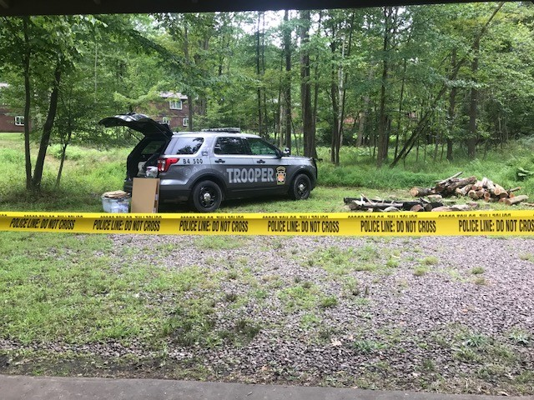For further information Please

contact the

Pittsburgh and Washington Station and Camp Co-Coordinator

Trooper

Katjie Rumbaugh
412-299-1607
Uniontown, Waynesburg and Belle Vernon Stations and Camp Co-Coordinator
Trooper
Robert Broadwater
724-439-7111

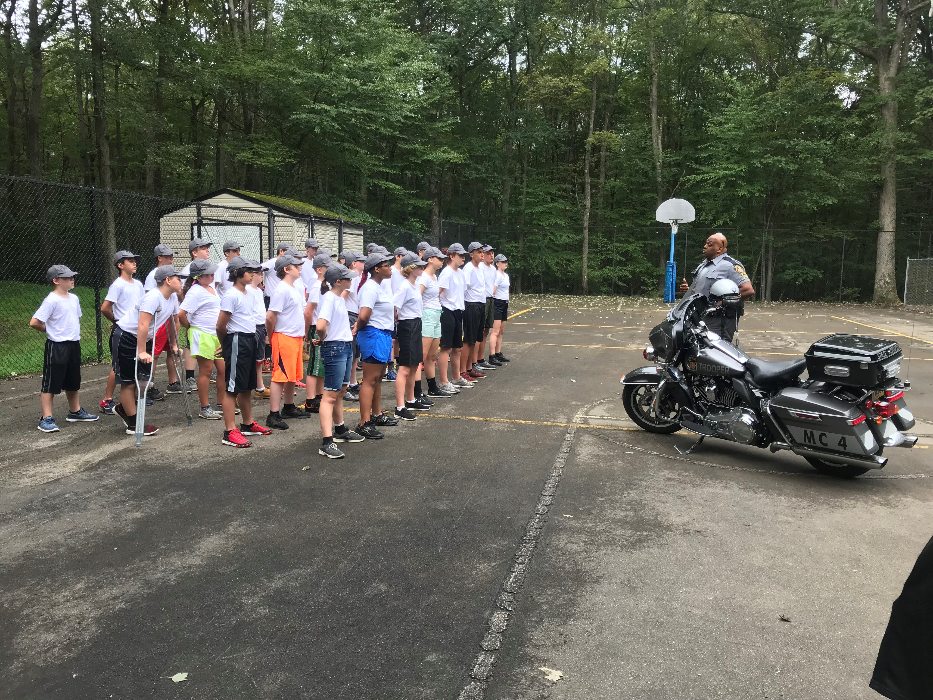

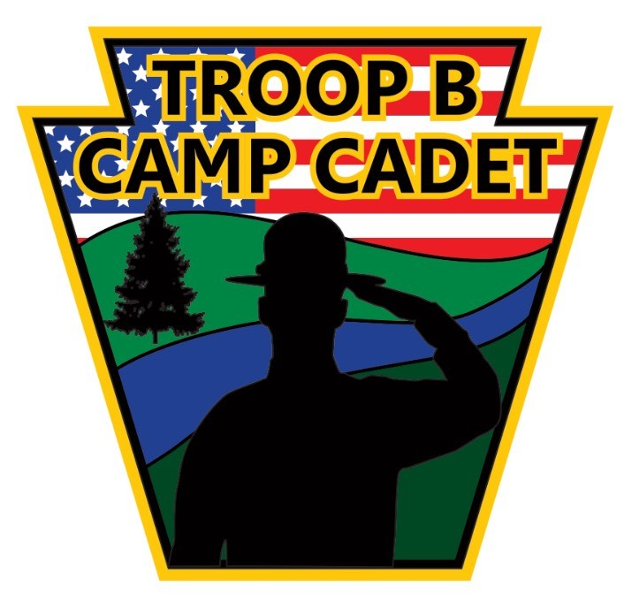

PENNSYLVANIA

STATE POLICE

TROOP B

CAMP CADET

2022

July 31st-August 6th, 2022

Mail completed applications to:

Trooper
Robert Broadwater

1070 Eberly Way

Lemont Furnace, PA 15456

By: May 6, 2022

CAMP CADET
2022
A positive
Experience for Youth

The members of the Troop B of the Pennsylvania State Police are proud to announce the sponsorship of Camp Cadet 2022.
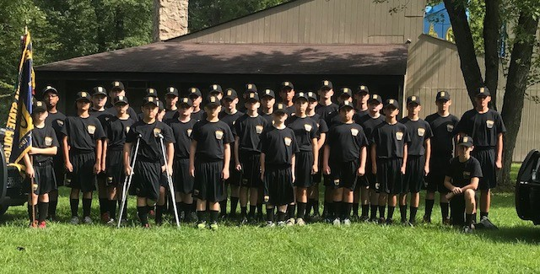

The camp is designed to bring a better
Understanding of law enforcement
Activities to youth while living in an atmosphere of an actual State Police
Training School. Emphasis is placed on personal development skills such as self-discipline, the ability to make new friends, and working as a member of a team.

The weeklong experience will be provided to boys and girls at no expense.

THANK YOU IN ADVANCE!
Camp Cadet operates solely through the generosity of individuals, businesses and civic organizations.
If you would like to support this effort, please make checks payable to:

Troop B Camp Cadet Inc.
1070 Eberly Way
Lemont Furnace, PA 15456

This year's presentations will include appearances by the State Police Motorcycle Unit, a radar demonstration, and a State Police Helicopter landing at the camp for a first-hand look. Members of the following organizations will be present to discuss their duties, answer questions and give demonstrations: Federal Bureau of Investigation, U S Secret Service, Game Commission, Pa State Police Special Emergency Response Team and the Pa Air National Guard. It is a week filled with excitement that will not soon be forgotten.

Each evening after dinner allows time for sporting activities such as softball, basketball, soccer, and volleyball.

The week begins with check-in on Sunday afternoon July 31st and the week is concluded on Saturday, August 6th with a graduation ceremony. Family and friends are welcome to attend.
The camp will be held at Heritage Reservation Boy Scout Camp, located in Fayette County. Directions to the camp and all other necessary information will be provided to applicants selected to attend.

To be eligible for consideration to
Camp Cadet you must be at least
12 years old but not older than 14 by July 31st, 2022; you must be a resident of the area served by Troop B (Fayette, Greene, Washington, and the South Western part of Westmoreland County) and in good physical condition.

Interested girls and boys must Mail applications no later than May 6, 2022 to:
Trooper Robert Broadwater
1070 Eberly Way.
Lemont Furnace, PA 15456

Applicants will be required to attend an interview by a Camp Counselor.

Additional applications may be obtained at the following State Police Stations:
Belle Vernon, Pittsburgh, Uniontown, Washington and Waynesburg.

During the week of Camp. The Camp Cadet Staff reserves the right to dismiss any cadet who violates any of the rules set forth by the Camp Staff.

If you have attended Camp Cadet, you are not eligible to attend a second time.

Visit our website
Pennsylvania State Police-Troop B Camp Cadet

Troop _b_camp_cadet

