QUALIFICATIONS:
Applicants MUST be:
- Resident of Fayette, Greene, Washington, or the South-Western part of Westmoreland County
- In good physical condition
- Boys & Girls Ages 12-14
- Willing to accept military discipline
- Has not attended Troop B Camp Cadet before or any other Camp Cadet Program

MAIL COMPLETED FORM BELOW TO:
Troop B Camp Cadet
PA State Police
1070 Eberly Way
Lemont Furnace, PA 15456
For additional information:
E-mail:
Trooper Kalee Barnhart kabarnhart@pa.gov
Trooper Rocco Gagliardi rogagliard@pa.gov
724-439-7111/
IMPORTANT DATES TO REMEMBER:
Application Due Date: Sunday, May 12, 2023
Interview Dates: Tuesday, June 6, 2023
Wednesday, June 7, 2023
Thursday, June 8, 2023
Location of interviews TBD
Camp Dates: Sunday, July 30, 2023- Saturday, August 5, 2023
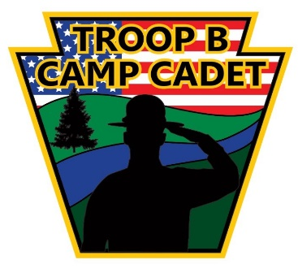
2023 Application Information

INFORMATION: PLEASE READ & KEEP FOR FUTURE REFERENCE
This year the Troop B Pennsylvania State Police Camp Cadet program will be held at the Heritage Reservation camp located at 300 Heritage Rd, Farmington, PA from Sunday, July 30, 2023, through Saturday, August 5, 2023. Only a total of 40 cadets will be selected for appointment and we receive more applications than we can accept. As a result, a Board of Selection will meet after the interviews and they will review all applications. You will be notified as to the results. If you are selected you will be required to pass a physical examination, by your physician, at your own expense.
Please visit our website at https://troopbcampcadet.com for more information about Camp and the activities during the week of Camp. Also, you can follow us on our Instagram at:
Troop _b_camp_cadet
INSTRUCTIONS: PLEASE READ & KEEP FOR FUTURE REFERENCE
This is the application form for the 2023 Troop B Camp Cadet program. If you are interested in attending, please complete the included application. After you have completed the application, detach it, and mail or drop it off at:
PA State Police
1070 Eberly Way Lemont Furnace, PA 15456.

Keep this brochure for future reference.
THE APPLICATION MUST BE RECEIVED ON OR BEFORE Sunday, May 12, 2023
******In addition, you will be required to attend an interview that will be held at multiple Pennsylvania State Police stations.
*** WE WILL CALL TO CONFIRM YOUR INTERVIEW DATE. ***
Due to various fundraisers and generous business and community donations Troop B Camp Cadet is provided to the applicant at NO COST.
The camp focuses on discipline, self-esteem, teamwork, drug and alcohol education, violence prevention and many other issues facing today's youth.

The goal of Camp Cadet is to introduce participants to the diverse criminal justice system and establish a positive relationship with law enforcement personnel.

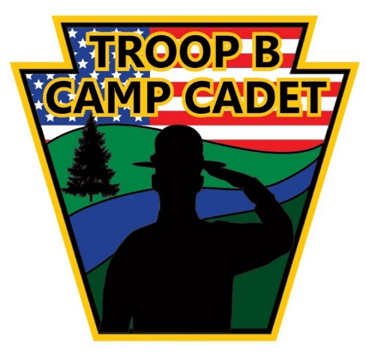

IMPORTANT DATES TO REMEMBER:
Application Due Date: Sunday, May 12, 2023
Interview Dates: Tuesday, June 6, 2023
Wednesday, June 7, 2023
Thursday, June 8, 2023
Location of interviews TBD
Camp Dates: Sunday, July 30, 2023, through Saturday, August 5, 2023
A letter of reference will be required from a teacher, administrator, counselor, employer, or individual with significant knowledge of the applicant. (This will be required at the interview phase)
___________________________________________________________________________________________________________________________________________________________________________________________________________________________________________________________________________________
___________________________________________________________________________________________________________________________________________________________________________________________________________________________________________________________________________________
___________________________________________________________________________________________________________________________________________________________________________________________________________________________________________________________________________________
___________________________________________________________________________________________________________________________________________________________________________________________________________________________________________________________________________________2023 APPLICATION FORM

Detach and Return after completion.

FILL IN ALL SPACES PRIOR TO RETURNING:
Applicant Information:
(Last) _______________________________
(First) _______________________ (Middle) ____________

Address: ___________________________________________________
City: ___________________________Stat: _PA_ Zip _______
County of Residence: _______________________________
Birth date ____/____/______ Age ________ Telephone:_______________________ Sex _____

School Name: _________________________ Grade: ______
T Shirt Size (adult): S M L XL
(youth) S M L XL
Short size (adult): S M L XL
(youth) S M L XL
Have you ever attended camp before? Yes No
Why do you want to attend Camp Cadet? (print your answer on the back of this application. No more than 100 words.)
Parent/Guardian Information:

Name: _____________________________________________ Phone Number: ________________________

E-MAIL: ____________________________________________

Signature of Parent/Guardian: ___________________________________________________
TO BE CONSIDERED THIS FORM MUST BE RECEIVED BY Sunday, May 12, 2023.

Camp Cadet is NOT a discipline camp for troubled children!

