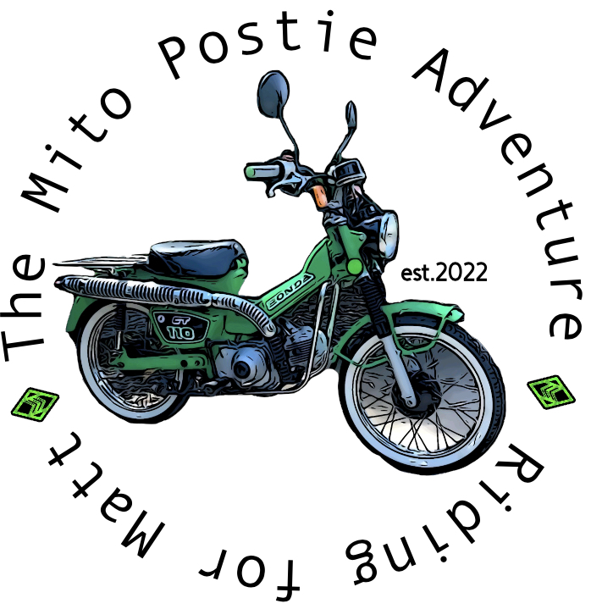
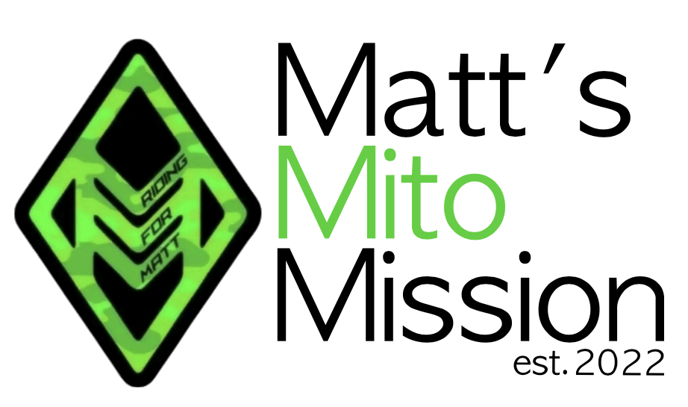

The Mito Postie Adventure
Tweed Heads 2026 - Entry Form
Name
Address
Phone
Email
Shirt Size (men’s sizing)
Motorcycle Licence | YES/NO or Driving ONLY
Emergency Contact Details
Name
Relationship to you
Contact Phone

I have read and agree to the terms and conditions for The Mito Postie Adventure (Matt’s Mito Mission – ABN 76771098291)
Name
Date
Signature

Once completed, please email to mattsmitomission@outlook.com

