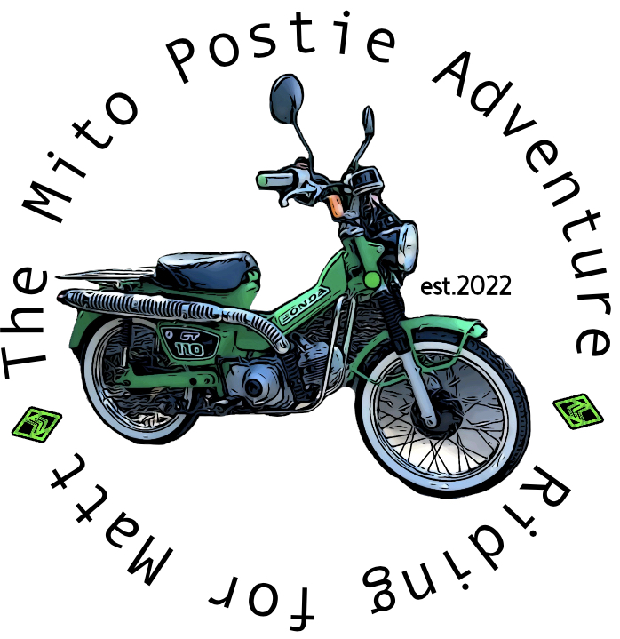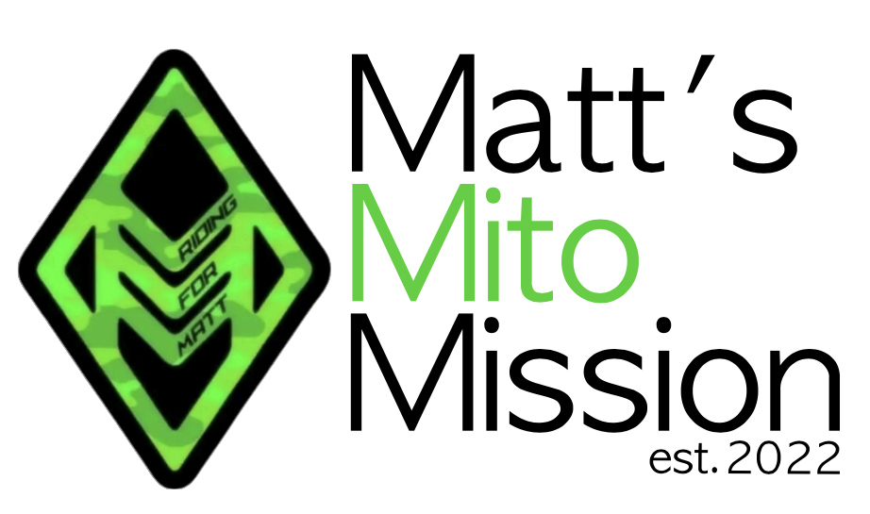

REGISTRATION DETAILS

MITO POSTIE BIKE ADVENTURE 2024

TERMS & CONDITIONS

We have limited the number of entrants to allow for appropriate planning and resourcing of the trip.

Only on receiving full payment of your registration fee and meeting entry criteria (e.g. motorcycle riders licence and evidence ambulance cover/insurance) will your participation be guaranteed.

A registration fee of $180 is required to reserve your position.  
The entry fee is due by 1st March 2025.

WHAT IS PROVIDED?

* A fluorescent vest to be worn when riding.
* Event t-shirt.
* Event cap.
* Facebook posts, website updates
* Daily running sheets with distance and stops via Facebook or Website.
* 2 mechanics.
* Trailer to carry luggage and spare parts.
* Several support vehicles with water and first aid supplies.

WHAT IS NOT PROVIDED?

* A registered Honda motorcycle for the event duration
* Purchase of drinks, souvenirs and personal items.
* Motorcycle gear - We do not provide helmets, riding clothing or motorcycle accessories.
* Camping gear (swag, tent, mattress and sleeping bag).
* Camp sites fees.
* Accommodation fees.
* Fuel
* Food and snacks

CANCELLATIONS, WITHDRAWALS AND REFUNDS

The following refund conditions apply to withdrawal from the event:

* $100 is non-refundable
* No refund after the event has started.

Withdrawal during the event

If you are injured or unwell you will be taken to the nearest doctor or hospital, with your permission, and if this is not possible, emergency services will be contacted. You will need medical clearance from the treating doctor to continue in the event. If you are unable to continue in the event this is considered a withdrawal from the event and you will need to make arrangements to transport yourself from the place of the withdrawal. If you receive medical clearance you can re-join the event but will need to make your own travel arrangements to meet the event.

If you decide for any reason just to withdraw, you will be taken to the nearest town and you will need to make arrangements to transport yourself from the place of the withdrawal. Please refer to the Indemnity and Release Form for further details regarding availability of medical care, expenses, and liability.

The event does not carry passengers in a tour-like arrangement. Participants may be transported in event vehicles for medical care with the permission of the event participant or at the direction of emergency services. Outside of this, event participants may be transported in event vehicles at the discretion of the event director.

Cancellations and Dismissals by The Event Organisers

The Event Organisers (Matt’s Mito Mission ABN: 76771098291) reserve the right to cancel the Adventure. In the event of the Adventure being cancelled for whatever reason the entrant will receive a full refund of all monies paid. The Event Organisers will seek to advise you not less than 28 days prior to the departure date. No further liability by the Mito Postie Bike Adventure its organisers or companies to the entrant with regard to cancellation will arise.

During the event should a participant, in the sole opinion of the Event Organisers or their duly authorised representative, be considered unsuitable to continue, due to engaging in illegal activities (drink driving etc), behaving in a manner considered dangerous to themselves or others, causing inconvenience or annoyance to other participants, ill-health, or bringing disrepute on the Adventure, then the Event Organisers may disqualify the participant without recourse. In such circumstances, the participant will be taken to the nearest town and will need to find their own means of returning home.

Once the Adventure has started there will be no refunds of any description regardless of the cause of withdrawal. No further liability by the Mito Postie Bike Adventure, its organisers or companies to the entrant with regard to cancellation will arise.

CHANGES

The Event Organisers do not accept liability arising out of changes to itineraries, or any other matters relating to a program, due to factors out of its control. These factors include weather, road conditions, delayed flights etc. Any expenses incurred by the participant arising out of these changes are for their own account. All information relating to the Event route is to be considered as a guide only and may be subject to change.

INSURANCE

The Mito Postie Bike Adventure is not a competition but rather a **motorcycle holiday with a charity focus**.

All bikes must be registered and carry compulsory third party insurance (CTP). CTP insurance does not cover you personally but covers any other person you might injure whilst riding the event motorcycle.

**We provide no accident insurance for your personal injuries.**

To minimise your risks, we require all entrants to purchase personal travel insurance or ambulance cover for the period of the event which may cover some the expenses should you injure yourself and be unable to complete the event or unable to return to employment. Please read the Product disclosure statement (PDS) supplied by the insurer you chose to be clear about what you are covered for. As the operator of the Event motorcycle you may want to take-out Third-party property insurance should you cause damage to the property of others in an accident.

RIDER HELMETS

**Riders are advised to wear a helmet with an integrated chin guard**. This can be a regular road helmet or moto-cross helmet. If you use a flip-face helmet the chin guard must be engaged at all times when riding. **Our experience has highlighted that open-face helmets provide insufficient protection from severe facial injuries in an accident**.

RISKS AND WARNING

Motorcycle riding is a potentially dangerous activity and riders have been injured when they fell from their bikes resulting in injuries from bruising to broken bones requiring hospitalisation.

If you have not ridden for a long time, we STRONGLY recommend a Stay Upright, skills refresher course etc. in addition to unsealed-road riding practice and/or training. The unsealed roads we will travel range from fast, well- graded surfaces to soft sandy soil roads, and rocky roads with unpredictable road conditions.

PERSONAL SPONSORSHIP

The Mito Postie Bike Adventure (Matt’s Mito Mission ABN: 76771098291) is not a charity organisation, but rather a motorcycle adventure company that raises money for the Mito Medical Network. Personal sponsorship arrangements are a contract between you and your sponsor. You should not represent yourself as being from the Mito Postie Bike Adventure, and therefore should not use or modify the Mito Postie Bike Adventure name or symbols to represent yourself or in formal correspondence. You can indicate to sponsors that you are taking part in the event and can use and reference information direct and unchanged from our website.