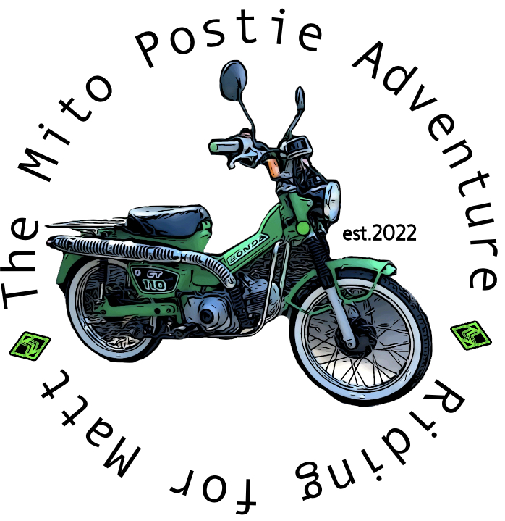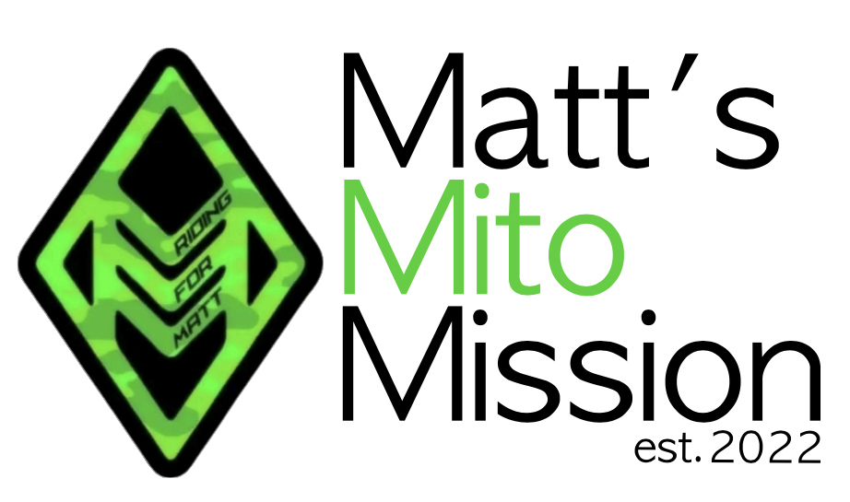

# The Mito Postie Adventure

Broken Hill 2025 - Entry Form

|  |  |
| --- | --- |
| Name |  |
| Address |  |
| Phone |  |
| Email |  |
| Shirt Size (men’s sizing) |  |
| Motorcycle Licence | YES/NO or Driving ONLY |
| Emergency Contact Details | |
| Name |  |
| Relationship to you |  |
| Contact Phone |  |

I have read and agree to the terms and conditions for The Mito Postie Adventure (Matt’s Mito Mission – ABN 76771098291)

|  |  |
| --- | --- |
| Name |  |
| Date |  |
| Signature |  |

Once completed, please email to [mattsmitomission@outlook.com](mailto:mattsmitomission@outlook.com?subject=Entry%20form)