**Lewis Family Farm**

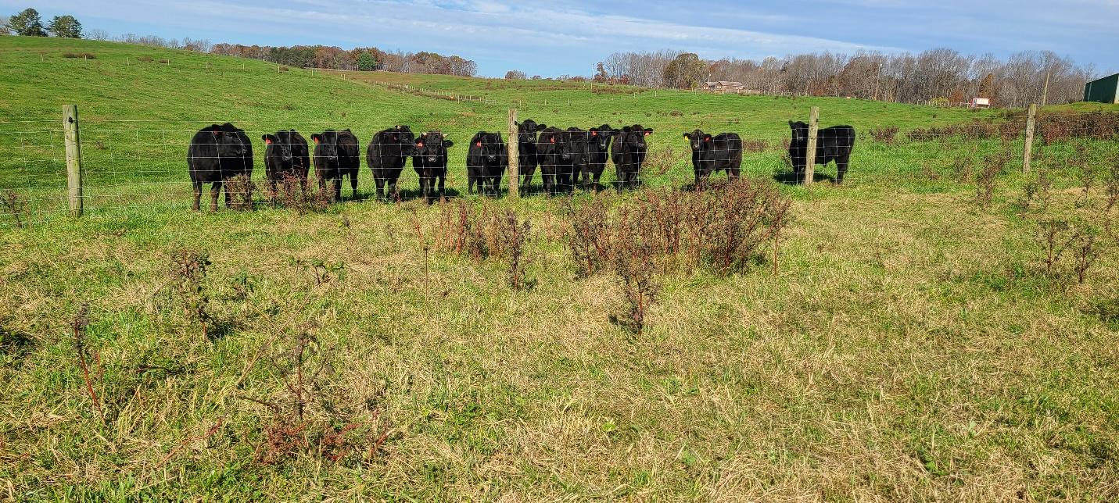**Fresh Frozen Prime Beef**

Lewis Family Farm, located in Appomattox, Virginia, is a family-owned and operated farm specializing in a Wagyu/Angus breed of cattle that is grain-finished to offer customers a prime grade beef that is farm-raised and locally produced. We certify that our animals are well-cared for and that our farming practices promote the well-being of both the animals and the environment. Our cattle are raised in a natural and humane way, with access to clean water and a healthy diet that includes grass and a proprietary mix of natural grains and minerals. Animals selected for harvest never receive any hormones, steroids, or antibiotics.

Through our efforts, we produce a unique blend of cattle that offers the rich quality and tenderness of Wagyu beef, combined with the flavor and affordability of Angus beef. This means you can have a variety of delicious, high-quality beef at your fingertips, without having to run to the store or pay premium prices for restaurant-quality beef. Beef is sold in a variety of portions; 1/8, 1/4, and 1/2, which offers a selection of custom cuts including steaks, roasts, ground burgers, and select cuts not commonly found in grocery stores. This is a great value to beef lovers, families, and adventurous home cooks. Lewis Family Farm beef is fresh-frozen and vacuum-sealed, making it easy to stock up and enjoy at any time.

We help to customize each order to your cooking preferences and coordinate with our buyers to make our sale process simple. Delivery is included to local customers.

**For more information and pricing please contact:**

|  |  |  |
| --- | --- | --- |
|  | **LEWISFAMILYFARMAPPOMATTOXVA.COM** |  |
|  | **LewisFamilyFarm-Appomattox, VA** |  |
|  | **LewisFamilyFarmAppomattoxVA@Gmail.com** |  |
| |  | | --- | | **Robert Lewis** | | **(434) 473-1273** | | **Call or Text** | |  | | --- | | **Josh Lewis** | | **(434) 660-1975** | |

**What is in a 1/4th of beef portion?**

|  |  |  |
| --- | --- | --- |
| Cut Type | Estimated Number of Packages | Estimated Count for Each Package |
| **Arm Roast** | 1 | 1 |
| **Bottom Round Roast** | 1 | 1 |
| **Brisket** | 1 | 1 |
| **Burger (Ground)** | 40 | 1 lb. package |
| **Burger (Patties)** | 9-10 | 4 (1/3 lb. patties) |
| **Chuck Steaks** | 3 | 1-2 |
| **Eye of Round Roast** | 1 | 1 |
| **Filets** | 3 | 2 |
| **Flank Steak** | 1 | 2 |
| **Flat Iron Steak** | 1 | 1 |
| **NY Strips** | 4 | 1-2 |
| **Ribeyes** | 3-4 | 1-2 |
| **Ribs** | 2 | 1 |
| **Shank Steaks** | 4 | 2-3 |
| **Sirloin Steaks** | 3 | 1 |
| **Sirloin Tip Roast** | 1 | 1 |
| **Skirt Steak** | 1 | 1 |
| **Stew Meat** | 5 | 1 lb. package |
| **Top Round Steak** | 2 | 2-4 |
| **Top Rump Steak** | 4 | 2 |

*Orders of ¼ or larger can be customized if desired.

Our average yield per ¼ beef averages ~120 lbs. of steak, roast, ground burger and other miscellaneous cuts. Organ meats include: Tongue, heart, liver, kidney, and bones are offered on a first come, first serve basis and not factored into the final yield upon request.

**Prices:**

**$5.85 per lb. on the carcass weight. $100 deposit required per order- remaining balance is collected on delivery.**

*This price includes the handling, processing, packaging, and delivery to local customers, extended delivery range for a small fee.

Price is finalized once processing begins.

Ex: Carcass weight is 800lbs

1000 x $5.85= $5850 $4680 x (1/4th) =$1462

Balance would be $1462 for a 1/4th portion ($100 deposit & $1362collected on delivery)