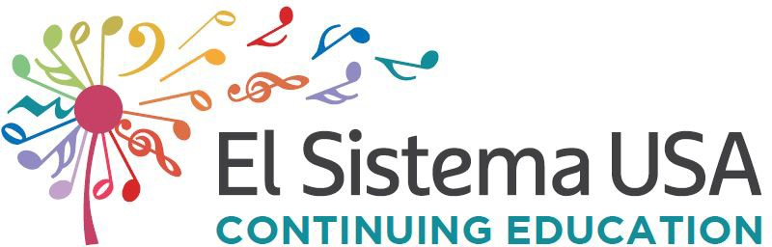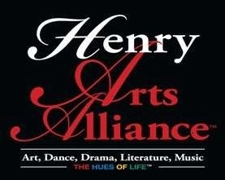

JOB TITLE:
Job Description
Youth Orchestra United Teaching Artist

ORGANIZATION: Henry for Music, Inc. / Henry Arts Alliance www.henryformusic.org

REPORTS TO: Program Director

SALARY RANGE: Compensation: commensurate with experience paid on an hourly basis

JOB SUMMARY:
The Youth Orchestra United Teaching Artist is a Teaching Artist responsible for group instruction, private lessons, and assisting in curriculum and planning. Henry for Music, Inc. is scheduled for the new upcoming academic year beginning in September 2019-2020. Classes for Youth Orchestra United occur Tuesday-Thursday from 5:00 p.m. to 7:00 p.m. Classes will not be in session on School District holidays or teacher workdays/staff development days. She or he will ensure that each student receives excellent instrumental instruction, aid in the development of curriculum that supports the goals of the program, an El Sistema inspired music education program, and the overall mission of Henry for Music. Modeled after El Sistema in Venezuela, Youth Orchetra United, currently in residence at Recreation Centers of Henry County Georgia, provides top-quality, comprehensive group music instruction for children in low socio-economic circumstances.

JOB DUTIES AND RESPONSIBILITIES:

Teaching
- Instruct group and private lessons
- Assist in group lessons
- Develop a daily lesson plan that challenges students and encourages creativity
- Maintain a healthy learning environment
- Collaborate with other faculty and the director to develop curriculum and pedagogy which falls within the ideals of El Sistema, and to set learning and performance benchmarks that are shared by the entire faculty
- Inspire students to develop their musicianship, self-confidence, focus, and ability

Responsibilities
- Keep an accurate log of student attendance and each group or private lesson taught
- Collaborate in managing inventory, maintenance and upkeep of Henry for Music, Inc.
instruments.
- Assist in recruitment and retention strategies
- Collaborate in organizing field trips and concerts for students
- Assist in student supervision, paperwork, setup, and travel for all student field trips and concerts
- Work with assessment tools to ensure continual progress, success, and growth of the program overall

Other
- Serve as the highest example of musical achievement and personal standards.
- Meet weekly with the Youth Orchestra United Director or your direct supervisor
- Attend all student field trips and concerts

- Assist with helping students to their appropriate rooms after daily arrival to campus
- Cultivate and nurture a healthy working relationship with all teachers and staff
- Establish and maintain open channels of communication between faculty, students, families, and the community.
- Attend training as requested by Henry for Music, Inc.

REQUIREMENTS: The successful candidate will have some knowledge of the philosophy and practices behind El Sistema. A bachelor’s in Music or Music Education is preferred but not required if equivalent experience can be shown. In addition, each candidate needs to be comfortable creating, supporting, and maintaining a structured and disciplined classroom environment. This position also requires the following qualities:

  - Personal commitment to social change through music and a love of the arts
  - Respect for children from all backgrounds and cultures
  - Exceptional musicianship
  - Confidence and energy
  - Experience teaching in private and group settings
  - Excellent classroom management skills
  - Solid knowledge of string pedagogy with certification preferred
  - Proficiency in Spanish a plus
  - Openness to evaluation and the learning process
  - Reliable communication through email, phone, and text
  - Willingness to adapt, be flexible, and above all have a sense of humor
  - Reliable transportation

EMPLOYMENT DETAILS: This is a temporary, part-time non-exempt position that pays on an hourly basis. The employment term runs from September through May and coincides with the academic calendar. Compensation is commensurate with experience paid on an hourly basis. Candidate must pass a criminal background check to be considered.

APPLICATION PROCESS:
Please submit ALL of the following materials:

    - Resume/Bio
    - Job History
    - References (3) to Director, henryformusic@gmail.com, 770-342-9045
Henry for Music, Inc.

[The Youth Orchestra United provides a rich offering of orchestral music, education and performance opportunities for young people throughout our geographic region.

