INSTRUMENT REQUEST FORM www.HenryforMusic.org
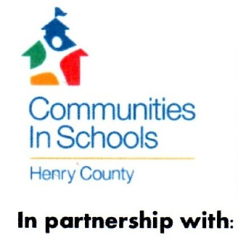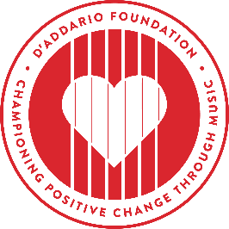
Name: _First:____________________Last:______________________________
Email: ___________________________________________________________
Phone:_________________________________
Instrument Requested:______________________________________________
Student Name: First ____________________ Last________________________
Name of Your School/Organization: ___________________________________
School/Organization Website: ________________________________________
Principal/Director Name:________________________ Email:_________________
Music Teacher Name: Email:__________________
City:__________________________ State: _____________
Additional Information: ______________________________________________
HenryforMusic@gmail.com HENRY FOR MUSIC HELPS:
1) children who cannot participate because of lack of funding.
2) Social workers who have young clients who would benefit from learning music.
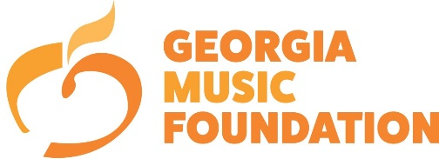
3) Music Teachers at innovative after-school music programs.

