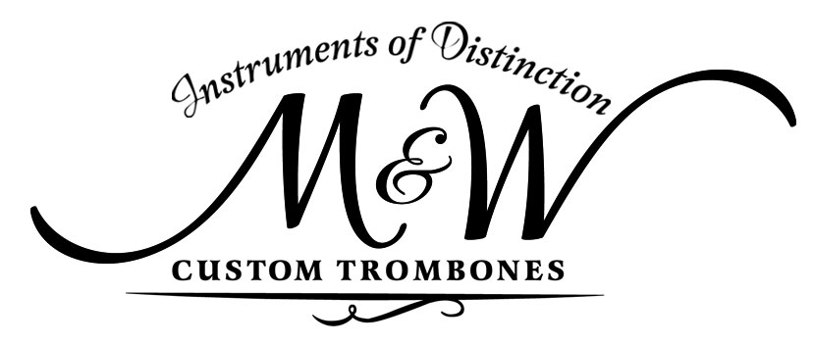**So, you're looking to buy a new trombone...where do you begin?**

*We understand that finding the best instrument for your performance needs is of utmost importance. We would like to share some suggestions and considerations that may help guide you during your search for the trombone that works best for YOU.*

* When testing an instrument, **begin by playing familiar and comfortable music-so you can play in a relaxed manner**. Bring sheet music with you, if you'd like! Play in the comfortable mid-range to get an idea of how the trombone responds. Once that is established, then begin to extend the range.
* **Avoid making quick judgments-give yourself time**. It seems obvious, but it takes more than a few seconds to realize if a particular instrument is a good fit. Remember to give yourself time to check multiple areas, including soft dynamics, full sounds, response, articulation, range, and tone.
* **Focus on sound, not "feel".** Remember that you are trying a different instrument than the one you have previously played. A different feel can be expected. Know that if the trombone "feels" different at first, with time your body can become comfortable to the change. Conversely, a player cannot change the fundamental tone/response of the trombone. If you are getting that great sound you desire, that is most likely the instrument on which to focus.
* **When play testing instruments, go in with an open mind.** Try not to have pre-conceived ideas of what you must have when considering alloy, bell construction, material, or particular instrument because [insert name] plays one. As you test instruments, remember to listen with an open ear and mind. What you may have originally thought you wanted or needed, might not actually turn out to be your optimal fit. The goal is to make sure you end up with the best instrument for YOU specifically.
* **Let the instrument freely play.**  Take note of the ease (or difficulty) of response and how it works with you. Avoid trying to force the instrument to do what you want. If you're used to "making it happen" with your current instrument, you may need to back off a bit to realize what the trombone can do. You may find that you don't have to work so hard in order to get the result you desire. Ideally, the instrument should allow you to play easily and freely, allowing your musicianship to shine. without fighting to "make it work".
* **Be careful of "gimmicks".** If you are told that "X" is going to take care of your articulation issues or range, etc., understand that if a horn is built to compensate or take care of an issue for you, other areas of performance will be compromised. It is in your best interest to look for an instrument that is fundamentally sound in all areas.
* **Remember your mouthpiece**. Please, remember your mouthpiece. 😊

We hope that this short list of suggestions to consider is helpful and provides some guidance while searching for a trombone that works best for you. If you choose to check out M&W trombones, we would be honored to help guide you in finding the best trombone for you and your performance needs.

~Michael Mc Lemore & Matthew Walker, M&W Custom Trombones