*Reification Project, LLC - Marketing Data*

THE REIFICATION of ENERGY is a visual media special effect created in postproduction to enhance the viewer experience by making visible, invisible energy and its interactions with the visible. It is applicable to all digital visual media, where it can target any market, anywhere.

The worldwide visual media market exceeds one trillion dollars, and is expanding.

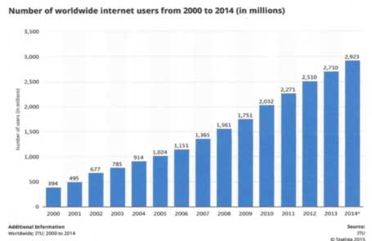

Reification of Energy’s emotional impact will be particularly effective in movies and advertising.

Reification’s effectiveness in communicating emotions will create demand. Ease of implementation and low cost make it practical.

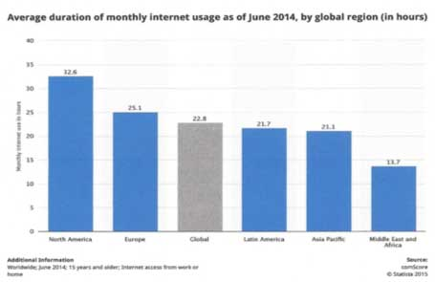World human population is 7,350,000,000; North America is 567,915,000. Internet users globally are 2,923,000,000; North Americas are 326,000,000. The average global monthly use is 22.8 hours per user; and North American is 32.6 hours. Global Internet usage is 66,644,400,000 person hours per month, and 10,627,600,000 in North America. The Internet is the largest, fastest growing, wide open market in the world. The Reification of Energy is tailor made for the Internet.

Assuming users see 10 adds an hour, worldwide users view 666,444,000,000 adds monthly; and North Americans view 106,276,000,000 adds monthly.

Global Internet users see 7,997,328,000 adds annually, 666,444,000 monthly, 153,373,414 weekly, 21,910,488 daily, 912,937 hourly, 15,216 a minute, and 255 adds per-second. **Now that is a market!**

The Reification of Energy effect will enhance the emotional impact of any product advertising, in any market. Internet advertisers will be globally make billions of memorable, high impact statements each year. **I ask, “How many advertisers will leave this opportunity on the table?”**

**WHY IS THE REIFICATION OF ENERGY SO POWERFUL?**

Through the introduction and manipulation of color, the Reification of Energy can give the writer, director, and special effects artist a pallet, a paintbrush, and creative license to direct the viewer’s perception of a scene, as much, or as little, as they choose, and have THE ABILITY TO TELL A STORY WITHIN A STORY.

The Reification of Energy captures a viewer’s attention with color and motion to evoke an emotional response. Using color makes it effective in any culture. With sustained exposure, the Reification of Energy special effect will become a learned language of color, conveying feelings and emotions in a way not previously available to the producer or viewer.  When a viewer sees an add, with the Reification of Energy effect, their mind bonds the emotion with the subject of the add. When the same person sees a still picture from that original add, the still picture triggers the bonded response, bringing back the memory of the video add and reinforcing the impact of the original video add. Thus, a still picture add provides a similar impact to the complete video add. Now the reification effect is giving that additional emotional response to the endless stream of still pictures on the Internet and in magazines, making it an extremely powerful marketing tool.

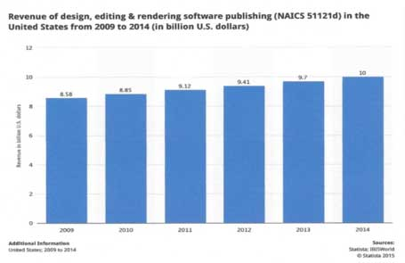

**The target market for Reification Project, LLC is digital visual media editing software companies.** This chart shows the annual U.S. market for editing and rendering software is $10,000,000,000 and growing. Total World market is over $15,000,000,000 annually and growing.

Expectations of advertisers and viewers will compel video editing software developers to incorporate Reification of Energy into their products.

The Reification of Energy patent, (Issued 30 August 2016), is to be licensed to Reification Project, LLC. The patent’s substance is solid, and the claims are strong.

NCP’s goal is to joint venture with software developers for the creation and editing of the Reification of Energy. The joint venture may then license its editing software to others.

The NCP and their joint venture partners will earn more and more of the $15,000,000,000 + a year market as demand grows for the Reification of Energy each year, and as new software is developed and licensed, or older software is upgraded with plug-ins.