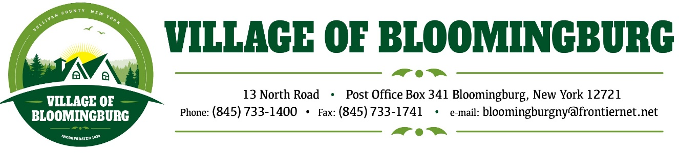

BOARD OF TRUSTEES
Regular Meeting
Monday January 6, 2025

TENATIVE AGENDA

Pledge of Allegiance

Call To Order

Regular Meeting
- Approval of Dec. Minuets
- Approval of Dec. Bills
- Tax Collection Report

Discussion
- Debit Card for Village Purchase.
- Increases for Permit Fees
- Purchased a scanner/ Printer for build Dept.
- Sewer Contribution Fee Changes
- Except online payments through QuickBooks for Permit Fee payments, Contribution Payments
etc.
- Starting the year 2025 to start a number system for Resolutions (Example: 01-25)
- Appoint Russell Wood Jr. For Assistant Mayor
- Appoint Moshe Gancz ZBA Chairman
- Budget Modification for Russell Wood Jr. $25,400.00

Mayors Report.
Add Multi Family in R1
Public Comments.
Please state you name and address
(3 minutes for each individual)

Motion to Adjourn

