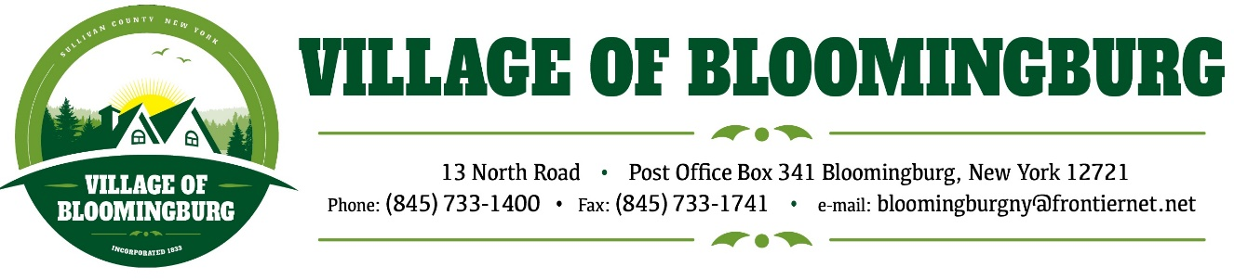

BOARD OF TRUSTEES
Regular Meeting
Thursday August 8, 2024

TENATIVE AGENDA

Pledge of Allegiance

Call to order

Reopen Public Hearing:
- Amendment of the PUDR for Chestnut Ridge

Open for Discussion:
- Village of Bloomingburg to change banks from Catskill Hudson to Northeast Community Bank.
  - List of requirements provided
  - Resolution needed
- Garbage Contract
- New Road Name Pozna CT. (37-41 Winterton subdivision)
- 2 President Way both Unit 101 and 102 requesting a payment plan on permit fees, sewer and park fees. (e-mail provided)

Meeting Minuets:
Approval of June 10, 2024, Minutes
Approval of July 8, 2024, Minuets

Mayors Report.

Public Comments.
Please state you name and address
(3 minutes for each individual)

Motion to Adjourn

