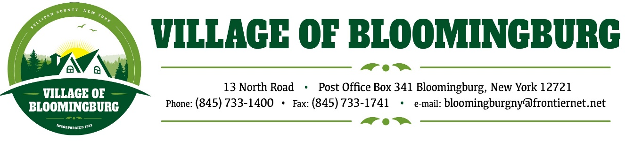

BOARD OF TRUSTEES
Regular Meeting
Monday September 9,2024

TENATIVE AGENDA

Pledge of Allegiance

Call to order

Speaker to present to apply for a Grant for the Village of Bloomingburg
- Looking for the Boards Approval

Open for Discussion:
- Purchasing a server for the Village Data System

Meeting Minuets:
Approval of Aug. 8, 2024, Minutes
Approval of Sept. 9, 2024, Minuets
Bills:
Approve August 2024 Bills

Mayors Report.

Public Comments.
Please state you name and address
(3 minutes for each individual)

Motion to Adjourn

