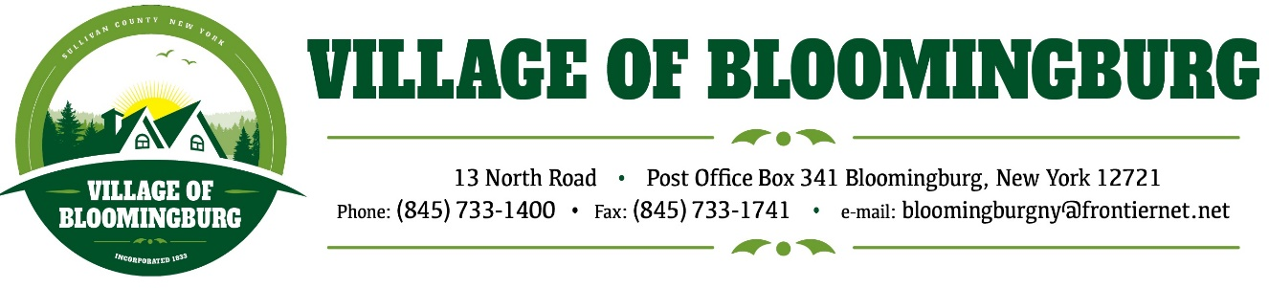

BOARD OF TRUSTEES
Regular Meeting
Monday February 10, 2025

TENATIVE AGENDA

Pledge of Allegiance

Call To Order

Regular Meeting
- Approval of January Minuets
- Approval of January Bills
- Tax Collection Report

Public Hearing
- Proposed Local Law #1 Amending the Village Code to Allow Multi-Family Housing as a Special Use in the R1 Zoning District

Discussion
- Pricing on Scanner/ Printer for Building/ Zoning Dept.

Mayors Report.

Public Comments.
Please state you name and address
(3 minutes for each individual)

Motion to Adjourn

