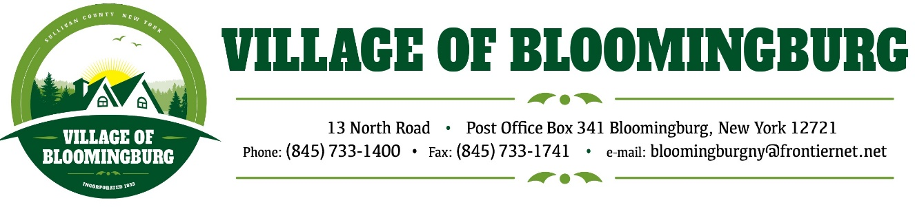

BOARD OF TRUSTEES
Regular Meeting
Monday December 9, 2024

TENATIVE AGENDA

Pledge of Allegiance

Call To Order

Regular Meeting
- Approval of Nov. Minuets
- Approval of Nov. Bills

Discussion
- Proposal for Ray S. Pantel on Traffic Light at Main St. & Winterton Road.
- Pro Housing Resolution
- Repay Sewer Capital Improvement Fund
- Treasure will be transferring the General Funds Saving into General Checking so that we can write a check to deposit it into the new savings account at North East Community Bank.

Mayors Report.
- All accounts have been opened at North East Community Bank.

Public Comments.
Please state you name and address
(3 minutes for each individual)

Motion to Adjourn

