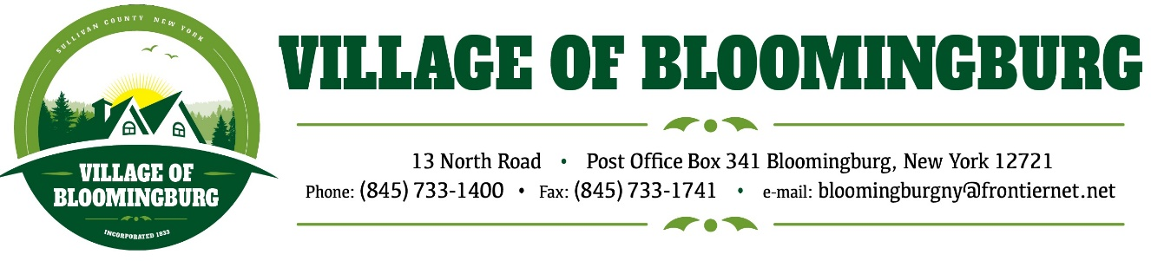

BOARD OF TRUSTEES
Regular Meeting
May 12, 2025

TENATIVE AGENDA

Pledge of Allegiance

Call To Order

Regular Meeting
- Approval of March and April Minuets
- Approval of April Bills
- Open Public Hearing for the Amending the Village Code to Allow Multi-Family Housing as a special Use in the R1 Zoning District

Discussion
- Planning and Zoning request for quote on software from IPS for “Planning and Zoning”
- Tax Collection Report
- IPS Building & Code Enforcement update

Mayors Report.

Sewer Plant Report

Public Comments.
Please state you name and address
(3 minutes for each individual)

Motion to Adjourn

