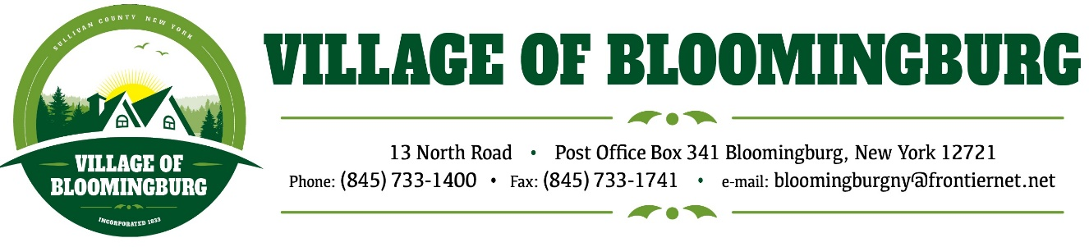

BOARD OF TRUSTEES
Regular Meeting
Monday, February 12, 2024

TENATIVE AGENDA

Call to Order/ Pledge of Allegiance

Regular Meeting

- Approval of January 8, 2024 Minutes
- Approval of January bills.
- Mayors Report.
- Public Comments. (3 minutes for each individual)

Motion to Adjourn

