**How To Install Supremacy on Kodi – Easy to Follow Guide**

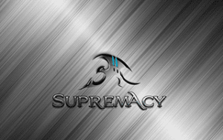

Use the step-by-step guide below to learn how to install Supremacy on Kodi.

The Supremacy add-on is full of content with Movies, TV Shows, Live Television, and so much more. Because it has tons of content and endless streams, Supremacy has been chosen as one of the [Best Kodi Add-Ons](https://troypoint.com/best-kodi-addons/) by many users.

Kodi doesn’t do much without the popular 3rd party addons that provide free movies, TV shows, live channels, sports and more.

**Step 1**

Open Kodi

From the main menu, Click the Settings icon  Kodi Settings Icon

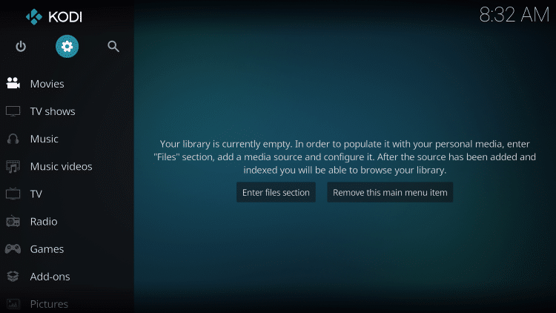

Click System settings

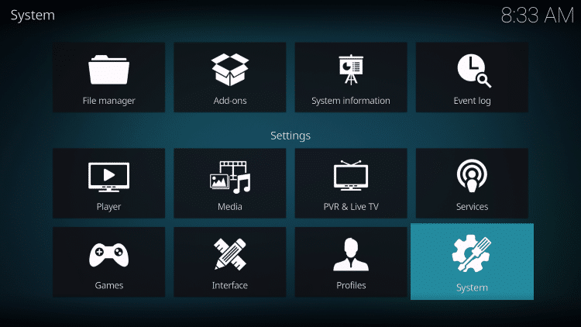

Turn on Unknown Sources

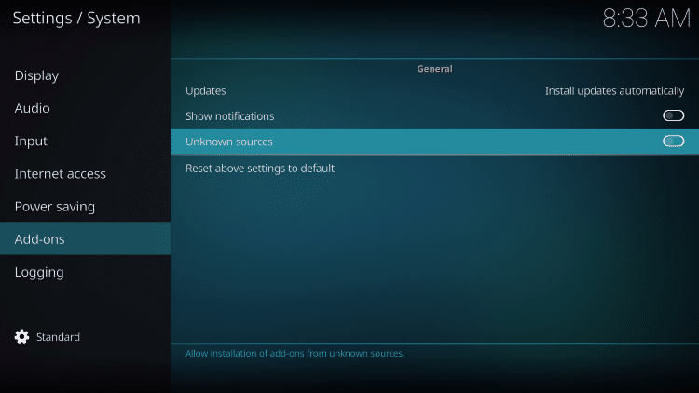

Return to System Page

**Step 2**

Open File Manager

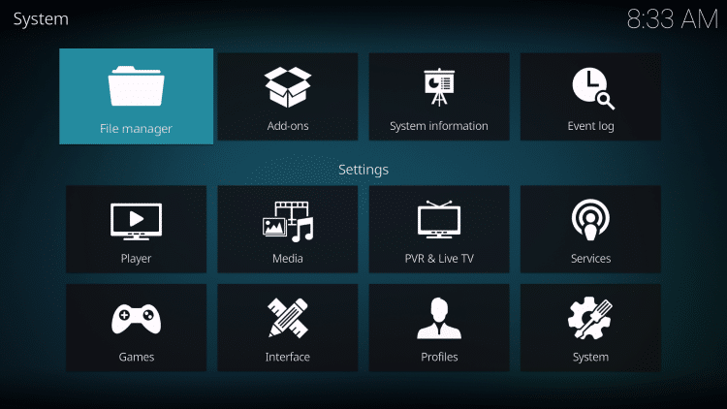

Click Add source, <None>, and type the following URL: http://supremacy.org.uk/zip/repo/

Make sure url is typed exactly as shown above or the file will not download

Enter a name for the media source by typing supremacy or other name of your choice

Click OK

Return to Kodi home-screen and Select Add-Ons

**Step 3**

Choose “open box” icon at top left side of page under Add-ons heading -

Install Kodi Addon

Click Install from zip file

Choose supremacy or other name you assigned the media source in previous step

Click repository.supremacy-x.x

Supremacy Add-On message will appear in corner of screen

**Step 4**

After message appears, click Install from Repository

Click Supremacy Repo - Video Add-Ons - Supremacy - Install

Wait for Supremacy add-on installed message to appear

The add-on is now installed!

**Step 5**

Click back on your remote to access File Manager

Kodi Supremacy Details & Description

Supremacy is great for Kodi users looking to host all their streaming needs with just one add-on. Due to its widespread amount of Categories, there is no shortage of items for viewing.

Categories included in Supremacy are: 24/7 Shows, Scraper Movies, Scarper Tv Shows, Freeview, Sport Replays, Sky Channels, 3D Films, 4K Movies, Live Tv, Kid’s Tv, Kid’s Movies, New Releases, Real Debrid Movies, Plex Scraper, TVshows, Movies, Movie Genres, Movies A to Z, Supremacy Box Set’s, Sky Movies, Sport, Supremacy Karaoke, Live Sport, Documentaries, Christmas, Youtube, and Testing lab.

As you can see, Supremacy is full of options to choose from. I have found that all streams in this add-on work exceptionally well. With Sections for 4K Movies and 3D films, high definition streaming will not be an issue.

One of the best things Supremacy provides is the automatic play feature. When using the provided Movies or TV Shows Category there is no list of stream options provided. Instead, after making your selection, the video will begin playing once you click on it. If you would still like to see your streaming choices, you can use the Scraper Movies/Scraper Tv Shows Sections.

You can install Kodi and the Supremacy add-on on Amazon’s [Firestick](https://www.amazon.com/Amazon-Fire-TV-Stick-With-Alexa-Voice-Remote-Streaming-Media-Player/dp/B00ZV9RDKK) and [Fire TV](https://www.amazon.com/dp/B01N32NCPM/ref=fs_ods_smp_ne) which are the most popular Kodi streaming devices available today.

Protect Yourself While Streaming CAUTION - YOUR STREAMING ACTIVITY IS BEING LOGGED   
  
We do not verify the legality or security of any applications or services covered on this Website.   
  
You should always use a VPN in conjunction with free or low-cost streaming solutions to protect your identity and security.   
  
Your Internet Service provider, government, app/addon developers, and hackers can log your online activity through your visible IP Address and location.   
  
A VPN will encrypt your connection to the Internet and mask your IP address so you will remain 100% anonymous while online.   
  
We recommend IPVanish VPN due to their blazing fast speeds and zero-log policy.