How To Remove a Build From Kodi Clearing Out Old Data
Kodi is a great media center to have with lots of Addon and Builds that can be installed.
The one downside is these plugins can go down or stop working cluttering up Kodi from working well.
A simple way to fix this is to start over and clear out a Build or any other old left over information.
Uninstalling and reinstalling Kodi can work but sometimes information is picked up again which can cause issues.
There is a nice Add-on called Fresh Start which clears / wipes all the old data from Kodi giving a factory default install.
If you install a lot of Builds it is a good Addon to download and have on hand and quickly install from internal storage when needed.
If you have a Build installed it is much easier to change the Skin back to the default Kodi skin Estuary to follow the instructions below.
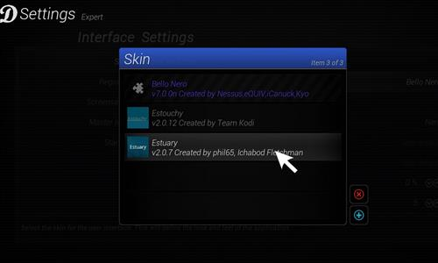
Each build will be different but the Skin options are usually found under Settings–>Interface Settings.
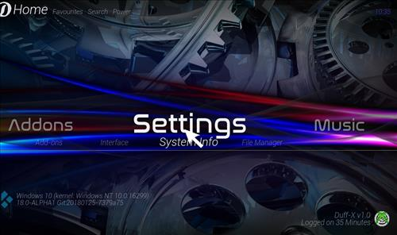
Using a VPN with Kodi is always recommended for privacy and security. Try IPVanish which is Kodi friendly, has no logs, and unlimited bandwidth.
How To Remove a Build From Kodi Clearing Out Old Data
Step 1) From home screen go to Settings
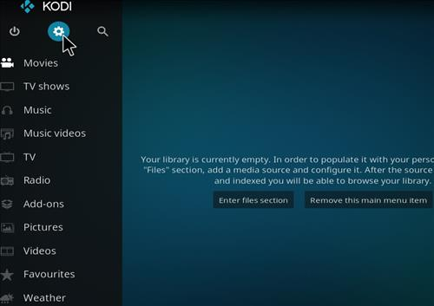
Step 2) Click File Manager
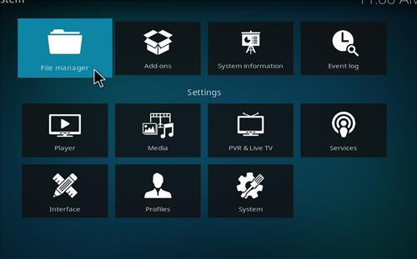
Step 3) Click Add Source
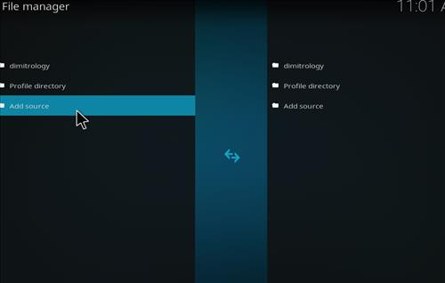
Step 4) Click None
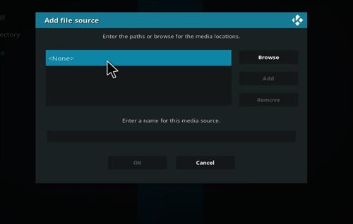
Step 5) Enter the following address: http://dimitrology.com/repo/
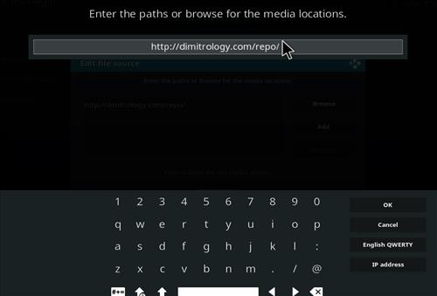
Step 6) Name it Dimitrology
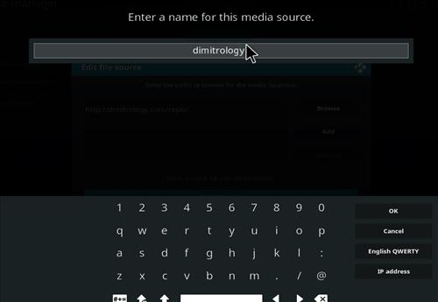
Step 7) The boxes should match the picture below
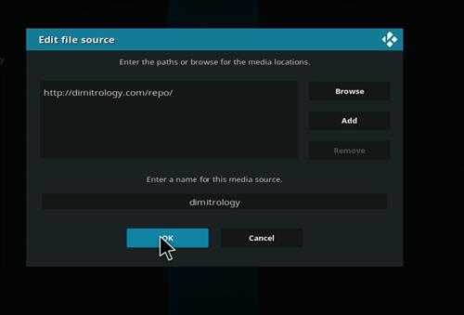
Step 8) Go back to Home screen and click add-ons
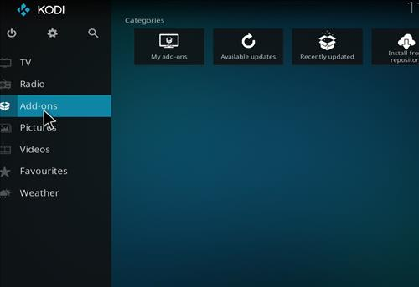
Step 9) Click the add-on browser from the top left
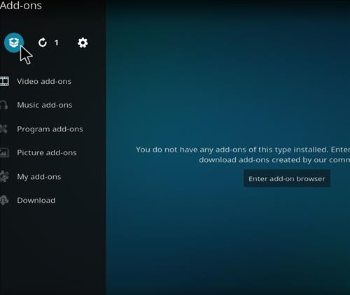
Step 10) Click Install from zip file
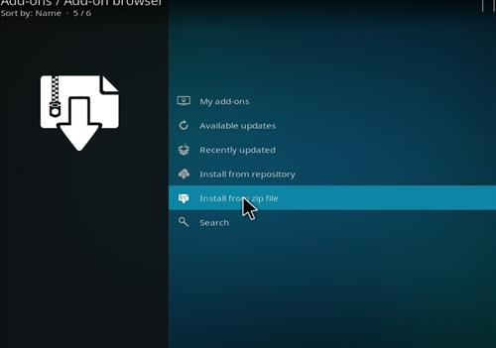
Step 11)A box will open click dimitrology
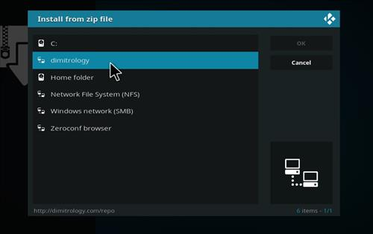
Step 12) Click plugin.video .freshstart-1.0.5.zip
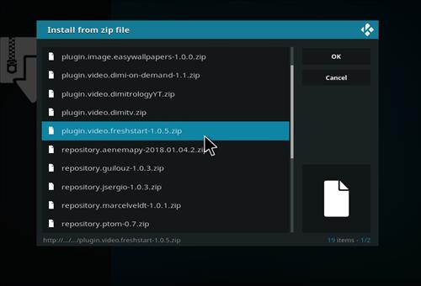
Step 13) Wait for the top right to popup Fresh Start Add-on Installed
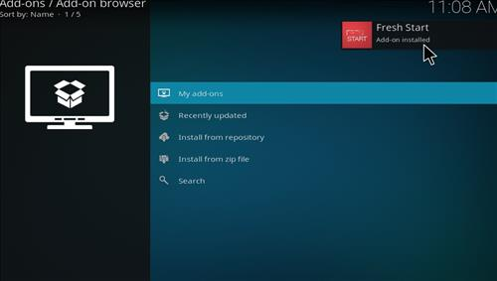
Step 14) Go back to Home screen and click Add-ons
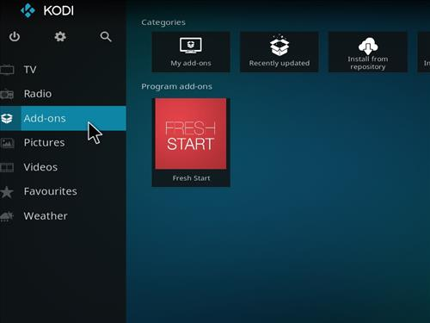
Step 15) Click Program Add-ons
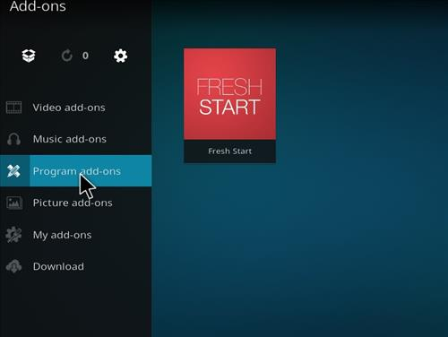
Step 16) Click Fresh Start
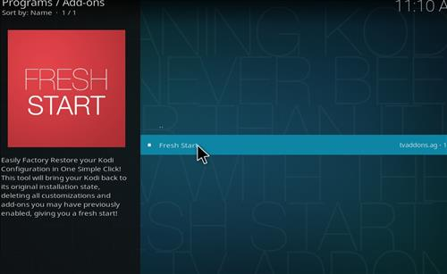
Step 17) Click Yes
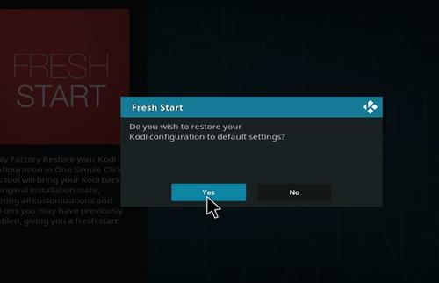
Step 18) Click OK
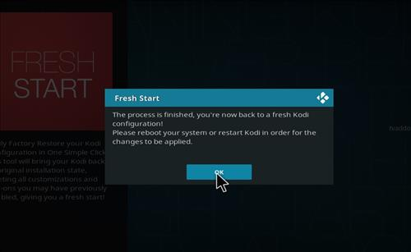
Step 19) Click Done
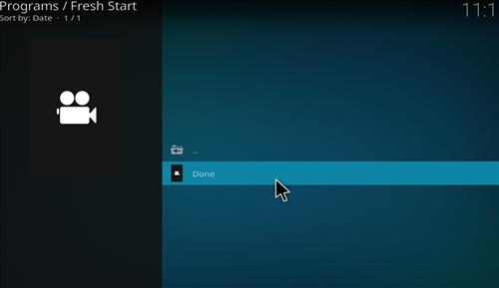
Manual Download and Install
The above method is the most common way to install an addon, but if it does not work for you it can also be manually downloaded and installed.
Basically the file is downloaded and installed from internal storage.
Where the file is stored after downloading depends on the hardware being used.
For Android TV box users it will be located in Download.
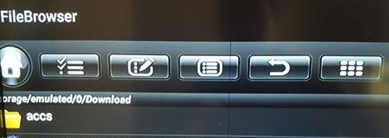
Windows users will need to copy the file from the Download Folder to the C: Drive. Kodi can not see the Desktop on a Windows PC.
Step 1. Open a Browser and go to http://dimitrology.com/repo/
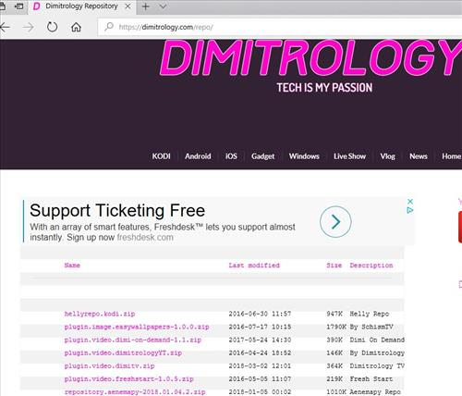
Step 2. Click on and download plugin.video.freshstart-1.0.5.zip
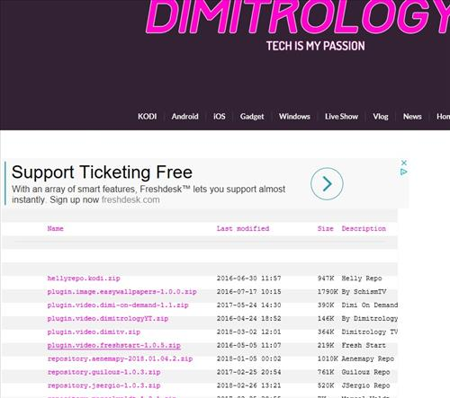
Step 3. Open Kodi and go to Install From Zip File
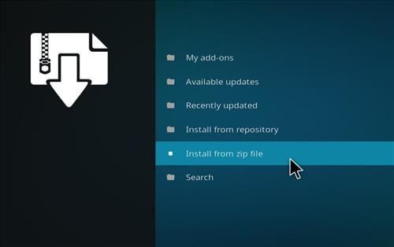
Step 4. Go to the local storage location. For example here a PC is being used and it has been copied to the C: Drive.
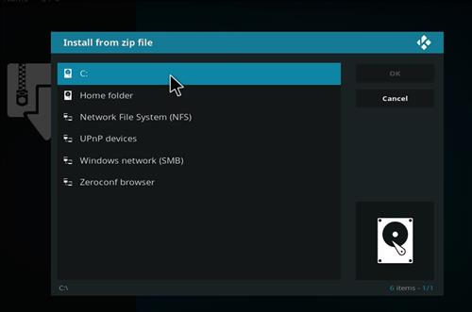
Step 5. Click fresh start and the Program Add-on will install.
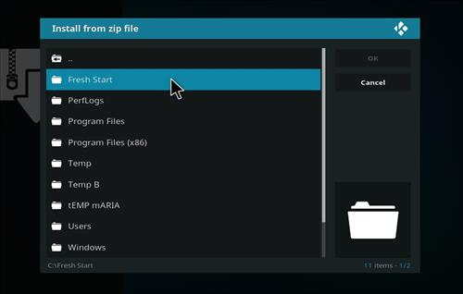
Follow from step 13 above to finish the install.

