How to Install Atriox Kodi 18 Leia Add-on
March 29, 2019 Whyingo Leave a comment
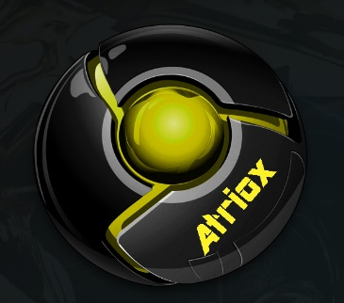
Overview Atriox
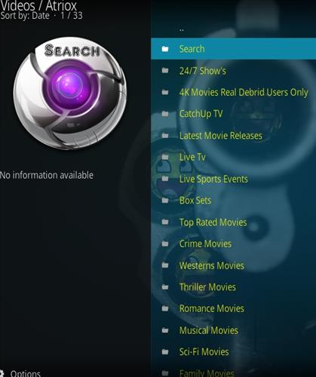
Atriox is Kodi Add-on for Leia 18 from Supremacy Repository. This add-on has sections fro 24/7 Shows, Catch up Tv, Latest Movie Releases, Live TV, Live Sports Events, Boxsets, Crime Movies, Wetern Movies, Sci-Fi Movies, Family Movies, Tv shows, Kids Movies, Kids Boxsets, Networks, Concerts, Production Movies, Comedy Movies and much more.
Using a VPN with Kodi is always recommended for privacy and security. Try IPVanish which is Kodi friendly, has no logs, and unlimited bandwidth.

Steps to Install Atriox Kodi 18 Leia Add-on
Step 1) From Home Screen go to Settings
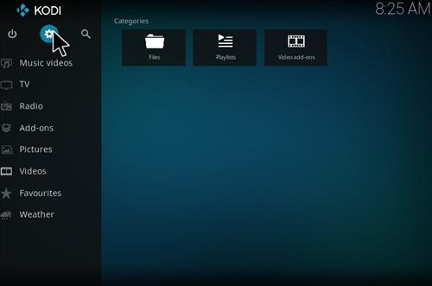
Step 2) Click File Manager
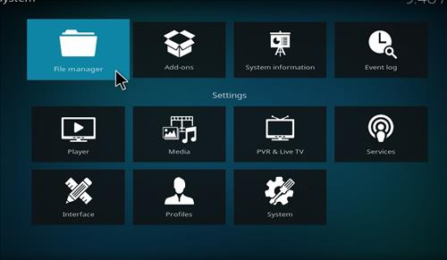
Step 3) Click Add Source
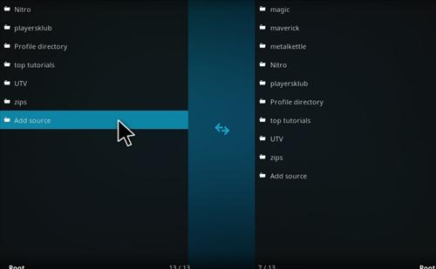
Step 4) Click None
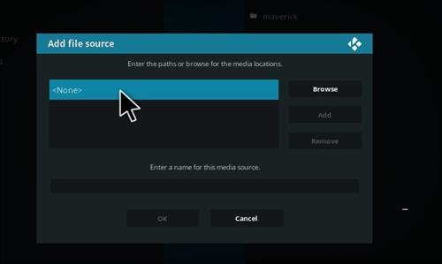
Step 5) Enter the following Address: http://2supremacy.uk/repo/
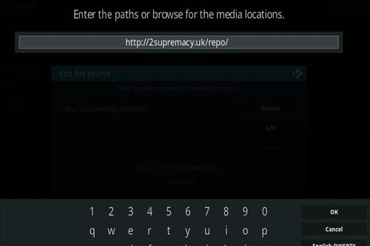
Step 6) Name it supremacy
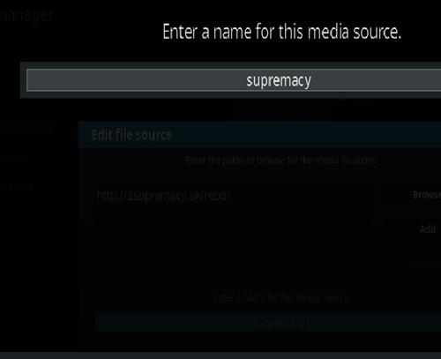
Step 7) The boxes should match the picture below
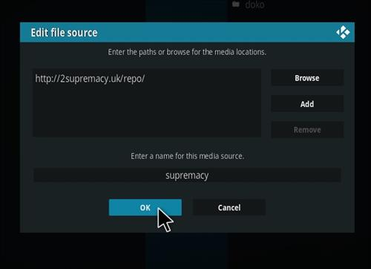
Step 8) Go back to Home Screen and click Add-ons
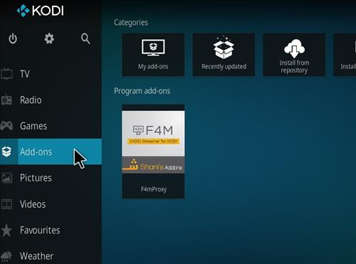
Step 9) Click the add-on installer from the top left
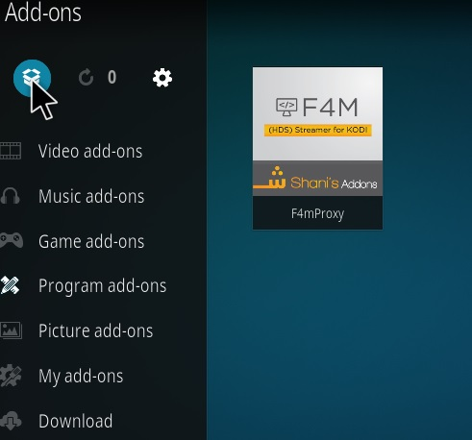
Step 10) Click install from zip file
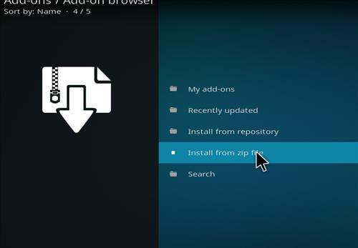
Step 11) A box will open click supremacy
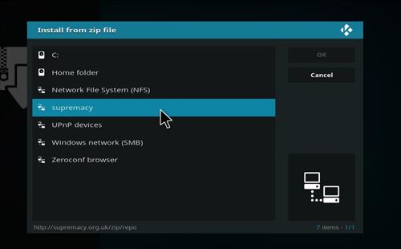
Step 12) Click repository.supremacy-1.0.zip
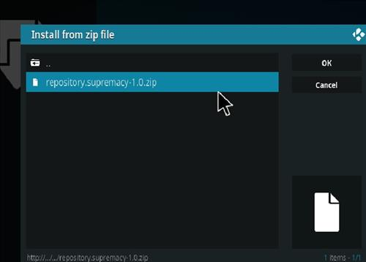
Step 13) Wait for the top right to popup Supremacy Repository Installed
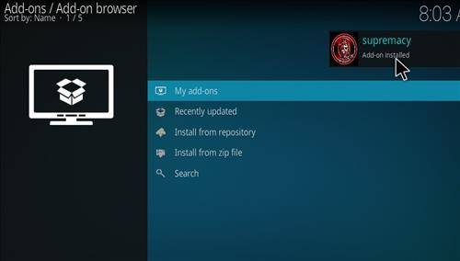
Step 14) Click Install from repository
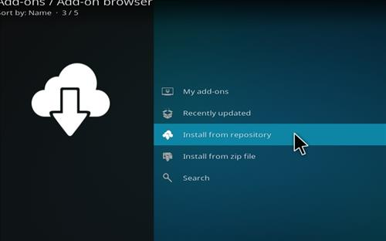
Step 15) Click Supremacy
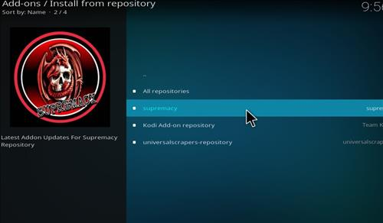
Step 16) Click Video Add-ons
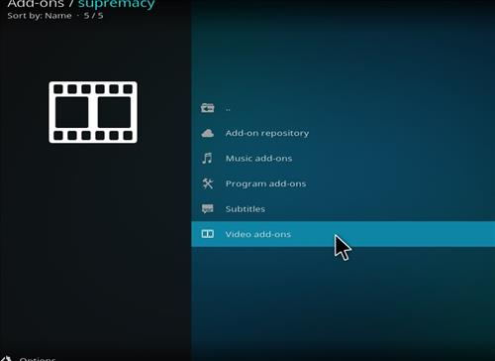
Step 17) Click Atriox
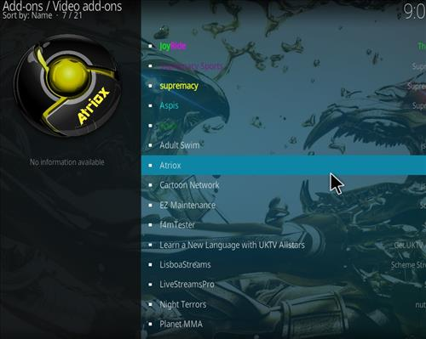
Step 18) Click Install
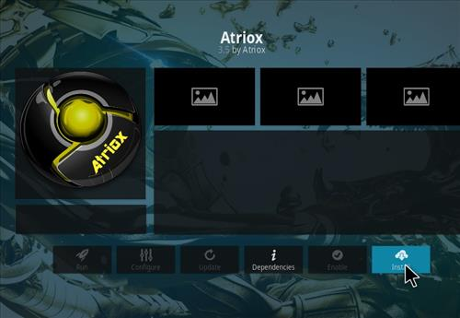
Step 19) It will pop up the additional dependencies click where it says OK
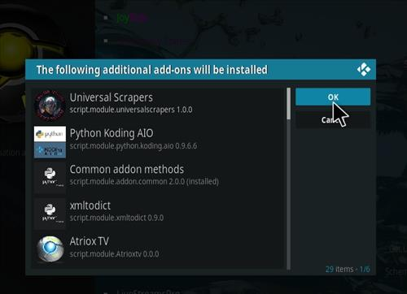
Step 20) Wait for the top right to popup Atriox Add-on installed
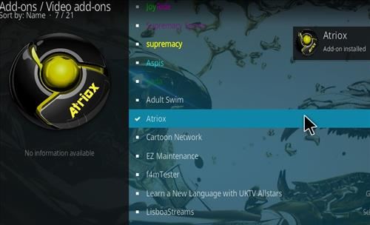
Step 21) After it installs it will be located on Home Screen Add-ons->Video Add-on
