How to Install Breezz Base Kodi Build 18 Leia
Breezz Base is a Build for those with Kodi 18 Leia installed from Breezz Wizard.
It uses Aeon Nox Silvo skin and it’s also perfect for PC’s, Android TV boxes, Amazon Fire TV Stick along with a fully working setup for everything you might want including Movies, Sports, Live TV, Kids, TV Shows, Music and a lot more.
Many top Kodi add-ons are included.
Using a VPN with Kodi is always recommended for privacy and security. Try IPVanish which is Kodi friendly, has no logs, and unlimited bandwidth.

Steps to Install Breezz Base Kodi Build 18 Leia
Step 1) From home screen go to Settings
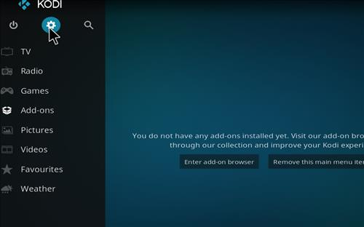
Step 2) Click File Manager
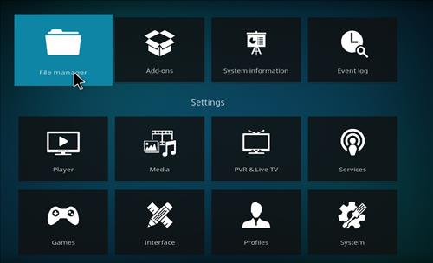
Step 3) Click Add Source
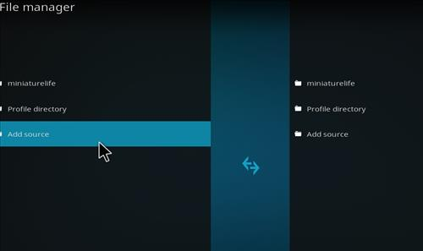
Step 4) Click None
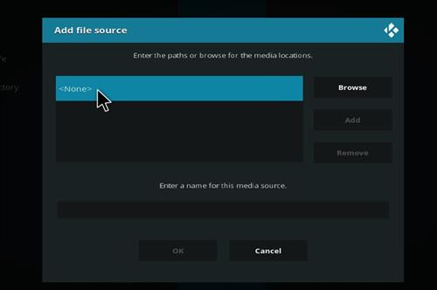
Step 5) Enter the following address: http://miniaturelife67.co.uk/repo/
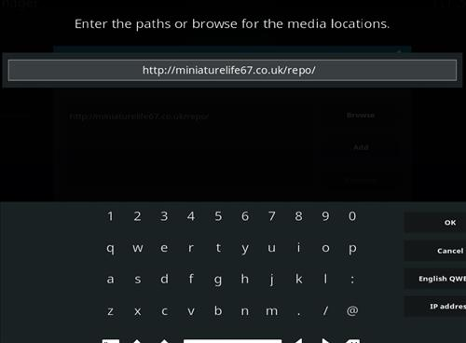
Step 6) Name it miniaturelife
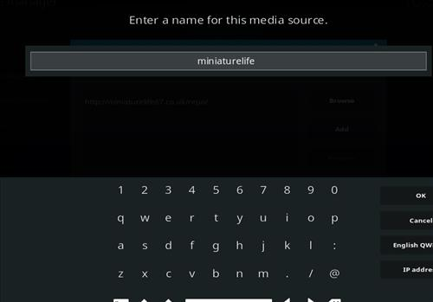
Step 7) The boxes should match the picture below
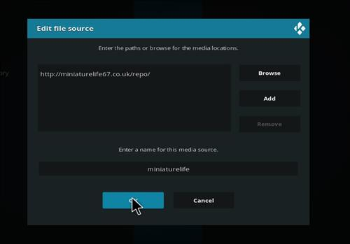
Step 8) Go back to Home screen and click add-ons
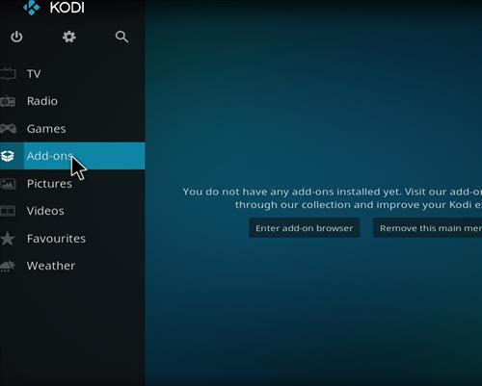
Step 9) Click the add-on browser from the top left
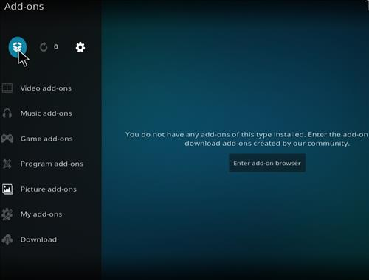
Step 10) Click Install from zip file
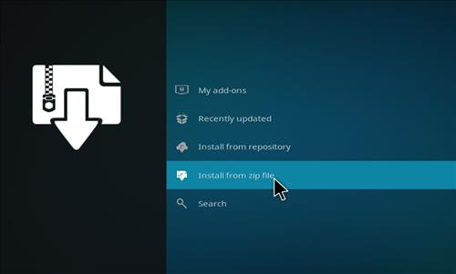
Step 11) A box will open click miniaturelife
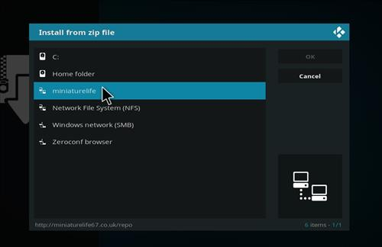
Step 12) Click repository.Ezzermacswizard.zip
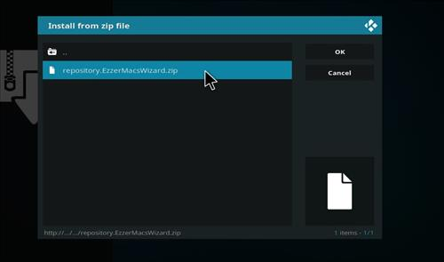
Step 13) Wait for the top right to popup Ezzermacs Wizard Repository Installed
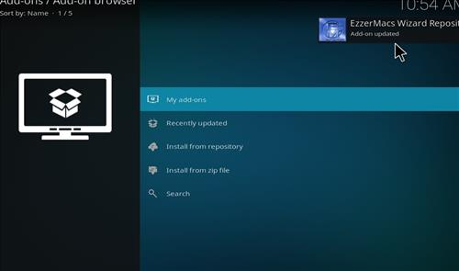
Step 14) Click Install from Repository
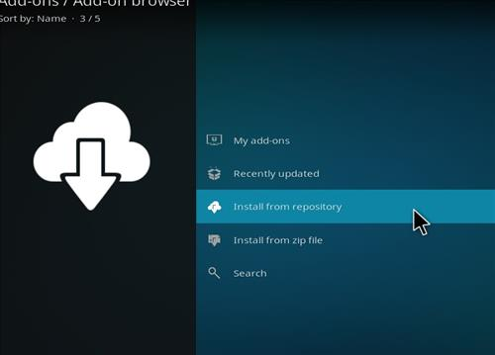
Step 15) Click Ezzermacs Wizard Repository
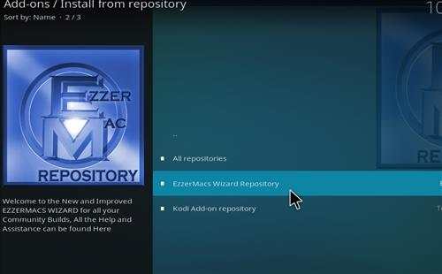
Step 16) Click Programs Add-ons
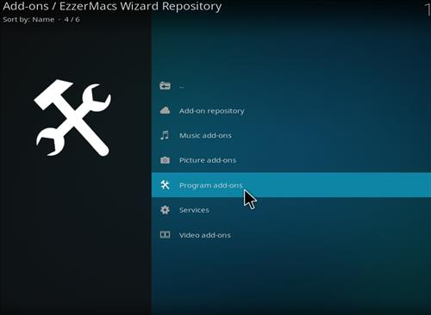
Step 17) Click Breezz Wizard
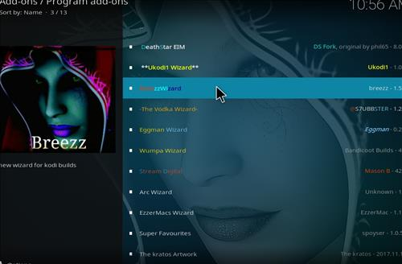
Step 18) Click Install
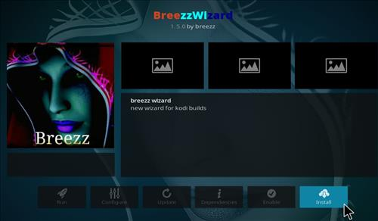

Step 19) Wait for the top right to popup Breezz Wizard Installed
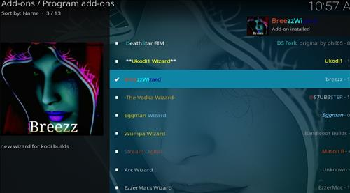
Step 20) Click Continue
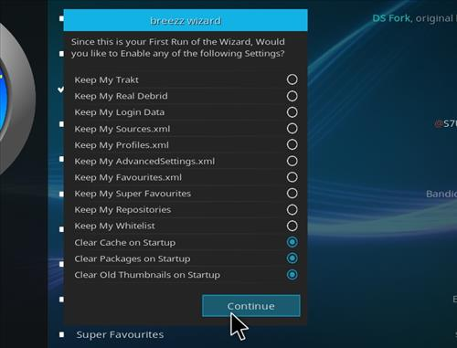
Step 21) Click Build Menu
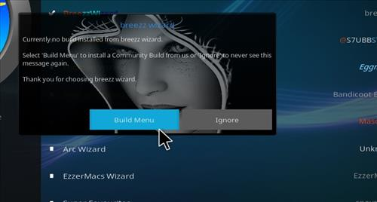
Step 22) Click Breezz Base
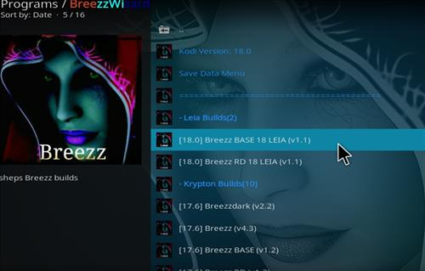
Step 23) Click Fresh Install or Standard Install (Fresh Install is usually bests)
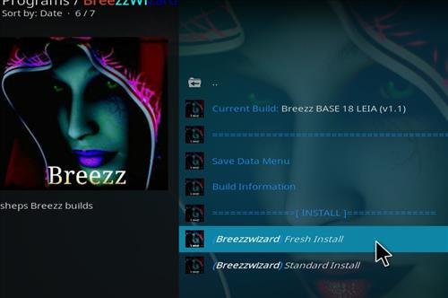
Step 24) Click Continue
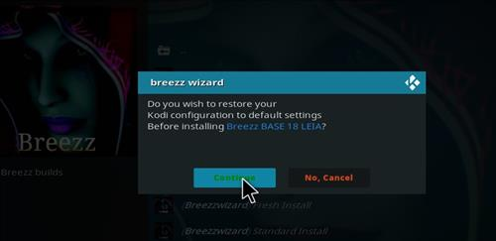
Step 25) It will download and install
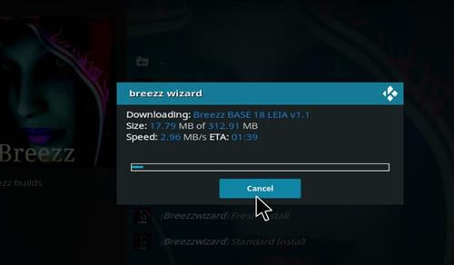
Step 26) Click Force close
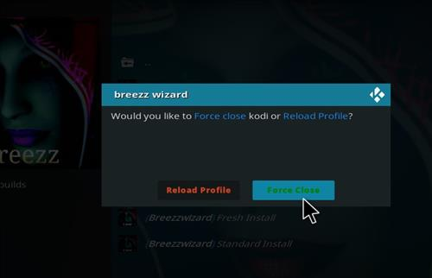

Step 27) After it installs restart Kodi and it should come up. Be sure to give it time to build menus and update add-ons.
How to change the Skin back to Default Estuary
If this Build does not work for you here is how to change the Skin back to default Estuary and remove it.
Step 1) From home screen go to Settings
Step 2) Click Interface Settings
Step 3) Click Skin
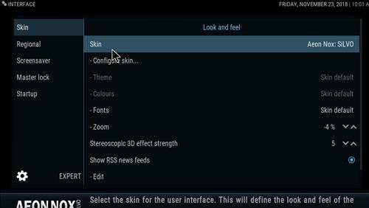
Step 4) Click Estuary
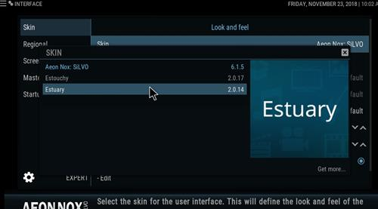
Step 5) Click Yes
