How to Install DandyMedia Repository Kodi 17 Krypton

Overview DandyMedia Add-on Kodi 17 Krypton
Here is a new Kodi add-on from dandy media for 2017. It allows you to watch 1080p Movies, 720p Movies, IMDB Playlist, More Debrid Movies, HD TV Shows, Popular TV Shows, HD Concerts, Anime, Top Documentary, UK Soaps and Children Shows.
Using a good VPN with Kodi is always suggested for privacy and security. If you need a good low cost VPN to use with Kodi Try IPVanish it has multiple high speed servers with no throttling or logs.
Be sure to have the Unknown Source box checked as Kodi 17 requires this before installing 3rd party add-ons.

Steps to Install DandyMedia Repository Kodi 17 Krypton
Step 1) From Home Screen go to Settings
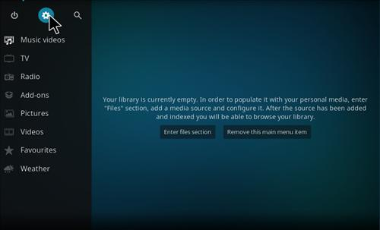
Step 2) Click File manager
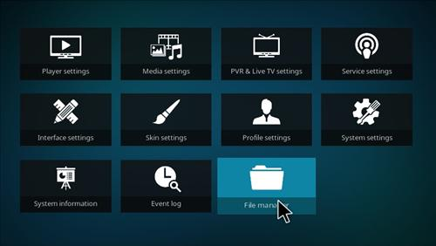
Step 3) Click Add Source
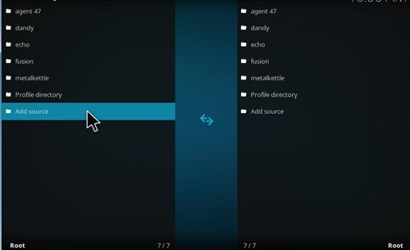
Step 4) Click None
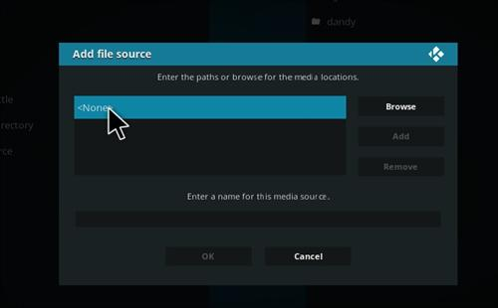
Step 5)Enter the following Address: http://dandymedia.club/repo/
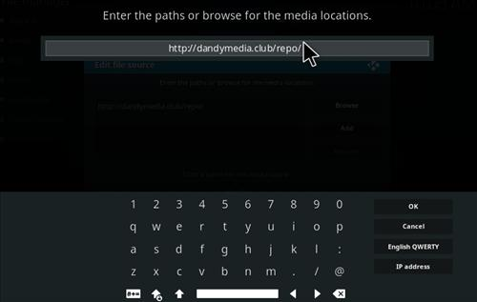
Step 6) Name it Dandy
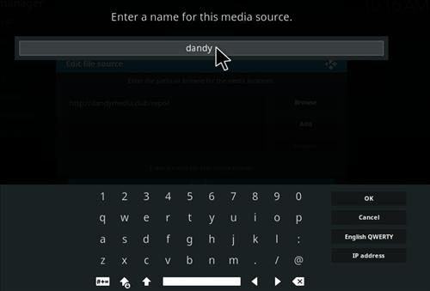
Step 7) Make sure everything is correct and click OK
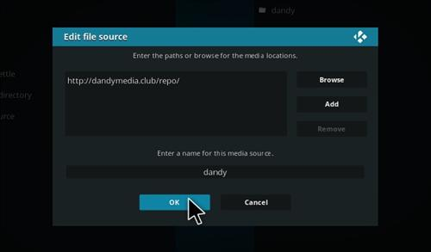
Step 8) From Home Screen go to Add-ons
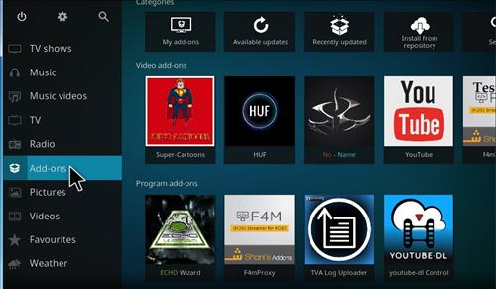
Step 9) Click the package installer from the top left
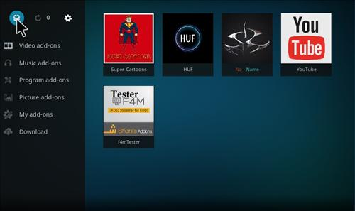
Step 10) Click install from zip file
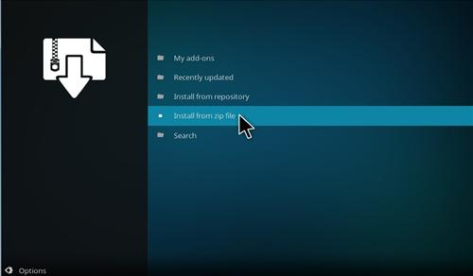
Step 11) Click Dandy
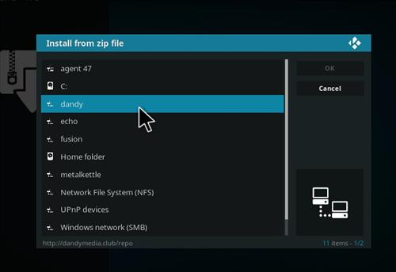
Step 12) Click repository.dandymedia.zip
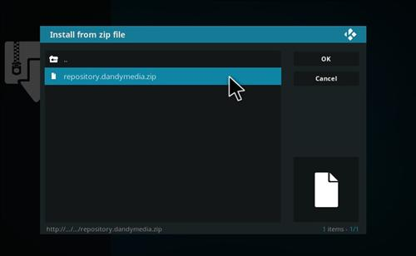
Step 13) It will pop up Dandymedia Repository Enabled
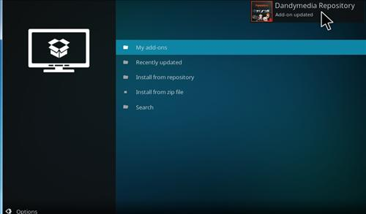
Step 14) Click Install From Repository
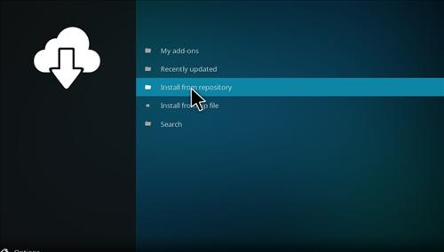
Step 15) Click Dandymedia Repository
