**How to Install Diggz XenoX Kodi 18 Leia Build**

Xenox Is a new Kodi Build for Leia 18 from the Chef Leia Wizard.  
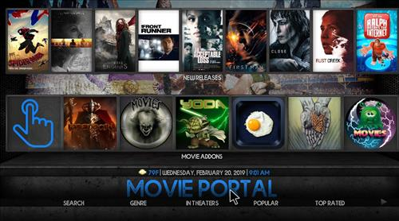  
This build has section for Movie Portal, TV Portal, Real Debrid, library, Live TV, Sports, Media Streams, Music, Kid Zone and Top Kodi Add-ons.  
   
Using a VPN with Kodi is always recommended for privacy and security. [Try IPVanish](https://www.ipvanish.com/best-vpn-kodi/?a_aid=580f5f02d1df9&chan=bvking) which is Kodi friendly, has no logs, and unlimited bandwidth.

**Steps to Install Diggz XenoX Kodi 18 Leia Build**   
   
**Step 1)** From home screen go to **Settings**  
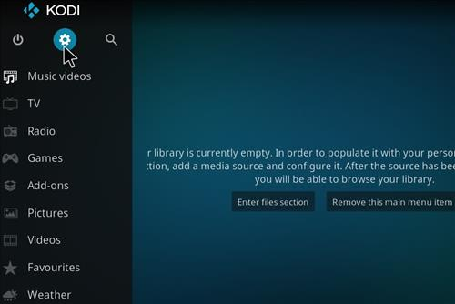  
   
**Step 2)** Click **File Manager**  
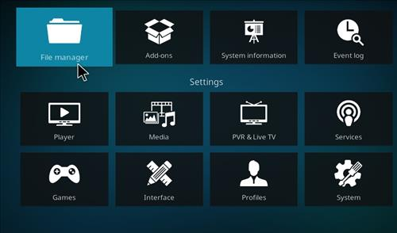  
 

**Step 3)** Click **Add Source**  
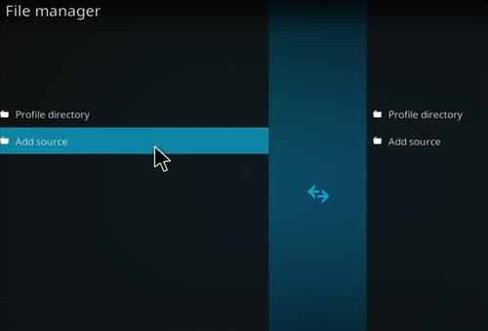  
   
**Step 4)** Click **None**  
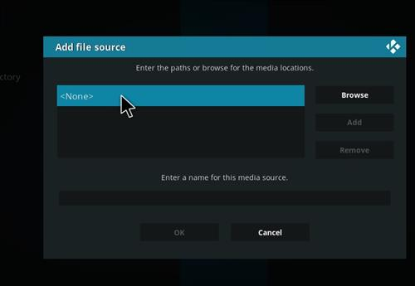  
 

**Step 5)** Enter the following address: **http://diggzrepo.ddns.net**  
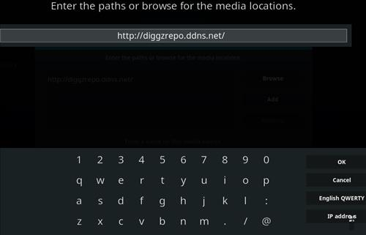  
   
**Step 6)** Name it **diggz**  
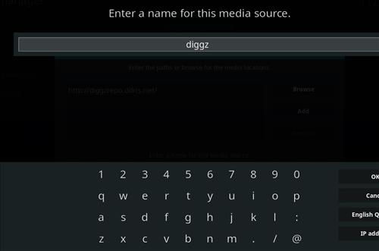  
 

**Step 7)** The boxes should match the picture below  
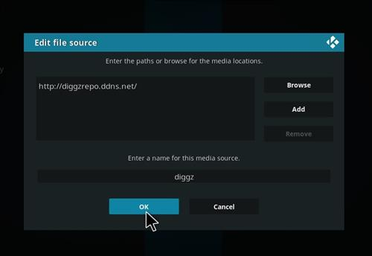  
   
**Step 8)** Go back to Home screen and click **add-ons**  
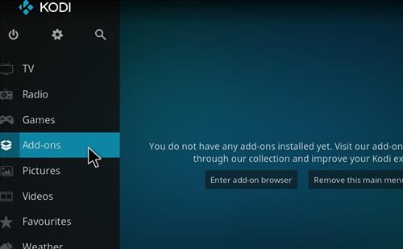  
 

**Step 9)** Click the add-on browser from the top left  
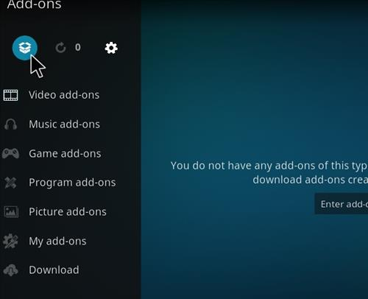  
   
**Step 10)** Click **Install from zip file**  
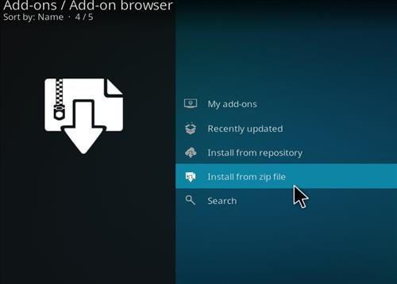  
   
**Step 11)** A box will open click **diggz**  
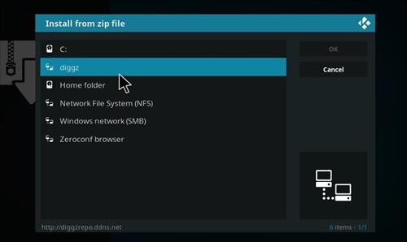  
   
**Step 12)** Click Install_Repo  
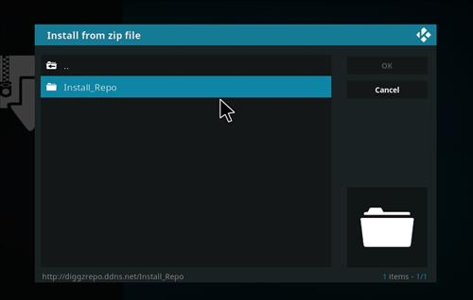  
 

**Step 13)** Click **repository.diggz-4.0.zip**  
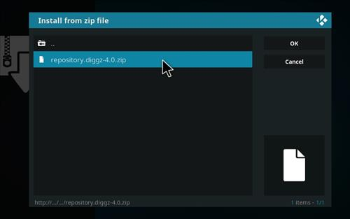  
   
**Step 14)** Click **Diggz Repository**  
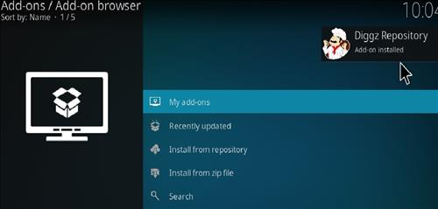  
 

**Step 15)** Click Install from Repository  
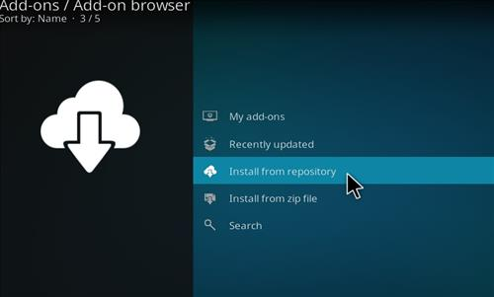  
   
**Step 16)** Click **Diggz Repository**  
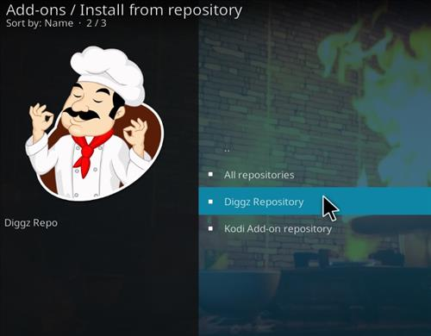  
 

**Step 17)** Click Program Add-ons  
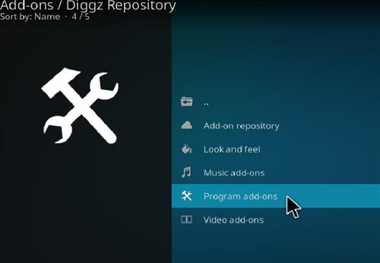  
   
**Step 18)** Click The Chef Leia Wizard  
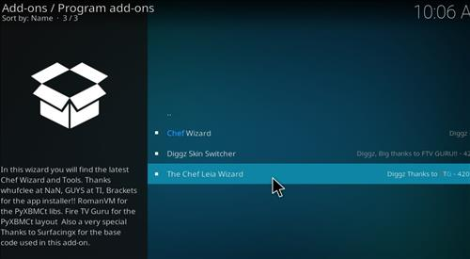  
 

**Step 19)** Click **Install**  
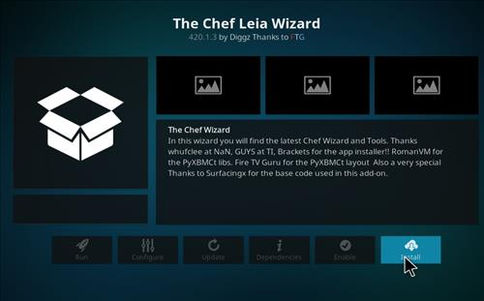  
   
**Step 20)** Wait for the top right to popup *The Chef Leia Wizard* Installed  
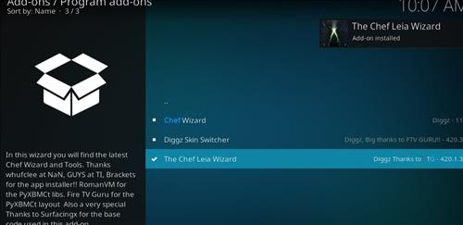  
 

**Step 21)** Click **Continue**  
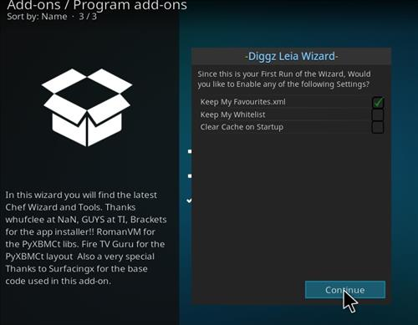  
   
**Step 22)** Click **Build Menu**  
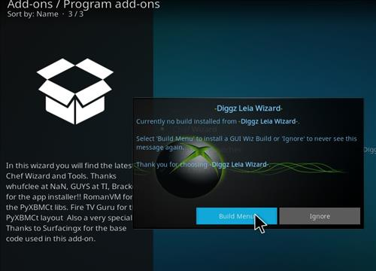  
 

**Step 23)** Clicl **Digzz XenoX**  
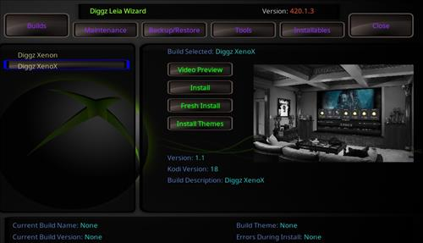  
   
**Step 24)** Click Fresh Install or Standard Install (Fresh Install is usually bests)  
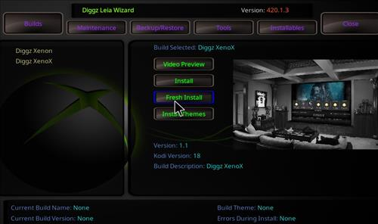  
 

**Step 25)** Click **Yes to Install**  
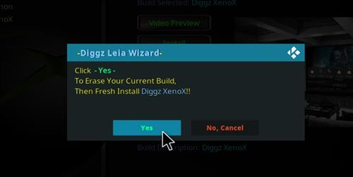  
   
**Step 26)** It will download and install  
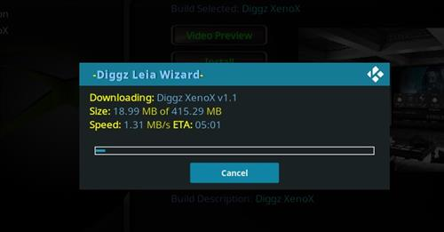  
 

**Step 27)** Click **OK** to force Close Kodi  
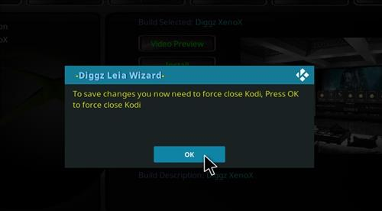  
   
**Step 28)** After it installs restart Kodi and it should come up. Be sure to give it time to build menus and update add-ons.  
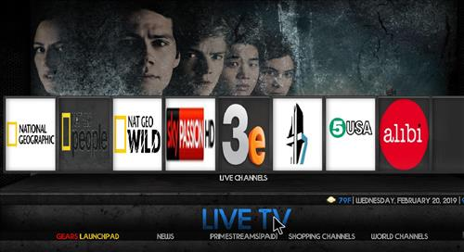  
   
 

**How to change the Skin back to Default Estuary**  
If this Build does not work for you here is how to change the Skin back to default Estuary and remove it.  
   
**Step 1)** From home screen go to **XenoX Setting**  
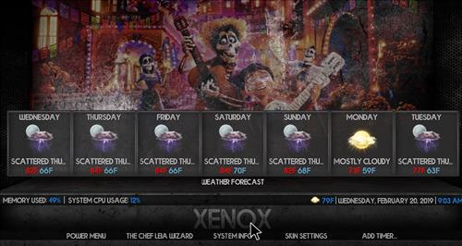  
   
**Step 2)** Click **Interface Settings**  
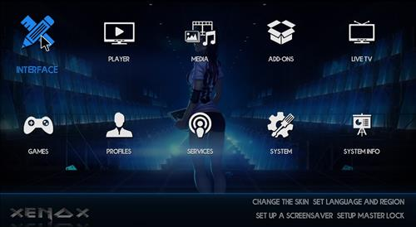  
 

**Step 3)** Click **Skin**   
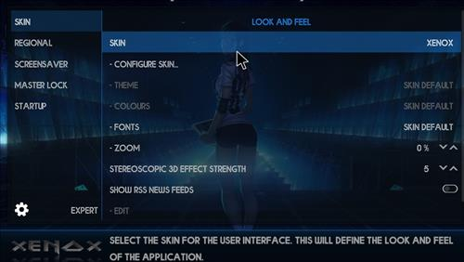  
   
**Step 4)** Click **Estuary**  
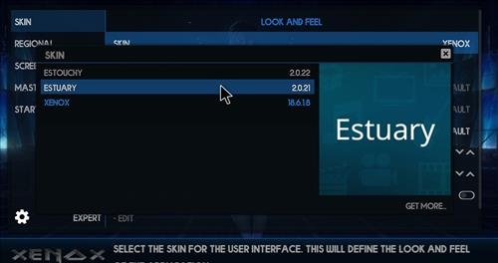  
 

**Step 5)** Click **Yes**  
